YOUTH CITIZENSHIP, DIGITAL ACTIVISM AND ELECTORAL MOBILISATION AHEAD OF NIGERIA’S 2027 GENERAL ELECTIONS

Janet Aver Adikpo, Ph.D.
Augustine University, Lagos, Nigeria
Email: jar.adikpo@gmail.com
ORCID: https://orcid.org/0000-0002-9634-120X

Abstract
Digital activism enables political participation beyond elections in Nigeria. This study examines how the #TinubuMustGo campaign on X connects youth citizenship, digital activism and electoral mobilisation ahead of Nigeria’s 2027 general elections. Guided by connective action theory, it uses qualitative content analysis of public posts published between 1 and 30 June 2026. Findings identify political voice, accountability demands, rights claims and agency as constructions of youth citizenship. Digital activism involves hashtag amplification, information sharing, calls to action and protest coordination. Electoral mobilisation emerges when governance concerns are linked to voting, re-election and electoral choice. However, much of the campaign remains focused on accountability and political dissent without explicit electoral appeals. The study shows how personalised grievances circulate through hashtag-mediated communication and sometimes acquire electoral significance. It contributes to African political communication research by distinguishing networked political dissent from electorally oriented mobilisation between national elections.

Keywords: Youth Citizenship, Digital Activism, Electoral Mobilisation, Connective Action, Hashtag Activism, Nigeria

Introduction
Digital media have transformed political participation across democratic and emerging democratic societies (Durotoye et al., 2026). Social networking platforms enable citizens to express political opinions, contest State policies, mobilise action and shape public discourse. In Africa, social media complement conventional political participation by enabling citizens, particularly young people, to organise protests, demand accountability and influence national conversations (Ajaegbu & Ajaegbu, 2024). In Nigeria, digital activism has characterised #OccupyNigeria (Uwalaka & Watkins, 2018), #BringBackOurGirls (Oriola, 2021), #EndSARS (Onayinka et al., 2026) and the #TinubuMustGo campaign.

Nigeria’s youthful population has played a central role in digital political participation. Young Nigerians use digital platforms to discuss governance, economic conditions, insecurity and issues affecting their lives (Obia, 2025; Apata, 2025). Political participation occurs beyond elections and party activities through networked communication, hashtag activism and digitally coordinated civic action (Ugwuoke & Erubami, 2021). Through hashtags, posts, images, videos and other forms of online communication draw attention to political issues, challenge government actions, demand accountability and mobilise others (Uwalaka & Nwala, 2023). Such activism can sustain political discussion between elections and link governance concerns to future political participation (Odeyemi et al., 2022). Whether it develops an electoral orientation, however, requires closer attention.
Existing scholarship on digital activism in Nigeria has focused on protest mobilisation, online advocacy, misinformation, election campaigns and democratic participation (Obisesan, 2022). Studies of #EndSARS, have examined protest organizations (Akerele-Popoola et al., 2022), digital political narratives (Aboh, 2024), civic resistance (Adeniyi, 2022) and State responses (Dim & Chow, 2026). However, less is known about how governance and accountability concerns expressed through activism between elections connect with subsequent electoral mobilisation (Onayinka et al., 2026).

This study addresses this gap through the #TinubuMustGo campaign on X (formerly Twitter). It examines how the campaign constructs narratives of youth citizenship and political participation, the forms of digital activism evident and how governance concerns connect with electoral mobilisation ahead of Nigeria’s 2027 general elections. It addresses three research questions: (1) How does the #TinubuMustGo campaign to construct narratives of youth citizenship and political participation? (2) What forms of digital activism are evident in the #TinubuMustGo campaign? (3) How does the #TinubuMustGo campaign connects governance concerns with electoral mobilisation ahead of Nigeria’s 2027 general elections?

The study uses qualitative content analysis of posts containing #TinubuMustGo. Connective action theory provides a framework for examining how personalised political expressions connect through hashtag-mediated communication. The study links youth citizenship and digital activism to electoral mobilisation by examining political communication between electoral cycles.

Conceptual Framework
This study examines three concepts: youth citizenship, digital activism and electoral mobilisation. They explain how youth participation in public affairs takes the form of digital activism and how governance-related activism may acquire an electoral orientation between elections.

Youth Citizenship
Citizenship has traditionally been understood as the legal relationship between individuals and the State, encompassing rights, responsibilities and participation in public affairs (Marshall, 1950; Wood, 2022). Classical conceptions emphasised voting, political representation and civic obligations within formal democratic institutions (Dalton, 2008). Contemporary scholarship, however, extends citizenship beyond legal status to participation in civic and political life (Wood, 2022). Citizenship can therefore be practised through public deliberation, collective action, advocacy and engagement outside formal electoral institutions.

Youth citizenship concerns young people’s exercise of rights and participation in public affairs (Vromen et al., 2016). Focusing on voting or party membership can overlook issue-based activism, advocacy, protest and community action. Youth engagement encompasses formal and informal political claims, public debate, accountability demands, agency and recognition (Staeheli et al., 2013). Despite formal rights, young people may have few opportunities to influence established decision-making (Harris et al., 2010). Alternative spaces let them voice claims, challenge decisions and act collectively (O’Loughlin & Gillespie, 2012).

Digital media extend youth citizenship into networked spaces (Bennett et al., 2011), where young people discuss public issues, scrutinise governments, organise around shared concerns, and circulate political information beyond traditional media and institutions (Loader et al., 2014). Using communication technologies to address public concerns can constitute citizenship (Choi, 2016), making it part of everyday political communication beyond elections (Bello & Kaufhold, 2023). However, digital citizenship is shaped by unequal internet access, misinformation, algorithmic visibility, and harassment, and does not necessarily lead to formal political action.

Digital Activism
Digital activism involves using digital technologies to communicate grievances, organise campaigns, disseminate alternative information and coordinate protest activities (George & Leidner, 2019). It covers advocacy and political discussion, protest coordination, citizen documentation, and networked mobilisation (Treré & Kaun, 2021). Digital activism may operate through formal organisations, but social media also enable decentralised participation, allowing individuals to contribute to campaigns without belonging to a central organisation (Wang & Zhou, 2021).

Digital platforms lower barriers to political participation (Boulianne, 2020). Hashtags, livestreams, images, videos and user-generated content connect dispersed participants, circulate political claims and spotlight issues (Uwalaka and Nwala, 2023). Hashtags also aggregate contributions into searchable streams (Wang & Zhou, 2021). Digital resistance occurs when citizens use digital communication to challenge political authority, policies or dominant narratives and to organise opposition (Castillo-Esparcia et al., 2023). Digital activism also involves civic education, advocacy, information sharing, electoral discussion and mobilisation.

The political consequences of digital activism remain contested (Freelon et al., 2020; Santini & Carvalho, 2019). Low-cost forms of participation such as posting, sharing and hashtag use can expand opportunities for engagement, visibility and mobilisation, but do not necessarily lead to sustained participation or institutional change (Castillo-Esparcia et al., 2023). This study defines digital activism as digital communication for political expression, advocacy, accountability, and networked mobilisation.

Electoral Mobilisation
Electoral mobilisation refers to activities that encourage citizens to participate in electoral processes through voting, political discussion, campaign engagement and other forms of participation (Vaccari & Valeriani, 2021). Traditional mobilisation strategies have relied on political parties, campaign organisations, community leaders and conventional media (Chadwick & Stromer-Galley, 2016). Digital communication has expanded mobilisation by allowing political information, appeals and discussion to circulate outside formal campaigns (Klinger et al., 2023).

Digital platforms also make the period between elections relevant to electoral mobilisation. Citizens can discuss public policies, assess government performance, exchange political information and debate political leadership before formal campaigns begin (Odeyemi et al., 2022). Such engagement can connect everyday political concerns with electoral (Kurniawan et al., 2024). However, political discussion or exposure to electoral information should not automatically be treated as mobilisation; electoral mobilisation requires an identifiable orientation toward electoral participation.

Protest-oriented participation and electoral participation are analytically distinct, but they may intersect when grievances about governance become linked to voting, voter registration, candidate evaluation, campaign participation or other election-related actions (Masunda, 2022). Digital activism connects dissatisfaction with current political conditions to electoral participation (Uwalaka et al., 2026). This study defines electoral mobilisation as digital communication that encourages, coordinates, or directs participation in elections, including voting, registration, political choice and other engagement.

The Connective Logic of Digital Activism
Digital activism raises the question of how dispersed individuals participate in political causes without relying on formal organisations or shared collective identities (Bennett & Segerberg, 2012). Connective action theory explains this participation through personalised communication across digital networks (Bennett & Segerberg, 2023).

The theory distinguishes collective action, which generally relies on organisational coordination and shared identities, from connective action, which emerges through personalised political communication (Pond & Lewis, 2019). Bennett and Segerberg (2012) describe connective action through personalised action frames, in which participants adapt political claims to their own experiences, while remaining connected to a broader cause. Hashtags bring individual contributions into a common political discussion (Vromen, 2017).

Connective action theory is relevant to this study because #TinubuMustGo connects individual political expressions through a common hashtag. It explains how personalised posts on governance, accountability and political participation contribute to a wider digital campaign (Carson, 2021). The framework guides the analysis of how personalised grievances and political claims relate to youth citizenship and digital activism and whether these expressions acquire an electoral orientation ahead of Nigeria’s 2027 general elections. An electoral orientation cannot be inferred from digital networking alone.

Contextual Literature and Research Gap

The #TinubuMustGo Campaign in Nigeria’s Pre-2027 Political Environment

The period leading to Nigeria’s 2027 general elections has been marked by debate over governance, economic conditions, insecurity and government accountability. Digital platforms have remained important spaces for political expression and mobilisation (Akamo, 2026). The #TinubuMustGo campaign examined in this study is situated within this pre-2027 political environment. The campaign provides a case for examining how governance-related digital activism between elections constructs narratives of youth citizenship and whether it acquires an electoral orientation ahead of 2027.

Digital Activism and Electoral Politics in Nigeria
Research on digital political participation in Nigeria has grown alongside social media use for protest, advocacy and electoral communication (Obia, 2025). #OccupyNigeria linked online communication to protests against the 2012 fuel subsidy removal (Uwalaka & Watkins, 2018). #BringBackOurGirls sustained attention to the abducted Chibok schoolgirls and connected Nigerian advocacy with transnational publics (Onah, 2024).

Studies of #EndSARS examined youth-led digital activism (Akerele-Popoola et al., 2022; Uwalaka & Nwala, 2023), including protest coordination, information sharing and citizen documentation (Uwalaka, 2024); youth political expression (Olaitan, 2024); police accountability (Abioye, 2026); participatory governance (Omilusi, 2025) and digitally networked resistance (Ilesanmi, 2025). Electoral studies examine online campaigning, political information, candidate communication and citizen engagement (Morah & Nwafor, 2024). The Obidient movement linked digital activism with the 2023 elections (Egbunike, 2025; Onayinka et al., 2026).

Studies of protest activism and electoral communication have largely developed separately, leaving inter-election political engagement less examined. Digital platforms enable discussion of government policies, accountability and leadership after elections (Boulianne, 2020), while studies of Nigerian political parties document online communication and mobilisation between elections (Odeyemi et al., 2022). X has been used for digital activism in Nigeria (Ataguba, 2026; Obia, 2025), and its searchable hashtags allow researchers to examine how grievances, accountability demands and election-related messages intersect.

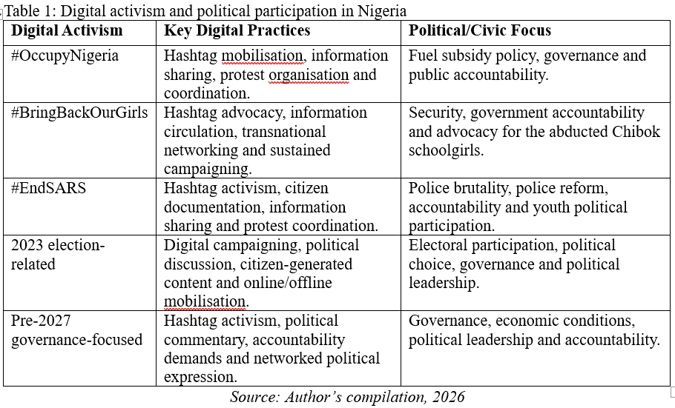

Research Gap
Research linking Nigerian digital activism directly to subsequent electoral mobilisation remains limited. Studies linking protest activism to electoral engagement include research on #EndSARS and the Obidient movement (Onayinka et al., 2026). However, participation in digital protest should not automatically be treated as evidence of subsequent electoral mobilisation. Existing scholarship identifies three dimensions of Nigeria’s digital political environment: social media facilitate protest and civic activism (Akerele-Popoola et al., 2022; Uwalaka & Nwala, 2023); young Nigerians are prominent participants in digitally mediated political engagement (Omilusi, 2025) and digital platforms support electoral communication (Morah & Nwafor, 2024; Onayinka et al., 2026). However, the electoral orientation of governance-focused activism between elections remains underexplored. To address this gap, the study examines how #TinubuMustGo constructs narratives of youth citizenship and connects governance concerns with electoral mobilisation ahead of Nigeria’s 2027 general elections.

Methodology
This study used qualitative content analysis to examine political communication within the #TinubuMustGo campaign on X (formerly Twitter). Qualitative content analysis enables systematic examination of texts to identify recurring meanings (Schreier, 2012). The analysis addressed youth citizenship and political participation, digital activism and electoral mobilisation.

The population comprised publicly accessible X posts containing the #TinubuMustGo. Posts published between 1 and 30 June 2026 were examined, situating the analysis ahead of Nigeria’s 2027 general elections. Although a longer period could capture changes in political communication as the elections approached, the study focused on participation and electoral references in June 2026. Posts were retrieved using X search functions and date filters. X was selected because its public hashtag-based communication allows political messages, calls to action and electoral references to be examined together.

The #TinubuMustGo hashtag was selected as a case of digital activism centred on governance and political accountability. Its relevance lies in examining whether dissatisfaction with government performance also references electoral participation. Other political hashtags were excluded to retain focus on this campaign.

Purposive sampling was used to select publicly accessible, English-language posts relevant to the research questions (Campbell et al., 2020). Posts were included if they used #TinubuMustGo and addressed governance, accountability, citizenship, political participation, digital activism, or electoral issues. Duplicate content, advertisements, spam, identifiable automated posts and unrelated hashtag use were excluded. Quote posts and replies were retained when they provided substantive commentary or clarified an original post’s political meaning, while reposts without commentary were excluded as analytical units.

The search retrieved 74 posts, screened against these criteria, yielding 18 for analysis. Each substantive post served as the unit of analysis.

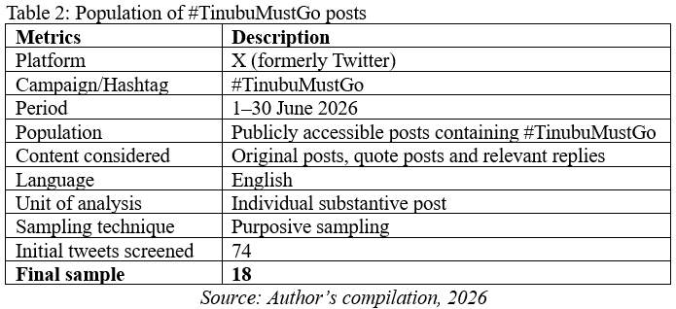
Posts were analysed using deductive and inductive coding (Kuckartz & Rädiker, 2023). Deductive categories covered three dimensions: youth citizenship and political participation, digital activism and electoral mobilisation. Initial codes included political voice, accountability, agency, digital resistance, information sharing, calls to action, personalised political expression, electoral references and electoral mobilisation. Inductive coding identified additional patterns. Codes were compared across the 18 posts and grouped into themes.

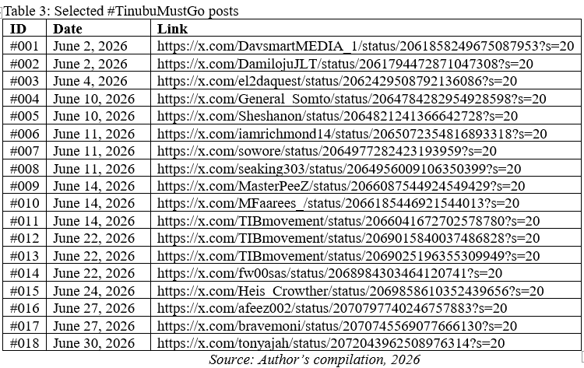
Connective action theory (Bennett & Segerberg, 2012) guided analysis of personalised political expressions within hashtag-mediated communication. The analysis examined personalised action frames, the hashtag’s connective role, digitally networked mobilisation and whether governance-related expressions remained protest-oriented or acquired an electoral orientation. The coding guide was refined through repeated readings and cross-post comparison. To strengthen trustworthiness, coding decisions were checked against the original posts to ensure themes reflected the language and political claims. Electoral mobilisation was coded only when posts contained textual or visual evidence linking political expression to electoral participation. Only public posts were analysed and usernames, profile photographs and other identifying information were removed from reported data.

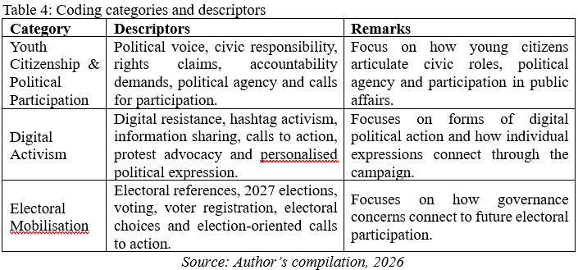

Findings and Analysis

Youth Citizenship through Political Voice and Accountability
The analysis reveals youth citizenship as active political engagement expressed through political voice, accountability demands and claims about the State’s responsibilities. These practices are evident in a post describing the #TinubuMustGo protest in Abuja:

“Nigerians are using their voices… In a democracy, protests remain one of the ways citizens make their feelings known.”

The post constructs political voice as a democratic practice through which citizens communicate dissatisfaction. Through the #TinubuMustGo hashtag, this expression joins a wider stream of governance-related communication.

Political participation is also connected to political awareness. One tweet states:

“The fact that some people are still supporting Tinubu despite everything that’s happening in Nigeria shows how messed up our situation is. There’s a very huge awareness gap we need to bridge for us to have the country of our dream!”

The “awareness gap” frames political awareness as necessary for change, while “the country of our dream” connects individual judgement with a shared political future.
Accountability constitutes a second dimension. One tweet states that:
“20 killed in Kebbi. Another massacre. Another tragedy. Another reminder that the State is failing to protect its citizens. Nigerians deserve better.”

The repeated “another” frames insecurity as an ongoing governance problem, while “Nigerians deserve better” expresses citizens’ expectations of the State.

Another tweet broadens political authority:

“Seyi o, Must Go. Makinde, must go. Tinubu, must go. Useless, must go Enough of Playing politics with insecurity, the useless government that can’t protect the people must leave. Be it president or governor. Be it IGP or COAS.”

Naming different officeholders, the tweet distributes responsibility for insecurity across institutions and positions citizens to demand accountability from public authorities.

The discourse also connects citizenship with rights, evident in the assertion that:

“No prison is strong enough to silence the demand for justice. Freedom for the Nigerian people.”

The language of “justice” and “freedom” constructs citizenship through rights claims, while “no prison is strong enough to silence” presents a political voice as persistent despite perceived constraints.

A further pattern concerns political agency:

“In case you missed this... #TinubuMustGo protest in Nyanya, Abuja. The day Nigerians decide to take back their country, all this political nonsense will end.”

The phrase “take back their country” assigns agency to citizens, while its connection to the Nyanya protest links dissatisfaction with calls for political action. Overall, youth citizenship is constructed through political voice, awareness, rights claims, accountability and political agency.

Digital Activism through Hashtag Amplification and Protest Mobilisation
The analysis reveals digital activism as a networked practice through which political messages are amplified, participation is encouraged and protest coordination is promoted. A tweet shows hashtag amplification directly:

“Hashtag tinubumustgo #tinubumustgo Push this hashtag guys”

The instruction to “push this hashtag” encourages users to increase campaign visibility.

A similar form of digital participation appears in another tweet:
“Everybody should #TINUBUMUSTRESIGN in the comments section it’s take you nothing to re-tweet.”

The expressions “everybody should” and “it’s take you nothing to re-tweet” present commenting and reposting as low-threshold forms of participation.

Beyond amplification, the discourse uses digital platforms to mobilise participation in physical protest. One tweet states:

“Nigerians, when you wake up NATIONWIDE tomorrow, June 12 Democracy Day Action! TAKE CHARGE.”

“NATIONWIDE” extends the call across locations, while “tomorrow” adds urgency to the appeal for protest participation.

More specific coordination is evident in another tweet:

“VDM said protests don’t work – but last night, him and his “rats” proved otherwise. I love it. Join the movement: Abuja – join VDM Lagos – Friday, June 12, Ikeja Under Bridge No more silence. Demand accountability. End insecurity.”

The tweet’s date and location, along with the instruction to “join the movement”, show how digital communication supports protest coordination across Abuja and Lagos. “No more silence” frames participation as a response to perceived government inaction.

Digital communication also circulates information about street-level action:

“Take It Back Movement protesters shut down Iwo Road, Ibadan this morning, demanding an end to insecurity and accountability over the ongoing kidnapping/abduction crisis.”

Unlike the preceding calls to participate, this tweet reports an action. Sharing the Ibadan protest extends its visibility beyond those physically present and connects local action with the wider #TinubuMustGo discourse.

Another tweet uses the platform to recruit participants to an ongoing protest:

“Leave that club plan and meet us outside. Tinubu must go protest is on now in Abuja. We don’t have a president and anybody occupying there who is clueless about running a nation, needs to get the hell out.”

The informal instruction to “leave that club plan and meet us outside” redirects everyday activity towards protest. The phrase “protest is on now” adds urgency to the recruitment appeal.

Electoral Mobilisation through Governance Evaluation and Electoral Choice
The analysis shows electoral mobilisation as a process that links dissatisfaction with governance to future voting decisions. The connection is evident in a tweet reflecting on the economic situation:
“Looking back at this tweet. I don’t think Nigerians are angry enough now add another 4 years. to your age.
Re-tweeted: The difference between ₦1 and $1 is so wild that even if you earn ₦1 every day, you still won’t have $1 after 4 years.”

The phrase “add another 4 years to your age” projects economic dissatisfaction into another electoral term, encouraging reflection on the consequences of political choices.

Another tweet links dissatisfaction more explicitly to political change:

“Tinubu has successfully failed Nigerians and it’s ripe for Nigerians to kick him out.
Re-tweeted:
ENOUGH IS ENOUGH Tinubu Must Go! Nigerians are suffering badly and we can’t continue like this. The hardship is too much and the promises are all lies. We want our country back! APC Must Go! Time to take our power back. Share if you’re tired too.”

Perceived hardship and dissatisfaction with government performance support the call to “kick him out”. The instruction to “share if you’re tired too” connects this demand to wider digital circulation.

Voting emerges more directly as a means of exercising agency in another tweet:

“BAT and his cohorts want to add akara to the cassava (garri) and corn he promised us last election. Collect the akara chop but VOTE your conscience. Our future is in our hands”

The “last election” links past campaign experiences to future electoral judgement. The instruction to “VOTE your conscience” presents voting as an individual decision, while “our future is in our hands” gives it collective significance.

The discourse becomes explicitly oriented towards re-election in the repeated appeal:

“Dear Nigerians Stop supporting Tinubu’s re-election stop supporting Tinubu’s re-election Stop supporting Tinubu’s re-election He has failed. APC has been failing Nigeria.”

The repetition adds urgency to the call against re-election and links the poster’s evaluation of government performance to a future electoral decision.

The 2027 election is invoked in another post:

“VeryDarkMan Just Post This: ‘RATEL Don Land. The message is clear: Bola Ahmed Tinubu is a failure and should not come back in 2027.’”

The phrase “should not come back in 2027” connects dissatisfaction with current leadership to the forthcoming election as an opportunity for political change.

This relationship between present experience and future voting is reinforced in the tweet:

“You can’t hear all this and still proceed to vote for Tinubu.
People are going through it mehnn”

The tweet makes hardship relevant to voting decisions, presenting electoral choice as a response to prevailing social and economic conditions.

Electoral mobilisation within #TinubuMustGo connects economic hardship, perceived government failure and dissatisfaction with leadership to re-election and voting in 2027.

Discussion
The findings show how youth citizenship within #TinubuMustGo connects with digital activism and electoral mobilisation between elections. Youth citizenship is expressed through political voice, accountability demands, rights claims and political agency, while digital activism provides networked practices through which these expressions circulate. Some expressions take on an explicit electoral orientation by linking dissatisfaction with government performance to voting, re-election, and the 2027 general elections.

The campaign’s construction of youth citizenship supports scholarship that conceptualises citizenship beyond voting and party membership (Vromen et al., 2016). Political participation within #TinubuMustGo is reflected in posts that discuss governance, demand accountability, assert rights and encourage protest. These practices position citizens as political actors who evaluate the State and articulate expectations concerning security, justice and government responsiveness.

Researchers have identified similar forms of digitally mediated citizenship outside conventional political institutions (Loader et al., 2014; Choi, 2016). Recent Nigerian studies link youth activism to civic agency, political expression and governance concerns (Apata, 2025; Omilusi, 2025). Within the campaign, citizenship expressed in protest and accountability discourse connects to electoral politics when governance evaluations inform electoral choices.

Digital activism connects these forms of participation. While hashtag amplification, reposting, sharing, calls to action and protest coordination enable participants to contribute at different levels (Wang & Zhou, 2021), digital platforms reduce organisational barriers and allow dispersed individuals to support political causes through flexible engagement (Bennett & Segerberg, 2012). Evidence from Nigeria’s #EndBadGovernance protests shows that social media facilitated protest coordination through digitally networked participation (Uwalaka et al., 2026). The use of digital communication to publicise and coordinate protest within #TinubuMustGo reflects a broader pattern in Nigerian digital activism.

Connective action theory helps explain how these practices form a political campaign. Bennett and Segerberg’s (2012) concept of personalised action frames is relevant because the posts do not reproduce a single organisational message. Participants articulate dissatisfaction through concerns about insecurity, economic hardship, justice, political leadership and government accountability. #TinubuMustGo connects these contributions without requiring identical motivations or organisational membership. However, connectivity alone does not establish electoral mobilisation.

Scholarship on digital activism cautions against assuming that posting, sharing or hashtag participation necessarily produces sustained participation (Boulianne, 2020; Castillo-Esparcia et al., 2023). Much of #TinubuMustGo remains centered on governance concerns, accountability and protest. Nevertheless, a distinct strand explicitly refers to voting, re-election, electoral choice and 2027. The campaign therefore contains both connective political dissent and electorally oriented mobilisation. This distinction between connective political dissent and electorally oriented mobilisation clarifies how connective action theory applies to governance-focused digital activism between elections.

Digital communication links personalised grievances, but these can remain protest discourse or become electorally oriented when hardship, insecurity and perceived government failure are tied to voting choices. Egbunike (2025) documents how digital media and deprivation-related grievances intersected with the Obidient movement’s electoral activities in 2023. Onayinka et al. (2026) likewise link #EndSARS activism, the Obidient movement and youth electoral participation.

The findings have practical implications for civic organisations, political communication practitioners and researchers. Hashtag activity should not be treated as evidence of electoral mobilisation without examining the messages. Governance-related posts may encourage public discussion, accountability demands or protest, while others explicitly call for electoral participation. Distinguishing these forms of engagement can help practitioners assess whether online campaigns encourage public debate, protest participation or electoral action.

This study focuses on the period between national elections, when governance-focused activism may remain protest-oriented or acquire electoral meaning. The relationship should nevertheless be interpreted cautiously. Election-oriented messages within #TinubuMustGo does not demonstrate that digital participation will translate into voting behaviour or determine electoral outcomes. The findings identify electoral mobilisation at the level of political communication without inferring subsequent electoral behaviour.

Conclusion
This study examined youth citizenship, digital activism and electoral mobilisation through the #TinubuMustGo campaign ahead of Nigeria’s 2027 general elections. The campaign provides a networked space where citizens demand accountability, exercise political voice and circulate governance concerns through hashtags, reposts, calls to action and protest mobilisation. Some expressions move beyond protest by linking government performance to voting, re-election and electoral choice.

Digital activism does not automatically become electoral mobilisation, although the two can intersect. Governance-related activism can remain centred on protest, accountability and resistance without an electoral orientation. Within #TinubuMustGo, however, some personalised grievances become electorally oriented when economic hardship, insecurity and perceived government failure are connected to voting decisions. Connective action theory helps explain how hashtag-mediated communication links personalised grievances without necessarily giving them an electoral orientation.

The study contributes to African political communication research by identifying the period between elections as a site of political participation. During this period, citizens evaluate governments, contest policies and articulate expectations about subsequent elections. #TinubuMustGo illustrates how digital platforms can connect civic activism, protest mobilisation and electoral communication between electoral cycles.

The study has limitations. Its focus on a single hashtag and platform captures only a segment of the wider political conversation. The qualitative analysis identifies patterns in public communication but cannot establish participants’ demographic characteristics, motivations or whether online expressions translate into voting or other electoral behaviour. Future research could examine the campaign across platforms, incorporate interviews or surveys and follow its development towards the 2027 elections to assess whether digitally networked engagement develops into sustained electoral participation.

References
Abioye, A. E. (2026). Digital activism and youth-led social movements: A Mixed-Methods Study of Twitter’s role in the #EndSARS protests and police reform advocacy in Nigeria. PLASU Journal of Communication Studies, 1(3), 1–17. https://doi.org/10.20370/wvbbv268
Aboh, S. C. (2024). ‘It will never be well with SARS’: A discourse analytic study of the #EndSARS protests on social media. Discourse & Society, 35(2), 153–173. https://doi.org/10.1177/09579265231200994
Adeniyi, E. (2022). ‘We’re now the Walking Dead’: Predatory policing, youth agency and framing in Nigeria’s #EndSARS social activism. African Studies, 81(2), 149–169. https://doi.org/10.1080/00020184.2022.2141686
Ajaegbu, O. O., & Ajaegbu, C. A. (2024). The new democratisation: Social media impact on the political process in Sub-Saharan Africa. Frontiers in Communication, 9, 1–6. https://doi.org/10.3389/fcomm.2024.1394949
Akamo, J. O. (May, 2026). Nigeria’s Journey to the 2027 General Elections: The African Union’s Resolve Under Test, Again. Institute for Peace & Security Studies Policy Brief, Vol.17-15. https://ipss-addis.org/wp-content/uploads/2026/05/Policy-Brief-Nigerias-Journey-1.pdf
Akerele-Popoola, O. E., Azeez, A. L., & Adeniyi, A. (2022). Twitter, civil activism and EndSARS protest in Nigeria as a developing democracy. Cogent Social Sciences, 8(1), 1–16. https://doi.org/10.1080/23311886.2022.2095744
Apata, S. B. (2025). Digital literacy and civic agency: Youth-led hashtag movements in Nigeria’s #EndSARS protest. De-centre: Journal of Interdisciplinary Studies, 1(1), 1–11. https://doi.org/10.36615/37t4gr11
Ataguba, O. A. (2026). Digital citizenship on Nigeria’s X, hashtags of contention and rights claims. In Yékú, J., & Junck, L. (Eds.), African Digital Cultures (pp. 216-237). Routledge. https://doi.org/10.4324/9781003690511
Bello, A. W. K., & Kaufhold, K. (2023). Power to the people: Social media as a catalyst for political participation in Nigeria. International Journal of Interactive Communication Systems and Technologies, 12(1), 1–17. https://doi.org/10.4018/IJICST.320652
Bennett, W. L. (2012). The personalisation of politics: Political identity, social media and changing patterns of participation. The Annals of the American Academy of Political and Social Science, 644(1), 20–39. https://doi.org/10.1177/0002716212451428
Bennett, W. L., & Segerberg, A. (2012). The logic of connective action: Digital media and the personalisation of contentious politics. Information, Communication & Society, 15(5), 739–768. https://doi.org/10.1080/1369118X.2012.670661
Bennett, W. L., & Segerberg, A. (2023). The logic of connective action: Digital media and the personalisation of contentious politics. In Coleman, S., & Sorensen, L. (Eds.), Handbook of Digital Politics (pp. 287–338). Edward Elgar Publishing. https://doi.org/10.4337/9781800377585.00030
Bennett, W. L., Wells, C., & Freelon, D. (2011). Communicating civic engagement: Contrasting models of citizenship in the youth web sphere. Journal of Communication, 61(5), 835–856. https://doi.org/10.1111/j.1460-2466.2011.01588.x
Boulianne, S. (2020). Twenty years of digital media effects on civic and political participation. Communication Research, 47(7), 947–966. https://doi.org/10.1177/0093650218808186
Campbell, S., Greenwood, M., Prior, S., Shearer, T., Walkem, K., Young, S., Bywaters, D., & Walker, K. (2020). Purposive sampling: Complex or simple? Research case examples. Journal of Research in Nursing, 25(8), 652–661. https://doi.org/10.1177/1744987120927206
Carson, A. (2021). The digital spotlight: Applying a connective action framework of political protest to global watchdog reporting. The International Journal of Press/Politics, 26(2), 362–384. https://doi.org/10.1177/1940161220912679
Castillo-Esparcia, A., Caro-Castaño, L., & Almansa-Martínez, A. (2023). Evolution of digital activism on social media: Opportunities and challenges. Profesional de la Información, 32(3), 1–16. https://doi.org/10.3145/epi.2023.may.03
Chadwick, A., & Stromer-Galley, J. (2016). Digital media, power and democracy in parties and election campaigns: Party decline or party renewal? The International Journal of Press/Politics, 21(3), 283–293. https://doi.org/10.1177/1940161216646731
Choi, M. (2016). A concept analysis of digital citizenship for democratic citizenship education in the Internet age. Theory & Research in Social Education, 44(4), 565–607. https://doi.org/10.1080/00933104.2016.1210549
Dalton, R. J. (2008). Citizenship norms and the expansion of political participation. Political Studies, 56(1), 76–98. https://doi.org/10.1111/j.1467-9248.2007.00718.x
Dim, E. E., & Chow, D. (2026). Nigeria’s political hangover: Military legacy, State repression and the #EndSARS protest movement. Current Sociology (Advance online publication). https://doi.org/10.1177/00113921261424499
Durotoye, T., Goyanes, M., Berganza, R., & Gil de Zúñiga, H. (2026). Online and social media political participation: Political discussion network ties and differential social media platform effects over time. Social Science Computer Review, 44(4), 697–717. https://doi.org/10.1177/08944393251332640
Egbunike, N. A. (2025). Relative deprivation, digital media and Nigeria’s Obidient political movement. African Identities, 0(00)1–17. https://doi.org/10.1080/14725843.2025.2513316
Freelon, D., Marwick, A., & Kreiss, D. (2020). False equivalencies: Online activism from left to right. Science, 369(6508), 1197–1201. https://doi.org/10.1126/science.abb2428
George, J. J., & Leidner, D. E. (2019). From clicktivism to hacktivism: Understanding digital activism. Information and Organisation, 29(3), 1–21. https://doi.org/10.1016/j.infoandorg.2019.04.001
Harris, A., Wyn, J., & Younes, S. (2010). Beyond apathetic or activist youth: ‘Ordinary’ young people and contemporary forms of participation. Young, 18(1), 9–32. https://doi.org/10.1177/110330880901800103
Ilesanmi, O. (2025). Discursive tropes of youth activism in the tweets of virtual #EndSARS protesters. African Identities, 1–21. https://doi.org/10.1080/14725843.2025.2593938
Klinger, U., Kreiss, D., & Mutsvairo, B. (2023). Platforms, Power and Politics: An Introduction to Political Communication in the Digital Age. John Wiley & Sons.
Kuckartz, U., & Rädiker, S. (2023). Qualitative Content Analysis: Methods, Practice and Software 2e. SAGE.
Kurniawan, W., Arham, M., & Muluk, H. (2024). Social media’s influence on political participation: Insights from a systematic review and meta-analysis in Indonesian psychology. Jurnal Psikologi, 51(3), 336–355. https://doi.org/10.22146/jpsi.101469
Loader, B. D., Vromen, A., & Xenos, M. A. (2014). The networked young citizen: Social media, political participation and civic engagement. Information, Communication & Society, 17(2), 143–150. https://doi.org/10.1080/1369118X.2013.871571
Marshall, T. H. (1950). Citizenship and Social Class and Other Essays. Cambridge University Press.
Masunda, O. (2022). Urban Youth Political Participation in Bulawayo, Zimbabwe. (Doctoral Dissertation, University of Johannesburg).
Morah, D. N. (2024). Beyond tribal politics for e-participation and development: Social media influence on Nigeria’s 2023 presidential general election. Journal of Innovative Digital Transformation, 1(1), 32–47. https://doi.org/10.1108/JIDT-08-2023-0004
O’Loughlin, B., & Gillespie, M. (2012). Dissenting citizenship? Young people and political participation in the media-security nexus. Parliamentary Affairs, 65(1), 115–137. https://doi.org/10.1093/pa/gsr055
Obia, V. (2025). Twitter activism: Understanding the Twittersphere as the foremost community for activism and dragging in Nigeria. New Media & Society, 27(1), 151–167. https://doi.org/10.1177/14614448231172967
Obisesan, O. F. (2022). The ‘#tag generation’: Social media and youth participation in the 2019 general election in Nigeria. Africa Development, 47(2), 107–145. https://doi.org/10.57054/ad.v47i2.2202
Odeyemi, T. I., Igwebueze, G. U., Abati, O. O., & Ogundotun, A. O. (2022). Political hibernation in-between elections? Exploring the online communication and mobilisation capacities of Nigeria’s political parties. Journal of Public Affairs, 22(S1), 1–24. https://doi.org/10.1002/pa.2804
Olaitan, Z. M. (2024). EndSARS protest and political participation of youths in Nigeria. In Akinola, A.O., & Liaga, E.A. (Eds.), Development and Regional Stability in Africa: Unlocking Potential (pp. 83–106). Cham: Springer Nature Switzerland. https://doi.org/10.1007/978-3-031-56695-0_6
Omilusi, M. (2025). Participatory governance and youth protests in the digital age: Interrogating the #EndSARS movement. African Security, 18(2), 122–144. https://doi.org/10.1080/19392206.2025.2474276
Onah, C. K. (2024). #BringBackOurGirls: Transnational activism and the remediation of the 2014 Chibok girls’ kidnapping in Nigeria. African Studies Review, 67(2), 295–320. https://doi.org/10.1017/asr.2024.13
Onayinka, T. S., Oluwasola, O., & Oyedele, O. J. (2026). Strategic political metamorphosis? Organised EndSARS protest and the online ‘Obidient’ movement as mediated political activism shaping Nigeria’s deliberative democracy. Journal of Asian and African Studies, 61(6), 5013–5029. https://doi.org/10.1177/00219096261440544
Oriola, T. B. (2021). Framing and movement outcomes: The #BringBackOurGirls movement. Third World Quarterly, 42(4), 641–660. https://doi.org/10.1080/01436597.2020.1811663
Pond, P., & Lewis, J. (2019). Riots and Twitter: connective politics, social media and framing discourses in the digital public sphere. Information, Communication & Society, 22(2), 213–231. https://doi.org/10.1080/1369118X.2017.1366539
Santini, R. M., & Carvalho, H. (2019). Online platforms for citizen participation: Meta-synthesis and critical analysis of their social and political impacts. Comunicação e Sociedade, (36), 163–182. https://doi.org/10.17231/comsoc.36(2019).2350
Schreier, M. (2012). Qualitative Content Analysis in Practice. SAGE Publications
Staeheli, L. A., Attoh, K., & Mitchell, D. (2013). Contested engagements: Youth and the politics of citizenship. Space and Polity, 17(1), 88–105. https://doi.org/10.1080/13562576.2013.780715
Treré, E., & Kaun, A. (2021). Digital media activism: A situated, historical and ecological approach beyond the technological sublime. In Balbi, G., Ribeiro, N., Schafer, V. & Schwarzenegger, C. (Eds.), Digital Roots: Historicizing Media and Communication Concepts of the Digital Age (pp. 193–208). De Gruyter Oldenbourg. https://doi.org/10.1515/9783110740202-011
Ugwuoke, J. C., & Erubami, J. A. (2021). Old war, new battleground: Deconstructing the potency of social media for community engagement in Nigeria’s human rights advocacy efforts. World of Media. Journal of Russian Media and Journalism Studies, 2021(2), 56–74. https://doi.org/10.30547/worldofmedia.2.2021.3
Uwalaka, T. (2024). Social media as solidarity vehicle during the 2020 #EndSARS protests in Nigeria. Journal of Asian and African Studies, 59(2). https://doi.org/10.1177/00219096221108737
Uwalaka, T., & Nwala, B. (2023). Examining the role of social media and mobile social networking applications in socio-political contestations in Nigeria. Communication and the Public, 8(3), 175–190. https://doi.org/10.1177/20570473231168474
Uwalaka, T., & Watkins, J. (2018). Social media as the fifth estate in Nigeria: An analysis of the 2012 Occupy Nigeria protest. African Journalism Studies, 39(4), 22–41. https://doi.org/10.1080/23743670.2018.1473274
Uwalaka, T., Nwala, B., Wokoro, P., & Daniel, P. U. (2026). Social media and protest planning: An examination of the 2024 #EndBadGovernance protests in Nigeria. Media, War & Conflict, 0(00), 1–21. https://doi.org/10.1177/17506352261458764
Vaccari, C., & Valeriani, A. (2021). Outside the Bubble: Social Media and Political Participation in Western Democracies. Oxford University Press.
Vromen, A. (2017). Digital Citizenship and Political Engagement: The Challenge from Online Campaigning and Advocacy Organisations. London: Palgrave Macmillan UK.
Vromen, A., Loader, B. D., Xenos, M. A., & Bailo, F. (2016). Everyday making through Facebook engagement: Young citizens’ political interactions in Australia, the United Kingdom and the United States. Political Studies, 64(3), 513–533. https://doi.org/10.1177/0032321715614012
Wang, R., & Zhou, A. (2021). Hashtag activism and connective action: A case study of #HongKongPoliceBrutality. Telematics and Informatics, 61, 1–18. https://doi.org/10.1016/j.tele.2021.101600
Wood, B. E. (2022). Youth citizenship: Expanding conceptions of the young citizen. Geography Compass, 16(12), 1–13. https://doi.org/10.1111/gec3.12669

YOUTHWASHING AS POLITICAL PERFORMANCE IN THE DIGITAL AGE: DISCURSIVE CONSTRUCTION ON X (TWITTER), INSTAGRAM, AND FACEBOOK DURING NIGERIA’S 2026-2027 ELECTIONEERING

Anu’ Steven Adesemoye, Ph.D.
Department of Mass Communication Lagos State University of Science and Technology.
ORCID: https://orcid.org/0009-0009-0557-8075
Email: adesemoye.a@lasustech.edu.ng

Olanrewaju Amos Arisoyin
Department of Mass Communication,
Trinity University,
Yaba, Lagos State.
ORCID: https://orcid.org/0009-0003-9751-1236
Email: lanreamos016@gmail.com

Bukola Elizabeth Ogunremi
Department of Mass Communication
Lagos State University of Science and Technology
Email; ogunremibukky2006@gmail.com

Abstract
During the second phase of INEC’s 2026 Continuous Voter Registration (CVR), 9,324,349 young Nigerians were newly registered. This period in the Fourth Republic marks an unprecedented democratic awakening, reminiscent of the #EndSARS protests and the 2023 Obidient Movement. While political elites acknowledge the electoral significance of youth demographics, much of their campaign messaging targets them. This study explored ‘youthwashing’ as a form of theatrical political rhetoric on X (formerly Twitter), Instagram, and Facebook between 19 August and 30 October 2026, during Nigeria’s 2027 election campaign preparations. Using multimodal discourse analysis and theories of mediated authenticity and performativity, it analysed how politicians and influencers portray “youth” as an electoral asset while marginalising them in policy engagement. A purposive sample of 60 public posts across Facebook, X, and Instagram was selected based on youth-oriented hashtags, visuals, and captions. The findings were examined against indicators such as hidden sponsorship, tokenistic youth imagery, hedged policy claims, and aestheticised politics, collectively revealing political elites' youthwashing. The study argued that these tactics foster an illusion of youth inclusion without genuine representation or accountability, influencing perceived legitimacy and potentially discouraging meaningful youth participation. Recommendations on campaign regulation, disclosure standards, youth, and media literacy will shape future electoral discourse in Nigeria.

Keywords: Digital Age, Electioneering, Facebook, Instagram, Nigeria, X, Youthwashing, Youth Agency, 2027 elections

Introduction
One enduring phenomenon shaping politics, polity, and policy is the internet's democratisation and its redefinition of political life, especially electioneering. The mass exodus of voters to social media platforms has reshaped political communication, including how it is framed and targeted. As digital natives grow, political elites match them with a vast supply of niche messages that mirror and resonate with them. This paradigm shift emboldens digital activism, social reengineering, and political manoeuvring. It is an unprecedented development for both encoders and decoders of digital semiotics. Incidentally, the forthcoming 2026-2027 Nigerian elections are set against a political climate in which youth have increasingly gained prominence in the country's democratic politics. One major sign of this trend was observed during the second round of the Continuous Voter Registration (CVR). According to INEC statistics, 9,324,349 young Nigerians were newly registered during the 2026 exercise (Akinwale, 2026). This increased visibility makes it possible to consider how political actors communicate with youth before elections.

Mustapha and Omar (2020) argued that Nigerian youths engaged in substantial online political activity during the 2019 elections and that social media use remained important even when other forms of civic and political engagement were controlled for the public good or for ulterior motives. Obisesan (2022) found that social media helped Nigerian youths build political agency, engage in debate, and develop socio-political networks during the 2019 elections. These studies collectively established that young Nigerians are both consumers and producers of political communication. This was evident during the youth-led #EndSARS protests against incessant police brutality in October 2020. The youths fiercely deployed social media such as Twitter (now X), Facebook, Instagram, WhatsApp, and others to inform, document abuses, organise protests, and lobby for reforms. The protests highlighted the role that digital platforms might play in youth political participation and collective action (Adegbola et al., 2022; Uwalaka, 2022).

According to Dambo et al. (2022), Chiluwa (2023), and Awopetu and Chiluwa (2023), social media gave Nigerian youths opportunities to express grievances collectively and organise protests, while also revealing the systemic constraints facing digitally mediated activism. The political forces of #EndSARS also converged with the 2023 political environment, especially the rise of the Obidient movement. This indicates that young people's political activism in Nigeria increasingly occurs through digitally mediated collective identity and communication. As Ezeigbo (2025) demonstrates in his analysis of the 2023 elections, youths used social media for political advocacy, communication, and political activities.

However, this trend creates a major paradox. As young Nigerians' electoral importance grows, political elites have an incentive to recognise, respond to, and connect with youth. Meanwhile, youth are excluded from candidate selection, policy creation, political decision-making, and leadership. This distinction between visibility and agency lies at the heart of contemporary political communication aimed at youth. Ezeigbo (2025) notes that with the youth's high level of social media engagement during the 2023 elections, young Nigerians' participation has increased; however, this does not mean political institutions have given young people equal influence.

In this context, youthwashing serves as the organising framework for the current research. Viterbo (2025) defined youthwashing as a cynical practice that exploits young people without necessarily addressing their problems or engaging them. This definition helps us develop a conceptual approach to studying situations where the symbolism of youth inclusion does not align with youth activism. Accordingly, the current study adopts youthwashing as a relevant concept for analysing youth-oriented political communication in Nigeria, treating it as an analytical lens observable in practices such as tokenistic youth imagery, behind-the-scenes sponsorship, policy hedging, and aesthetic politics.

Research Questions
The research questions that guide the study are as follows:
1. How is youth participation discursively constructed on X, Instagram, and Facebook during Nigeria’s 2026-2027 electioneering?
2. In what ways are youth represented through textual, visual, and audiovisual features in selected political posts on X, Instagram, and Facebook?
3. In what ways can youthwashing be observed through sponsorship, tokenism, hedging in policy discourse, and the aesthetics of politics?
4. How do the constructions and manifestations of youthwashing vary across X, Instagram, and Facebook during Nigeria’s 2026-2027 electioneering?

Literature Review
This study reviews existing literature on social media, youth as a communication agency, and media advocacy as an intervention tool for the silenced voices. The review covers relevant concepts, theories, and empirical studies to help define the existing knowledge base and to lay the groundwork for the present study.

Youthwashing as Political Performance
According to Viterbo (2025), youthwashing is the self-centred appropriation of youth that fails to adequately address their interests. Viterbo shows how organisations may invoke youth participation while retaining considerable discretion over whose voices they listen to and how they define participation. Youthwashing becomes relevant to political communication in electoral competition, and when politicians try to show their connection to young voters. The “washing” family of concepts highlights situations in which institutions, companies, or politicians strategically associate themselves with socially valuable causes or identities through communication, even when the link between symbolism and practice is minimal or even contradictory. For example, greenwashing refers to communication that can give audiences an overly positive image of an organisation’s environmental practices (Delmas & Burbano, 2011; Lyon & Montgomery, 2015). The key message is that claims and performances need to be examined in relation to the practices they supposedly represent. In this study, youthwashing is defined as the strategic construction of youth inclusion in discourse and multimodal performance, whereby youth participation can be visible, linguistically or symbolically constructed, without any proof of actual youth engagement, representation, or political responsiveness. Youthwashing thus deliberately differs from normal youth-focused political communication. The presence of youth in a political campaign message cannot be considered youthwashing on its own. It becomes a possibility for analysing youthwashing only when youth inclusion is continuously constructed in political communication despite a lack of evidence of engagement, accountability, and policy specificity.

Mediated authenticity, the first theoretical point of reference, has become an important feature of modern political communication, as political actors must demonstrate sincerity, approachability, and relevance to citizens. In his definition of political authenticity, Luebke (2021) argues that it is a social construct developed and negotiated through political communication among politicians, the media, and the public. He distinguishes performed, mediated, and perceived authenticity and highlights the dimensions used to construct political authenticity. Similarly, Enli (2015) shows that mediation creates authenticity rather than simply transmitting a pre-existing quality. This mediation is intensified on social media platforms, where political actors can communicate directly with audiences by carefully curating the images, experiences, and interactions that shape their public identity (Enli, 2016; Marwick & Boyd, 2011).

Mediated authenticity is particularly relevant to youthwashing, as political actors may seek to perform sincerity in relation to youth politics. Casual images, youthful language, videos in direct address, popular cultural references, youth fashion choices, influencers, and spontaneous interactions can create an image of intimacy and shared identity. According to Marwick & Boyd (2011), social media users negotiate authenticity in relation to imagined audiences, while Luebke (2021) argues that politicians’ authenticity is constantly constructed and negotiated through mediation. Therefore, youthwashing can be viewed as an attempt to perform a sincere connection with youth rather than to make explicit claims about youth inclusion.

The second theoretical frame is performativity, specifically the approaches of Goffman (1959) and Butler (1990). Goffman's (1959) dramaturgical theory focuses on the theatricality of social interaction, impression management, audience expectations, and the presentation of identity. This blend of mediated authenticity and performativity frames youthwashing as staged inclusion rather than genuine representation. A politician can repeatedly perform closeness to young people through photographs, videos, hashtags, and youth-centric speeches, while the communicative performance itself becomes evidence of their assumed inclusion. Symbolic visibility does not imply political agency.

This framework is salient to studies of Nigerian political communication. Most existing work has focused on how social media became a panopticon for youth engagement and political mobilisation. Aduloju (2016) argued that social media remained an effective avenue for youth political networking and discourse in the run-up to the 2015 elections. In contrast, Mustapha and Omar (2020) reviewed Nigeria's 2019 general elections and argued that young people's political participation was online rather than offline. Similarly, Obisesan (2022) argued that social media became influential in youth agency, political debates, and agenda-setting for the 2019 elections. Most recently, scholarship on Nigeria has focused on digitally mediated activism, identity construction, and political impact.

Youth Political Participation in the Nigerian Fourth Republic
Youth political participation has become an increasingly salient feature of the Nigerian Fourth Republic- the current democratic dispensation that started on 29th May 1999, based on the constitution that was designed in the same year to favour the federal presidential system. Although youth numbers have not necessarily translated into equal representation in formal politics, statistics illustrate the rising importance of youth as an electoral constituency (Mustapha & Omar, 2020; Obisesan, 2022). INEC's preparations for the 2027 election continue to focus on maintaining and updating the integrity of the voter register, making youth registration and mobilisation especially relevant in the current electoral climate. Youth participation has not been limited to electoral processes; it has also become increasingly digital. The #EndSARS campaign underscored the role of social media in mobilisation, identity formation, resistance, and the dissemination of protest discourse (Bodunrin & Matsilele, 2024; Awopetu & Chiluwa, 2023). This meant the movement involved more than commentary on social media; it included both physical protest and calls for political accountability.

Furthermore, the ‘Obidient’ Movement- a socio-political and grassroots network that supported the presidential ambition of the Labour Party candidate, Peter Obi, in the 2023 general elections further highlighted another aspect of political participation through youth-mediated political activism, linking social media activism with electoral politics (Obisesan, 2022; Onayinka et al., 2026). According to Egbunike (2025), Twitter (now X) was particularly significant in mobilising young people within the movement, with identity formation and perceptions of economic disadvantage as key factors. More recent studies, such as those by Onayinka, Oluwasola, and Oyedele (2026), have also examined connections between the #EndSARS and Obidient movements through mediated political activism, as well as voting and political involvement.

Political Marketing: Tokenism, Symbolic Politics and Concealed Promotion
The growing professionalism of digital political campaigns has also raised questions about the relationship between political marketing and political representation. Political marketing applies techniques to political actors, parties, ideas, and identities, which can lead campaigns to focus on image-building, emotional appeals, and audience segmentation (Lees-Marshment, 2001; Scammell, 2015). This suggests that symbolic politics will gain prominence, since political meanings can be conveyed without mentioning policies at all.

One example is tokenism, which uses particular groups symbolically to create the impression of involvement without real influence. In youth-oriented campaigning, images of young people, events targeting young people, youthful communicators, or the use of the term “the future” may signal inclusion of a generation. However, at the same time, they may not provide clear information about involvement in decision-making or how the needs of young people are translated into policy. This kind of communication should be studied multimodally, since meaning can be created through the interaction of written text, visual design, gesture, costume, music, editing, and platform norms (Kress & van Leeuwen, 2006; Machin & Mayr, 2012).

Another issue is astroturfing, which involves organising apparently spontaneous grassroots support to mimic genuine public enthusiasm. Modern political influence campaigns may involve influencers, paid promoters, and secret relationships between politicians and communicators. In Nigeria, Uwalaka, Amadi, and Enyindah (2025) found secret influencer-based political promotion involving compensation, exaggeration, disguise, and public image management for politicians.

Cross-platform research shows that political campaigning often occurs behind the scenes, where large clusters of influencer accounts and compensation arrangements make it difficult to distinguish authentic political expression from strategically sponsored communication (Gaw et al., 2026). These practices apply to youthwashing, as youth voices can be used as political promotional material without audiences fully understanding the sponsorship and strategic nature of the messages.

Literature Gap and Justification for the Study
Several previous studies indicate that young people in Nigeria play a prominent role in elections, activism, and political mobilisation (Aduloju, 2016; Mustapha & Omar, 2020; Obisesan, 2022; Egbunike, 2025). Previous research has analysed social media campaigns, political influence operations, and electoral communication dynamics on specific social media platforms (Ahmad et al., 2026; Uwalaka et al., 2025). Nevertheless, this literature tends to focus on youth as political participants, users, and mobilised audiences, without examining how political actors construct images and meanings of youth participation through multimodal political campaigning.

Further comparative work is needed on textual, visual, and audiovisual political communications aimed at youth on X, Instagram, and Facebook in Nigeria. Current scholarship usually focuses on individual platforms, political engagement, mobilisation, misinformation, or campaign efficiency. Less work examines how youth inclusion is represented in images, captions, videos, hashtags, influencers, sponsorship indicators, and policy statements.

This gap justifies the current research. By studying youth-oriented political posts through multimodal discourse analysis, the research goes beyond whether Nigerian youths engage in politics to examine how political actors portray, present, and perform youth participation. Tokenistic representation of youth, covert sponsorship, vague political statements, and aesthetic politics are ways to analyse how youthwashing manifests. The research, therefore, combines literature on youth participation, digital election politics, and political marketing with youthwashing, while also developing Nigerian political communication research from youth mobilisation to youth inclusion.

Methodology
The study employs multimodal discourse analysis (MDA) as a framework to analyse how digital political communication constructs and represents youth participation across textual, visual, and audio-visual modalities (Kress and van Leeuwen, 2006; Machin, and Mayr, 2012). This approach is well-suited, given that political messages on contemporary social media platforms are multimodal and combine captions, hashtags, photos, videos, slogans, graphics, music, and other semiotic resources. As such, it enabled the study to go beyond what political actors say about young people and to examine how youth participation is rhetorically and visually performed.

The study used purposive sampling, and 60 political posts were publicly obtained from Facebook, X, and Instagram, with approximately 20 posts from each platform. The choice of Facebook, X, and Instagram was informed by their functionalities and the specificity of their users. Twitter/X is known for civic activism and public discourse (Obia, 2025); Facebook for its mass community and entertainment; and Instagram for visual branding and visibility. In addition, among Nigeria’s young users, Instagram is estimated at 77%, Facebook at 94.7%, and X at 64% (Statista, 2026).

The posts were collected from Wednesday, 19 August, when INEC lifted the ban on political campaigns, through 30 September 2026, within the stipulated period for political campaigning ahead of the 2027 elections in Nigeria. Only posts containing youth-oriented hashtags, captions, images, slogans, or an explicit reference to youth participation, leadership, empowerment, mobilisation, and political inclusion were included. The selection focused on how young people are represented as voters, supporters, campaign volunteers, leaders, or agents of political change. The research used only publicly available social media information and anonymised data (Franzke et al., 2020) on regular users where necessary. This study is constrained by the purposeful sampling of 60 posts and its narrow scope on Facebook, X, and Instagram. Interpretive MDA (Machin and Mayr 2012) involves subjective researcher judgement, but systematic coding and intercoder checks enhanced analytical rigour.

Findings and Analysis
In this study, the posts were analysed across four dimensions of youthwashing: hidden sponsorship, tokenistic youth imagery, hedged policy statements, and aestheticised politics.

Coded Frequencies
Table 1: Platform-by-Indicator Frequency of Youthwashing Indicators
Platform | Hidden sponsorship | Tokenistic youth imagery | Hedged policy claims | Aestheticized politics | Posts analysed
X | 7 (35%) | 12 (60%) | 14 (70%) | 13 (65%) | 20
Instagram | 8 (40%) | 16 (80%) | 12 (60%) | 18 (90%) | 20
Facebook | 6 (30%) | 14 (70%) | 13 (65%) | 15 (75%) | 20
Total | 21 | 42 | 39 | 46 | 60

Note. The percentages were calculated based on the number of posts examined per platform (n=20) for the platform rows and the total number of posts from all platforms (N=60) for the total row. Indicators were independently coded and were non-mutually exclusive.
Frequencies indicate the number of posts in which each indicator was identified. Percentages are calculated from the 20 posts analysed on each platform. The indicators are not mutually exclusive; hence, one post may exhibit two or more indicators.

This provisional distribution has aestheticised politics in the sample more often, especially on Instagram, where visual presentation, short-form video, and curated political imagery offer ample opportunities for stylistic performance among youth. Tokenistic youth imagery is also prevalent across the three platforms. Hedged policy claims are much more frequent on X and Facebook, where textual political messaging is more prominent. Hidden sponsorship is the least frequent because it is most difficult to establish sponsorship or political coordination from publicly visible content.

Table 2: Coded Examples and Analytical Interpretation
Indicator | Platform | Example of observable message/hashtag | Coding interpretation
Hidden sponsorship | X | #FixNASS2027 | Youth-oriented political mobilisation presented through a civic/youth movement rather than conventional candidate advertising; sponsorship/organisational relationships require examination.
Hidden sponsorship | X | #YouthLeadership / #YouthDevelopment | Youth-oriented political messaging can circulate through organisational and political networks, making the boundary between civic communication and political promotion important to examine.
Hidden sponsorship | Facebook | Youth mobilisation and “support” messages circulated through movement/community pages. | Potentially organic-looking political advocacy; coding requires checking whether the account is formally connected to a political organisation or campaign.
Tokenistic youth imagery | Instagram | Images showing political figures surrounded by young supporters at youth-oriented events | Youth presence functions as visual evidence of popularity/inclusion, but the image alone does not demonstrate decision-making participation.
Tokenistic youth imagery | Facebook | Youth rallies, empowerment events, and group photographs | Young people are highly visible, but often positioned as audience/supporters rather than policy actors.
Tokenistic youth imagery | X | Photographs accompanying youth-support messages | Youth imagery reinforces the textual claim of generational support but may provide limited evidence of substantive youth agency.
Hedged policy claims | X | “Youth leadership,” “youth empowerment,” “youth development” | Positive but broad claims; policy mechanisms, beneficiaries, timelines, and measurable outcomes may be unspecified.
Hedged policy claims | Facebook | “Empowering young Nigerians” / “creating opportunities for youth” | Aspirational language constructs responsiveness without necessarily specifying implementation arrangements.
Hedged policy claims | Instagram | “Empower, Engage, Elevate” | Strong emotional and motivational framing, but limited policy specificity.
Aestheticized politics | Instagram | #InternationalYouthDay2026 #YouthEmpowerment #EmpowerEngageElevate | Youthfulness is communicated through polished graphics, slogans, hashtags, and visual branding.
Aestheticized politics | Instagram | Youth-focused campaign/event reels | Music, editing, fashion, crowd shots, and rapid visual transitions can make the political message appear contemporary and youth-oriented.
Aestheticized politics | X | Short slogans + hashtags + campaign photographs | Political identity is compressed into highly shareable textual and visual units.
Aestheticized politics | Facebook | Branded youth-movement graphics and event photography | Visual branding creates a coherent identity around youth participation and political mobilisation.

Table 3: Cross-Platform Frequency by Indicator
Indicator | X (n=20) | Instagram (n=20) | Facebook (n=20) | Total occurrences
Hidden sponsorship | 7 | 8 | 6 | 21
Tokenistic youth imagery | 12 | 16 | 14 | 42
Hedged policy claims | 14 | 12 | 13 | 39
Aestheticized politics | 13 | 18 | 15 | 46
Total indicator occurrences | 46 | 54 | 48 | 148

The cross-platform pattern shows that Instagram had the most prominent visual and aesthetic dimension, with 18 of 20 posts being aestheticised political statements and 16 posts featuring tokenised youth imagery. Hedged policy statements occurred more frequently on the X platform due to its relatively text-based political rhetoric. In turn, Facebook occupied the middle ground, combining visuals with text and community communication.

Hidden Sponsorship: Unacknowledged Political Sponsorship Behind Alleged Spontaneous Youth Content
Hidden sponsorship was coded in 21 of the 60 posts (35%), making it the least common of the four codes. This lower frequency does not detract from its analytical significance, as sponsorship is often less observable than other elements, such as language and imagery. The coded posts contained youth-oriented content that appeared to come from individual youth, influencers, or supporters. However, their content showed features pointing to political coordination and sponsorship, without necessarily acknowledging the same level.

The coded data, therefore, indicate that hidden sponsorship may play a role in youthwashing when the political or promotional connection underlying the communication is not sufficiently disclosed. The coding did not establish hidden sponsorship based solely on stylistic similarity. In cases where sponsorship could not be proven with observable evidence, the post was treated as an indication of potential hidden political promotion rather than as proof of sponsorship. Thus, sponsorship through hidden channels could be confirmed by evidence of political financing, association, or coordination without disclosure, while sponsorship disclosure was not taken as sole evidence of such sponsorship.

Tokenistic Youth Imagery: Youth as Backdrop vs Substantial Participation
Tokenistic youth imagery was observed in 42 posts (70.0%), making it the second most frequent indicator. The coding involved analysing how young people appeared in political pictures and videos and whether they appeared as political actors or merely as evidence of a political figure's popularity. A common theme was young people appearing around political figures at rallies, consultation meetings, empowerment programmes, and campaign meetings. The appearance of young people in political pictures and videos signals relevance, support, and inclusion, but the political figure remains the dominant political actor.

Hedged Policy Claims: Ambiguous and Vague Policy Statements about Youth
There were 39 examples (65.0%) of hedged policy claims. These tended to use very broad statements about empowering young people, offering employment or entrepreneurship, encouraging youth participation in leadership or politics, and promoting innovation, education, and other policies, without clearly explaining how these would be implemented. Examples of this pattern of communication include statements such as “empowering the next generation,” “giving young people a voice,” “creating opportunities for young people,” and “supporting young leaders.” All these statements sound appealing, but might lack substance if the actual measures for implementation are not explained in the communication.

Aestheticised Politics: Substance Under the Guise of Style in Campaign Materials Targeting Youth
Aestheticised politics had the highest frequency of use, appearing in 46 of the 60 posts (76.7%). This refers to the use of visual styles, including youthfulness, music, fashionable clothing, dynamic editing, contemporary cultural references, slogans, hashtags, stylish photography, and videos, to convey youthfulness and political substance.
The high frequency in this category underscores the importance of style in contemporary political communication aimed at youth. Social media platforms provide political actors with resources to construct their political identities through images, sound, typography, editing, and performance (Kress & van Leeuwen, 2006; Machin & Mayr, 2012). The coded materials revealed that youthfulness might be expressed less through discussions of youth issues and more through aesthetic links to contemporary youth culture. This highlights a clear distinction between youth-centred political materials and youth-centred political aesthetics.

Cross-Platform Comparison: X, Instagram, and Facebook
The coded indicators showed that youthwashing also occurred in different ways, depending on the affordances of the platforms. X was more closely linked to discursive and conversational performances, such as concise youth claims, hashtags, slogans, and impromptu youth political interactions. Instagram offered a suitable environment for visual performances, making tokenistic imagery and aesthetics more prominent. Facebook supported both visual and textual performances, as well as video performances.

These differences support Bossetta's (2018) thesis that platform architecture shapes political communication. Likewise, Kreiss et al. (2018) show how political actors tailor their communication to each platform's audience, affordances, genre, and timing. Accordingly, youthwashing should not be conceived as a single communication strategy. Performative modes vary with each platform's capabilities. X enables immediacy and conversational authenticity; Instagram enables visual intimacy, lifestyle, and politicised self-representation aesthetics; Facebook combines community-oriented interaction with text, visual, and audiovisual campaign communication.

Among the frequency distribution, aestheticised politics (76.7%) and hedged policy claims (65.0%) were the most common indicators, with tokenism of youth visuals appearing in 70.0% of posts and sponsorship hiding in 35.0%. Youthwashing involves the interplay of visibility, authenticity, ambiguity, and aesthetics. The present analysis does not claim that all youth-oriented messages were deceitful or that political actors intended to mislead their youth audience. Rather, it identifies a set of communicative patterns that enable the performance of youth inclusion in ways that may overshadow youth agency and specific politics.

Discussion
The results suggest that youthwashing is not a single communication practice but a hybrid of discourses, images, and promotion. Hidden sponsorships, tokenistic youth visuals, ambivalent policy statements, and aestheticised politics operated at different levels to construct youth inclusion in the political discourse of Nigerian electoral communication as performance. It builds on Viterbo’s (2025) conceptualisation of youthwashing as co-option without addressing youth concerns in the context of electoral communication in Nigeria, through authenticity, visibility, ambiguity, and aesthetics.

The first indicator, hidden sponsorship, concerns the creation of ostensibly authentic political communication. Messages targeting youth audiences, disseminated via influencers or supporters without any obvious political sponsorship, can appear as organic youth expression. This aligns with Uwalaka, Amadi, and Enyindah's (2025) study of Nigerian political influence operations, which identified remuneration, hyperbole, and concealment. It also supports Luebke's (2021) concept of political authenticity via media. Therefore, youthwashing can be used to create seemingly organic political communication from youth citizens.
Tokenistic youth imagery was the second indicator, highlighting the distinction between youth visibility and youth agency. The youth were depicted as crowds, supporters, or participants at events, or as visible proof of the generation’s attractiveness, without participating in decision-making. This finding is especially important because young Nigerians have demonstrated their political agency through social media, elections, and digital activism (Aduloju, 2016; Mustapha & Omar, 2020; Obisesan, 2022). This contradiction is evident in the relationship between youth as political actors and symbolic capital. A multimodal approach accentuates this issue by showing that composition, salience, framing, and positioning define meaning in political images (Kress & van Leeuwen, 2006; Machin & Mayr, 2012).

The third indicator, namely hedged policy claims, extends youthwashing into the linguistic domain. Mentions of youth empowerment, leadership, employment, and opportunities signal responsiveness but often omit details on implementation methods, beneficiaries, timing, or commitments in measurable terms. This finding is relevant to studies in political marketing on image, appeal, and audience-centred communication (Lees-Marshment, 2001; Scammell, 2015). Hedging is significant in this context because persistent vagueness allows politicians to connect with youth concerns without making concrete commitments.

The fourth indicator, aestheticised politics, synthesised the various dimensions aesthetically. Music, fashion, visual design, editing, cultural references, and format were among the elements that created youth and generational proximity. According to Kress and Van Leeuwen (2006) and Machin and Mayr (2012), political meaning arises from the interplay of linguistic and visual meaning. In this regard, youthfulness could become a political aesthetic that performs closeness to youth, particularly.

The implications of the indicators above for political legitimacy and youth political trust are that political legitimacy, in part, rests on perceptions of responsiveness, representation, and connectedness to citizens. When youth inclusion is largely symbolic, a gap may arise between perceived and actual inclusion. This research does not test political trust, nor does it imply causality. Nevertheless, a persistent disparity between symbolic representation and active participation over time might affect how young audiences perceive political sincerity. Luebke (2021) highlights that authenticity is negotiated by the audience, not solely controlled by politicians.

The results also suggest the possibility of demobilisation from politics. It might be assumed that youthwashing makes young people feel represented because of the prominence of their images, voices, and culture. In such a case, if visibility becomes equivalent to influence, some individuals may feel that participation is no longer necessary. Alternatively, awareness of the discrepancy between representation and responsiveness might lead to cynicism or demobilisation. These factors have not been examined, yet they matter, as social media is part of Nigerian youth political participation and political mobilisation (Aduloju, 2016; Obisesan, 2022; Onayinka et al., 2026).

The study's main theoretical contribution is to broaden the scope of mediated authenticity and performativity in the context of elections in Nigeria. The existing literature focuses on the idea that political actors increasingly use the media to demonstrate sincerity and credibility (Enli, 2015; 2016; Luebke, 2021), while performativity helps explain how identities emerge through acts (Butler, 1990; Goffman, 1959). The current study combines these approaches and demonstrates how youth inclusion can be performed as a political identity. Thus, youthwashing reveals the link between digital political communication and symbolism; youth visibility does not necessarily imply youth agency.

Recommendations
Based on the study’s findings, the following recommendations are proposed. First, campaign regulations and disclosure requirements should be strengthened to enhance transparency in digital political communication. Those engaged in political campaigns, including political actors, campaign groups, and influential figures involved in sponsored political communications, should disclose their funding, sponsorship, and promotional associations. Electoral commissions should also provide clear definitions of what constitutes political advertisements and organised campaign communications on social media channels.

Secondly, media and digital literacy programmes for young people should be strengthened. These programmes will equip young people with the skills to analyse political messages critically; spot tokenistic portrayals of youth, visual persuasion techniques, and policy promises; and distinguish between sponsored and independent political communications. This can be achieved through universities, civil society organisations, and media institutions.

Third, INEC must intensify its monitoring and civic-education efforts on digital politics, particularly in political advertising and sponsorship disclosure. Civil society organisations must be able to independently monitor political communication among young people and develop civic-education resources based on documented trends. Social media sites must also become more transparent about political advertisements by providing more information about sponsors and, where possible, making archived political content available on their sites.
Lastly, political campaign organisations must actively engage young people in consultations, policy formulation, and campaign management, rather than relying on symbolism in political campaigns. Researchers and journalists must continue analysing youth-related political claims, sponsorship, and political representations.

Conclusion
The study explored youthwashing as a political performance in the digital age, specifically examining how youth participation in politics was discursively and multimodally constructed on social media platforms X, Instagram, and Facebook during Nigeria’s 2026-2027 election campaign. The core premise of the study is that greater visibility of youth participation in political communication does not necessarily indicate youth agency or youth representation in that communication. Rather, youth-focused political communication uses specific linguistic and visual representations of youth participation in politics to create impressions of the inclusiveness of its content.

Further research should extend the study longitudinally through the 2027 elections to examine how youthwashing is produced and evolves across the stages of the electoral cycle. Multimodal discourse analysis could be combined with interviews, surveys, digital ethnography, and platform-use data to examine the relationship between political representation and audience interpretation and participation.

References
Aduloju, A. A. (2016). Youth networks on Facebook and Twitter during the 2015 general elections in Nigeria. Journal of African Elections, 15(2), 28–49. https://doi.org/10.20940/JAE/2016/v15i2a2
Ahmad, M. A., Ersoy, M., Salisu, Y. M., Dambo, T. H., & Dalhatu, S. (2026). Trends in political and journalistic tweeting during electoral campaigns: A glimpse from Nigeria’s digital democracy. Journalism, 27(6), 1797–1817. https://doi.org/10.1177/14648849251351494
Akinwale, A. (2026). https://www.thisdaylive.com/2026/10/02/inec-registers-9-3m-youths-during-continuous-voter-register-exercise/
Awopetu, I., & Chiluwa, I. (2023). Resistance in visual narratives: A multimodal critical discourse analysis of images of the #EndSARS protests in Nigeria. Visual Communication Quarterly, 30(3), 155–167. https://doi.org/10.1080/15551393.2023.2232296

Bodunrin, I. A., & Matsilele, T. (2024). Social media and protest politics in Nigeria’s #EndSARS campaign. In Handbook of social media in education, consumer behaviour and politics (pp. 109–122). Academic Press.
Bossetta, M. (2018). The digital architectures of social media: Comparing political campaigning on Facebook, Twitter, Instagram, and Snapchat in the 2016 U.S. election. Journalism & Mass Communication Quarterly, 95(2), 471–496. https://doi.org/10.1177/1077699018763307
Butler, J. (1990). Gender trouble: Feminism and the subversion of identity. Routledge.
Chiluwa, I. (2023). # EndSARS Protests and the Search for Social Justice in Nigeria: Examining Activist Discourses on Police Brutality, Politics and Human Security. Protest, 3(2), 200-224.
Dambo, T. H., Ersoy, M., Auwal, A. M., Olorunsola, V. O., Olonode, A., Arikewuyo, A. O., & Joseph, A. (2022). Nigeria's EndSARS movement and its implications for online protests in Africa's most populous country. Journal of Public Affairs, 22(3), e2583.
Delmas, M. A., & Burbano, V. C. (2011). The drivers of greenwashing. California Management Review, 54(1), 64–87. https://doi.org/10.1525/cmr.2011.54.1.64
Egbunike, N. A. (2025). Relative deprivation, digital media and Nigeria’s Obidient Political Movement. African Identities, 1–17.
Enli, G. (2015). Mediated authenticity: How the media constructs reality. Peter Lang.
Enli, G. (2016). “Trust me, I am authentic”: Authenticity illusions in social media politics. In A. Bruns, G. Enli, E. Skogerbø, A. O. Larsson, & C. Christensen (Eds.), The Routledge companion to social media and politics (pp. 121–136). Routledge.
Ezeigbo, M. E. (2024). Social media and youths' participation in the 2023 general elections in Nigeria. International Journal of Public Administration, 3(2), 221–232.
Franzke, A. S., Bechmann, A., Ess, C. M., & Zimmer, M. (Eds.). (2020). Internet research: Ethical guidelines 3.0. Association of Internet Researchers. https://aoir.org/reports/ethics3.pdf
Gaw, F., Bunquin, J. B. A., Lanuza, J. M. H., Cabbuag, S. I., Sapalo, N. H., & Yusoph, A. H. (2026). Covert political campaigning: Mapping the scope, scale, and cost of cross-platform election influence operations. New Media & Society, 28(4), 1686-1709.
Goffman, E. (1959). The presentation of self in everyday life. Doubleday.
Kreiss, D., Lawrence, R. G., & McGregor, S. C. (2018). In their own words: Political practitioner accounts of candidates, audiences, affordances, genres, and timing in strategic social media use. Political Communication, 35(1), 8–31. https://doi.org/10.1080/10584609.2017.1334727
Kress, G., & van Leeuwen, T. (2006). Reading images: The grammar of visual design (2nd ed.). Routledge.
Lees-Marshment, J. (2001). The marriage of politics and marketing. Political Studies, 49(4), 692–713. https://doi.org/10.1111/1467-9248.00337
Luebke, S. M. (2021). Political authenticity: Conceptualisation of a popular term. The International Journal of Press/Politics, 26(3), 635–653. https://doi.org/10.1177/1940161220948013
Lyon, T. P., & Montgomery, A. W. (2015). The means and ends of greenwashing. Organisation & Environment, 28(2), 223–249. https://doi.org/10.1177/1086026615575332
Machin, D., & Mayr, A. (2012). How to do critical discourse analysis: A multimodal introduction. SAGE Publications.
Marwick, A. E., & boyd, d. (2011). I tweet honestly, I tweet passionately: Twitter users, context collapse, and the imagined audience. New Media & Society, 13(1), 114–133. https://doi.org/10.1177/1461444810365313
Mustapha, L. K., & Omar, B. (2020). Do social media matter? Examining social media use and youths’ political participation during the 2019 Nigerian general elections. The Round Table, 109(4), 441–457. https://doi.org/10.1080/00358533.2020.1788766
Obia, V. (2025). Twitter activism: Understanding the Twittersphere as the foremost community for activism and dragging in Nigeria. New Media & Society, 27(1), 151–167. https://doi.org/10.1177/14614448231172967
Obisesan, O. F. (2022). The “#tag generation”: Social media and youth participation in the 2019 general election in Nigeria. Africa Development, 47(2), 107–145. https://doi.org/10.57054/ad.v47i2.2202
Onayinka, T. S., Oluwasola, O., & Oyedele, O. J. (2026). Strategic Political Metamorphosis? Organised EndSARS Protest and the Online Obidient Movement as Mediated Political Activism Shaping Nigeria’s Deliberative Democracy. Journal of Asian and African Studies, 00219096261440544.
Scammell, M. (2015). Politics and image: The conceptual value of branding. Journal of Political Marketing, 14(1–2), 7–18. https://doi.org/10.1080/15377857.2014.990829
Statista. (2026). [https://www.statista.com/statistics/1028396/nigeria-instagram-user-age-distribution/]
Uwalaka, T., Amadi, F., & Enyindah, S. C. (2025). Social media influencers and political influence operations: The Data Boys example in Nigeria. Public Relations Inquiry, 14(1), 89–115. https://doi.org/10.1177/2046147X241301524
Viterbo, H. (2025). Youthwashing: The co-optation of young people—and how child rights enable it. Childhood. https://doi.org/10.1177/09075682251384437
FRAMING ELECTORAL CREDIBILITY ON X: PUBLIC DISCOURSE ON REAL-TIME RESULT TRANSMISSION AHEAD OF NIGERIA’S 2027 GENERAL ELECTIONS
Godlyn Chidiadi Abisoye
Department of Mass Communication,
Veronica Adeleke School of Social Sciences,
Babcock University, Ilishan–Remo, Ogun State, Nigeria
https://orcid.org/0009-0006-7906-6011
Email: abisoyeg@babcock.edu.ng

Adesegun Samson Adetola, Ph.D.
Department of Mass Communication
Babcock University, Ilishan-Remo
Ogun State, Nigeria
https://orcid.org/0000-0001-7753-616X
Email: adetolas@babcock.edu.ng

Abstract
As the 2027 general elections in Nigeria approaches, real-time result transmission has become an important battleground for negotiating, building, and challenging electoral credibility. This study analyses how X becomes a platform where electoral transparency, trust, reform, and suspicion are discussed long before votes are cast. In addition to being seen as a legal and technological practice, the discussion of result transmission is also regarded as a political communication practice that emerges from elite framing, platform logic, news dissemination, and public response. Through a qualitative textual analysis of posts and reply threads shared by electoral agencies, political parties, civil society organisations, journalists, and influential individuals, this study uncovers the main frames in pre-election discussions on X. Rather than being an attempt to comment on the policies being discussed, the online debate on the issue actually becomes a source for setting public expectations regarding the integrity of the 2027 polls. Thus, this research contributes to the existing body of literature on platforms and political communication in Nigeria by analysing how electoral credibility is framed, amplified, and challenged through X. It becomes clear, then, that digital framing has become one of the most important preconditions for whether electoral results are going to be accepted, rejected, or contested in Nigeria.

Keywords: Electoral credibility; Result transmission; 2027 general elections; Nigeria; Political communication; X

Introduction
The 2027 general elections in Nigeria are currently taking shape during the pre-election phase. Independent National Electoral Commission (INEC) has released a new schedule for conducting presidential and National Assembly elections on 16 January 2027 and governorship and State Assembly elections on 6 February 2027. Along with these early arrangements, there is ongoing discussion about real-time electronic result transmission, which has emerged as a major credibility issue in the election process. Reuters reported in February 2026 that the Nigerian Senate approved the real-time transmission of results despite reservations from some members about insecurity and unequal internet access. Such trends suggest that the credibility of elections is being challenged before the election process, not just afterward (INEC, 2026; Reuters, 2026).

Election credibility relies not only on regulations and procedures, but also on how they are framed and explained to the public. Ajaegbu and Ajaegbu (2024) found that social media has become a norm for political participation in Sub-Saharan Africa, while Fisher et al. (2024) noted that, in West Africa, digital media is now integral to political communication and party messaging. Therefore, debates about election procedures on social media are part of that process and shape how citizens view transparency and institutional effectiveness. The platform is examined not so much as a means of transmission as a place where legitimacy and visibility are mediated. As Naranjo-Vinueza et al. (2025) note, the dynamic nature of X influences how political communication on the platform constructs notions of authority and public meaning. This relates to the Nigerian example, where real-time result transmission is seen not only as an improvement in administrative processes but also as a way to verify and test the election process itself.

Research suggests that political discourse can undermine electoral trust before voting begins at polling units (Sinclair et al. (2018). Negative campaigns especially reduce trust where confidence in institutions is already lacking (Amakoh, 2025). This is relevant because debate about result transmission occurs in an environment already fraught with trust and legitimacy issues. While most discussions focus on administrative and legal aspects, less attention is given to discussions regarding electronic transmission of results on X. This study investigates how posts and comments have framed the transmission of results as a symbol of transparency and legitimacy ahead of the 2027 elections. This study addresses this gap by analysing discourse on X about the transmission of results before Nigeria’s 2027 general elections, treating it as a communicative practice that shapes perceptions of electoral credibility. Two main objectives guide the study:

- To examine how selected posts and reply threads on X frame real-time result transmission ahead of Nigeria’s 2027 general election; and
- Analyse how these frames shape public understanding of electoral credibility, transparency, and trust in the pre-election period.

Platforms and the Public Construction of Electoral Credibility
Political communication research has evolved from merely studying digital media as channels for disseminating messages to recognising their role as spaces where platform-specific mechanisms create legitimacy, visibility, and power. As Naranjo-Vinueza et al. (2025) note, X has become a platform that puts political visibility and public authority at stake. This aspect is critical to this research, as a discussion of technical or administrative matters can swiftly become a symbolic battle over trust in institutions once taken up on X. This means the meaning of regulations is determined not solely by the regulations themselves but also by how they are framed.

Research suggests that electoral trust is sensitive to the overall communication context. According to Amakoh (2025), negative media reporting adversely affects electoral trust in contexts where institutional trust is weak. Similarly, Mauk and Grömping (2024) observe that online misinformation reduces accuracy and polarises beliefs about election fairness, whereas Cohen et al. (2024) note that electoral trust is contextual and depends on citizens' interpretations of elections. Overall, this research implies that procedures are not sufficient for credibility, but that credibility is constructed publicly through communication, interpretation, and exposure to rival claims. Therefore, in the present research, it is essential to view the debate over the real-time transmission of results on X as an integral part of the credibility process.

Social Media and Election Communication in Africa
The debate around the role of social media in African elections research is no longer largely centered on whether social media is important. What is more crucial is the discussion of its relevance within particular political and media systems. According to Abboud et al. (2024), in their research on the 2022 presidential election, the influence of social media on politics is contingent on interactions among platforms, conventional media, and politics. This is relevant because it does not treat social media as an entity in its own right.

Research conducted in recent years on Africa suggests the same. According to Ajaegbu and Ajaegbu (2024), social media is now an everyday tool for political participation and discourse throughout sub-Saharan Africa. Fisher et al. (2024) illustrate how WhatsApp plays a pivotal role in the organisation and control of messages by the parties in Ghana and Nigeria. News and political conversations motivate people to participate actively in 30 African countries. Yet, the correlation is contingent on context (Adegbola & O’Neil, 2025). For instance, Omoniyi (2026) illustrates that the voter education programme run by INEC in Ondo City, Nigeria, was neither fully inclusive nor timely. The evidence above suggests that both social media and civic communication, whether effective or ineffective, can influence the pre-election information environment. That is why social media discussions of electoral procedures within the framework of the 2027 Nigerian elections are especially vital

Electoral Credibility and the Pre-Election Information Environment
Electoral credibility would also need to address the disinformation problems that have characterised pre-election discourses. According to Hassan (2023), disinformation is a major element of political and electoral discourse in Nigeria, especially on social media platforms. Omilusi (2025) noted how election disinformation in Africa undermines not only the electoral process but also democratic values and people's rights. The significance of these studies is that they demonstrate that public discourse on transparency does not occur in a neatly organised information environment.

The recent studies from Nigeria support this notion. As shown by Okorie and Olagunju (2025), Lagos social media users encounter false information despite their high level of fact-checking knowledge. Additionally, Schwemmer and Riedl (2025) show how political influencers can sway elections by establishing specific structures of visibility and influence within networked environments. As shown by Uwalaka et al. (2025), secret influencer communities or “Data Boys” can be leveraged to advance and restore the reputations of political actors on social media, maintaining the façade of authenticity. In other words, these studies suggest that pre-election discussions on X encompass both sincere debate and organised efforts.

Theoretical Framework
This research is based on the Framing Theory. Entman (1993) offered one of the best formulations of this framework, arguing that framing is a process of highlighting selected aspects of reality and making them more visible in a communicative text to diagnose problems and their causes, make moral judgments, and offer solutions. . In other words, public matters do not simply get into communication spaces, they get there after being chosen and highlighted in a particular way. It is also helpful because it connects media texts to public interpretation. As Scheufele (1999) states, framing is a process in which communicators create frames, audiences accept them, and public interpretations are formed. In the context of an upcoming election, this implies that rival posts, comments, and discussions on X will not only reflect public opinion but also help shape the interpretation of the election's credibility. Therefore, a discussion on the transmission of results can be framed as a technical necessity, an impossible expectation, an indication of weak institutions, or a means of protecting people from rigging.

According to de Vreese (2005), framing should be seen as an aspect of media production and of its effects on audience interpretation of messages. Chong and Druckman (2007) reinforce this framework by arguing that framing is important because people respond differently depending on which aspects are emphasised in the communication process. This is important to this study since X is not just a platform for communicating in the official language. It is also a place for responses by journalists, activists, political allies, opponents, and regular users to interpretations of events. This means that the transmission of results will not be decided by formal policy discourse alone. In most cases, public trust in elections depends on the first emphasis that attracts people’s attention. For instance, if the dominant frame is about transparency, then the transmission of the results can be seen as an improvement in credibility. On the other hand, if the dominant frame is on technical problems or security issues, the same process can raise doubts among citizens.

In a nutshell, this framework works well for the study in two respects. First, it provides an ideal platform for identifying the patterns that define real-time discussions about result transmission on X. Second, it helps explain how these patterns can shape public perceptions of the credibility, transparency, and trustworthiness of the 2027 general election. This theory works well for the research because it enables the researcher to shift from describing patterns of result transmission to interpreting them.

Methodology
This research uses a qualitative textual methodology to examine the meanings constructed in selected messages and reply threads on X about the real-time transmission of results before the Nigerian general elections of 2027. This qualitative methodology is appropriate because it explores debates and discussions about the credibility of the election in an increasingly rapid digital environment. Qualitative methodology is appropriate for exploring topics in which language, context, and the meanings of communication conveyed by the text are essential (Creswell & Poth, 2018; Tracy, 2010).

Purposive sampling identifies relevant messages and reply chains from publicly available messages related to the research objectives. Messages are included in the analysis if they directly discuss the transmission of election results, electronic result transmission, or similar topics related to the 2027 election in Nigeria. To explore different perspectives on the topic, the sample of messages is collected from categories of actors, including institutional actor (INEC), political actors (Atiku Abubakar, Peter Obi, Yunusa Tanko/Obidient Movement, Official PDP, Nasiru Ahmad El-Rufai), civic actors (EiE Nigeria, Nigeria Civil Society Situation Room), and media institutions (ARISE News, TheCable, The Sun. and THISDAY), were selected because they directly addressed real-time result transmission, electronic result transmission, IReV, BVAS, manual backup, statutory backing or related electoral credibility debates and because such actors occupy visible positions in Nigeria’s pre-election information environment. The corpus comprised 14 original public posts and seven selected replies on X between January and May 2026. This period was selected because it captured the emergence and continuation of the public debate central to this study

The selection was also guided by public accessibility, traceability through post URLs, actor diversity, and clear framing relevance to transparency, institutional sincerity, technical feasibility, electoral preparedness, or public trust. Ethically, ordinary users were included only through selected replies that substantively accepted, extended, questioned or challenged the frames in the original posts. However, they were anonymised because they participated as private individuals rather than as official or organisational actors. This aligns with internet-mediated research ethics on participant confidentiality and identifiability, which recommend contextual ethical judgement and the careful handling of identifiable online data, even when such data are publicly available (Kaye et al., 2021; frannzke et al., 2020). Additionally, because political debate on social media can contain sensitive language, particularly in the context of pre-election.

The original posts and replies were selected purposively because the study sought information-rich texts that could illuminate how real-time result transmission was framed and contested within selected X discourse. This aligns with qualitative framing approaches that support analysis of purposively selected, meaningful, and manageable online-media samples rather than statistically representative datasets (Wachinger et al., 2025). The reply-thread sample was used as supplementary evidence of audience engagement with the frames identified in the original posts; it was not intended as a representative sample of all responses to the 14 posts, nor as a matched reply for every post. Replies were included only where they made substantive contributions by accepting, extending, questioning, or challenging the frames under analysis. This use of replies aligns with conversational framing research on X, which shows that replies can extend, challenge, or reframe meanings introduced in original posts (Zade et al., 2024). The six replies should therefore be read as information-rich examples within the selected X discourse, consistent with the qualitative framing purpose of examining how meanings were constructed and contested rather than measuring the volume or representativeness of responses across the platform.

Framing forms the foundation of thematic coding. The first step involves rereading the selected texts to identify patterns in framing and evaluation of real-time result transmission. This step focuses on problem identification, causal explanation, evaluation, and proposed solutions, following the structure of frame analysis (Entman, 1993). The second step involves organising the identified patterns of recurrence into broader interpretive frames. This allows us to determine how electoral credibility relates to the chosen topic. For this purpose, we used Braun and Clarke’s (2022) approach to thematic analysis and Saldaña’s (2021) principles of coding.
This research applies qualitative standards of rigour through coding notes, categorisation, and memo writing. Reflexivity is another crucial aspect because prior understandings of elections, media, and institutions may shape interpretations of political discourse. As Tracy (2010) claims, the credibility of a qualitative analysis relies on transparency, sincerity, and consistency in the methodological framework and the arguments raised by the researcher. These aspects shape the current analysis and allow frames to emerge from the data rather than being preconceived.

Results
This section presents the key frames that emerged from selected public X posts and replies on the issue of real-time transmission of results in preparation for the 2027 general elections in Nigeria. Public entities, including individuals, media institutions, civic associations, and others, are named as they posted using public accounts. Regular users in the reply thread are represented using codes such as R1, R2, and R3, and so forth. The original posts are represented using codes such as P1, P2, P3, etc.

Table 1: Selected X Posts on Real-Time Result Transmission and Electoral Credibility
Code | Account/Source | URL | Actor Category | Date | Tweet Focus | Dominant Frame
P1 | Atiku Abubakar | https://x.com/atiku/status/2019385644535984634 | Political actor | February 5, 2026 | Senate rejection of real-time electronic transmission of election results | Transparency, safeguard, and Institutional sincerity
P2 | Peter Obi | https://x.com/PeterObi/status/2019414618280513851 | Political actor | February 5, 2026 | Electronic transmission, electoral credibility, and public trust | Transparency, safeguard, and Institutional sincerity
P3 | Yunusa Tanko / Obidient Movement | https://x.com/YunusaTanko/status/2019818843422761336 | Political movement voice | February 6, 2026 | Obidient Movement’s rejection of the non-passage of electronic result transmission | Political contest and transparency demand
P4 | THISDAY LIVE | https://x.com/THISDAYLIVE/status/2016549361883238913 | Media organisation | January 28, 2026 | Senate move to mandate real-time electronic transmission of results | Media reporting and reform debate
P5 | The Sun | https://x.com/thesunnigeria/status/2019690305025712368 | Media organisation | February 6, 2026 | Criticism of Senate rejection of automatic real-time result | Transparency, safeguard, and Institutional sincerity
P6 | TheCable | https://x.com/thecableng/status/2019876744157925819 | Media organisation | February 6, 2026 | Obidient Movement’s planned march over Senate rejection of real-time result transmission | Political contest and civic mobilisation
P7 | Official PDP | https://x.com/OfficialPDPNig/status/2021328436820836402 | Political party | February 10, 2026 | PDP reaction to Senate position on electronic transmission | Institutional sincerity and political contest
P8 | Barristerstreet | https://x.com/Barristerstreet/status/2020904036237488479 | Legal and civic commentary | February 9, 2026 | Olisa Agbakoba’s call for statutory backing of electronic result transmission | Legal reform and credibility safeguard
P9 | Nasir El-Rufai | https://x.com/elrufai/status/2020798513093771315 | Political elite/commentator | February 9, 2026 | Electronic transmission, BVAS, IReV, and electoral integrity | Technical credibility and institutional trust
P10 | EiE Nigeria | https://x.com/EiENigeria/status/2019425749762208148 | Civic advocacy organisation | February 5, 2026 | Call to restore mandatory electronic | Civic accountability and voter education
P11 | Nigeria Civil Society Situation Room | https://x.com/SituationRoomNg/status/2021199912256323685 | Civic advocacy organisation | February 10, 2026 | Senate approval of electronic transmission of results | Civic accountability and vote protection
P12 | ARISE NEWS | https://x.com/ARISEtv/status/2023034517628334306 | Media organisation | February 15, 2026 | Senate approval of amendment allowing electronic transmission with manual backup | Media clarification and technical distinction
P13 | INEC Nigeria | https://x.com/inecnigeria/status/2036444224443310460 | Electoral institution | March 24, 2026 | INEC engagement with political parties on draft 2026 regulations ahead of 2027 elections | Institutional preparedness and procedural trust
P14 | INEC Nigeria | https://x.com/inecnigeria/status/2059246341335687663 | Electoral institution | May 26, 2026 | INEC media engagement and preparation for the 2027 general elections | Institutional readiness and electoral trust
Source: Author’s compilation from selected public X posts on real-time result transmission and electoral credibility ahead of Nigeria’s 2027 general elections.

Table 2: Reply Thread
Code | Linked to Original Post | Reply Focus | Selected Reply Excerpt | Frame Supported or Challenged
R1 | P1 | Links real-time transmission to the prevention of result manipulation | “They kept the old discretionary clause… instead of locking in real-time upload to IReV. This preserves the same loopholes for tampering…” | Transparency and safeguard
R2 | P2 | Connects electronic transmission to public trust in 2027 elections | “Electronic transmission is no longer a luxury or an experiment; it is a minimum standard for trust, accountability, and electoral peace.” | Transparency and safeguard
R3 | P7 | Questions the sincerity of political actors resisting transmission | “BVAS that will accredit hundreds of people will suddenly not have network to upload an 800kb… result sheet. We must not accept this.” | Institutional sincerity
R4 | P9 | Raises concern about BVAS, IReV, and implementation reliability | “How do you prevent claim of SERVER RESULTS… transmission is not the same as collation?” | Technical and infrastructural risk
R5 | P11 | Questions whether the network or connectivity failure clause could weaken real-time electronic transmission | “if it fails? They will make sure it fails and resort to manual collation.” | Technical risk and procedural suspicion
R6 | P12 | Questions whether manual backup may weaken electronic transmission | “We said we need it to be made a law MANDATORY… with no option of manual collations.” | Technical risk and procedural suspicion
R7 | P13 | Connects INEC regulations to preparedness for credible elections | “Early engagement with parties can help improve transparency and build trust ahead of 2027.” | Institutional preparedness
Source: Author’s compilation from selected replies to public X posts on real-time result transmission and electoral credibility ahead of Nigeria’s 2027 general elections.

Real-Time Result Transmission as a Transparency Safeguard
This frame presents real-time result transmission as a protection against electoral manipulation, and transparency during voting. From table 1, posts under this frame connected real-time result transmission to transparency, immediate access to results, reduced chances of manipulation, and increased public trust. Atiku Abubakar and Peter Obi linked real-time transmission of results to election transparency and public trust before the 2027 elections (P1; P2). The discussion implies that the issue of real-time transmission of results reflects a lack of trust in the democratic process. EiE Nigeria demanded the mandatory real-time transmission of results to protect votes and ensure accountability in the elections (P10). Situation Room (11) framed real-time transmission of results as a civic accountability and vote protection issue by calling for the conference committee to adopt the house version that included real-time transmission,

The media organisations also propagated the transparency frame. THISDAY LIVE featured the Senate's move to mandate real-time electronic transmission of results (P4), while The Sun Nigeria and The Cable covered public and political reactions to the ongoing Senate debate (P5; P6). Meanwhile, ARISE NEWS covered the Senate's decision on electronic transmission and manual backup, taking the discussion further by explaining how electronic transmission works (P12). In the replies, X users supported the transparency frame by linking electronic transmission to protecting results from manipulation from the polling unit to the collation centre (R1; R2). Additionally, R7 extended this concern by suggesting that the conditional transmission clause could be exploited as a loophole for manual collation.

Real-Time Result Transmission as a Test of Institutional Sincerity
In the second frame, real-time result transmission was seen as a way to assess the sincerity of political/electoral institutions. Posts in this frame focused on the implications of supporting or opposing electronic result transmission for the intentions of political leaders, legislators, and electoral administrators. In this respect, the official People Democratic Party (PDP) in Nigeria interpreted the Senate's stance on electronic result transmission as raising concerns about political commitment to credible elections (P7). Yunusa Tanko, from the standpoint of the Obidient Movement, found the failure to pass legislation on compulsory electronic result transmission unacceptable and called for civic engagement on the matter (P3). Both posts framed electronic transmission not just as a technical issue but also in terms of political trust and the integrity of the 2027 elections.

In addition, this frame included legal and civic discourses. The discourse provided by Barristerstreet in relation to Agbakoba’s plea for statutory support for the electronic result transmission showed the significance of legal discourses in building public trust in the electoral process (P8). The replies to the tweets raised doubts about the motives of actors unwilling to back compulsory electronic transmission (R3). The responses suggested that resistance to electronic transmission would indicate a lack of commitment to transparency in the electoral process.

Result transmission as a Technical and Infrastructural Risk
The third frame highlighted the need to disseminate results in real time, but this depended on infrastructure. Accordingly, posts and responses focused on implementation, network access, insecurity, rural connectivity, logistics, and election preparedness. Nasir El-Rufai's post discussed the link between electronic transmission and the Bi-modal Voter Accreditation System (BVAS), the INEC Result Viewing Portal (IReV), and electoral integrity (P9). In this regard, the post places this issue in the broader context of electronic transmission of results in Nigeria's election management system. ARISE NEWS added to this frame by reporting that the Senate had adopted electronic transmission with manual backup. Thereby raising the question of how the two processes could work together (P12). While some comments raised doubts about the effectiveness and adoption of electronic transmission across the country in terms of internet connectivity, poor infrastructure, or insecurity in particular areas (R4; R6), such comments did not oppose electronic transmission but rather expressed fear of technical failure or lack of universal implementation that would affect the credibility of the process. Similarly, INEC's posts on the draft regulations of 2026 and preparations for the 2027 general elections were framed in the same context, shifting focus to preparedness issues (P13; P14).

Competing Interpretation in the Reply Threads
The fourth frame largely appeared in response threads, where people responded in different ways to posts about the real-time transmission of election results. For instance, some preferred mandatory electronic transmission, while others raised concerns about the political intentions behind the demand, its implementation, and the concept of manual transmission. In posts by Atiku Abubakar, Peter Obi, EiE Nigeria, and Official PDP Nigeria, some individuals suggested that real-time transmission could help stop result manipulation and build trust among people (R1, R2, R3). The language used here revolved around frames such as transparency, safeguarding of votes, and stopping rigging when collecting results. However, other responses questioned the political nature of the debate, as it seemed that politicians were using the demand for compulsory electronic transmission to mobilise people in preparation for 2027 rather than improve elections (R6; R7).

The third group of responses focused on implementation. In response to posts reporting electronic transmission with manual backup, respondents raised concerns about whether manual backup could interfere with the purpose of real-time electronic transmission (R6). Other responses also raised concerns about network coverage, the reliability of the INEC Result Viewing Portal (IReV), and the Bimodal Voter Accreditation System's (BVAS) ability to implement a uniform process in polling places (R4; R6). Later comments in response to posts from INEC discussed result transmission and other election-preparation issues, such as voter registration, regulations, the voter database, and organizational readiness (P13; P14).

Discussion of Findings
The research results address the study's two objectives by showing how specific X posts and replies shaped the framing of real-time result transmission before Nigeria's 2027 general elections. They also show how this framing influenced perceptions of electoral credibility and transparency. The study identified four major frames: transparency as a shield, institutional sincerity, technical and infrastructural threat, and differing perceptions in replies. The study regarded real-time result transmission as an indicator of institutional trust, political sincerity, technological preparedness, and electoral credibility.

In the transparency frame, political and civic actors used real-time results transmission to support credible elections. For instance, Atiku Abubakar, Peter Obi, and EiE Nigeria mentioned real-time results transmission in connection with vote safety, verification, and protection from manipulation (P1; P2; P10). Situation Room’s emphasis on conditional electronic transmission shows that public concern was on the procedure containing loopholes that could return the process to manual collation. This supports the first research objective by showing how selected X posts use real-time results transmission to ensure transparency and safeguard election integrity. This aligns with framing theory, since framing clarifies what is at stake by emphasising specific elements of the issue at hand (Entman, 1996). In the selected posts, the main concern was not just about moving results from one place to another. Instead, electronic transmission was seen as proof that the electoral process could be open, traceable, and less likely to be tampered with. This shows that electoral trust depends not only on formal institutions but also on how citizens and political actors see the fairness and openness of election procedures (Amakoh, 2025; Mauk & Grömping, 2024).

The technical and infrastructural risk paradigm challenges the idea that technology necessarily leads to trust in the election process. The messages regarding the BVAS, IReV, manual contingency, network problems, and INEC preparations indicate that, apart from the concerns related to the necessity for electronic result transmission, the concerns were related to the ability to implement it successfully across all polling stations (P9; P12; P13; P14; R4; R5). This addresses the second research objective by showing that public trust in elections is affected not only by support but also by fears about the effectiveness of technological measures. Network problems, unclear procedures, and inconsistent implementation create mistrust. This aligns with literature arguing that although digital political communication makes democracy visible, it also makes it ambiguous and open to multiple interpretations (Naranjo-Vinueza et al., 2025; Stremlau, 2025).

The discussion threads reveal that X was not just a platform for political communication but also a forum for negotiating meanings. While some participants subscribed to the narrative of transparency and regarded the electronic transmission process as a means of protecting themselves from manipulation (R1; R2), others challenged the reasons for making the results mandatory or raised feasibility and manual-counting issues (R4; R5; R6). This highlights that public discourse on electoral integrity is negotiated and contested. This finding resonates with recent literature on African political communication, where political parties, civil societies, media, politicians, and citizens communicate on the same platforms when discussing elections (Ajaegbu & Ajaegbu, 2024; Fisher et al., 2024).

However, the conflicting views in the reply threads reflect anticipatory distrust. Although some commenters used electronic transmission to demand for electoral transparency, others acted out of partisanship, institutional distrust, or technological failure. As a result, transmission of results became a focus for expectations, doubts and suspicions about the 2027 elections. This is consistent with research on election communication in Nigeria: digital platforms can generate uncertainty through conflicting stories, emotionally charged statements, and distrust of political institutions (Hassan, 2023; Omilusi, 2025; Okorie & Olagunju, 2025).

Overall, the findings indicate that this study achieved its two objectives. The research identified the frames used in some X posts and reply discussions to transmit real-time results, and how these frames shaped Nigerians' views on transparency, institutional trust, technological readiness, and electoral cynicism ahead of the 2027 elections. The study shows that the debate over real-time result transmission is not merely procedural, but ideological.

Conclusion
This study examines the discourse frames surrounding real-time result transmission in selected X posts and threads before Nigeria's 2027 general elections, and how this discourse shapes perceptions of electoral credibility, transparency, and trust. The results show that real-time transmission of results on X has become a significant indicator of election credibility, rather than an election procedure. Specifically, the analysis identified four frames: transparency shield, institutional sincerity, technical and infrastructural risks, and competing interpretations. These frames show that public discussion of the process's technological, institutional, political, and verification aspects shapes trust in the upcoming elections.

Overall, real-time result transmission has become a symbolic indicator of electoral credibility in Nigeria's emerging digital political space. Beyond being an essential part of the election process, it symbolises transparency, institutional sincerity, and the need to verify results. To overcome distrust in electronic result transmission in Nigeria, it is important to consider features of its communication environment, including distrust in manual collation, inconsistent trust in BVAS and IReV technologies, concerns about network infrastructure, and X-based public expectations. Further research should compare X discourses with discourses on other communication platforms and track how those pre-election frames evolve during and after the 2027 general elections.

References
Abboud, E., Ajwang, F., & Lugano, G. (2024). Social media and politics as usual? Exploring
the role of social media in the 2022 Kenyan presidential election. Journal of Eastern African Studies, 18(2), 321–343. https://doi.org/10.1080/17531055.2024.2377403

Adegbola, O., & O’Neil, M. (2025). A multilevel analysis of news and communication
influences on political engagement in Sub-Saharan Africa. International Journal of Public Opinion Research, 37(2), edaf011. https://doi.org/10.1093/ijpor/edaf011

Ajaegbu, O. O., & Ajaegbu, C. A. (2024). The new democratisation: Social media impact on
the political process in Sub-Saharan Africa. Frontiers in Communication, 9, Article 1394949. https://doi.org/10.3389/fcomm.2024.1394949

Amakoh, K. O. (2025). Beyond the headlines: Examining the role of negative campaigning
media coverage on electoral trust. The International Journal of Press/Politics. Advance online publication. https://doi.org/10.1177/19401612251375535

Braun, V., & Clarke, V. (2022). Thematic analysis: A practical guide. SAGE.

Chong, D., & Druckman, J. N. (2007). Framing theory. Annual Review of Political Science,
10, 103–126. doi:10.1146/annurev.polisci.10.072805.103054

Cohen, M. J., Noh, E. E., & Zechmeister, E. J. (2024). Vote buying, norms, context, and trust
in elections. Comparative Political Studies, 58(4), 647–679. https://doi.org/10.1177/00104140241252099

Creswell, J. W., & Poth, C. N. (2018). Qualitative inquiry and research design: Choosing
among five approaches (4th ed.). SAGE.

de Vreese, C. H. (2005). News framing: Theory and typology. Information Design Journal +
Document Design, 13(1), 51–62. https://doi.org/10.1075/idjdd.13.1.06vre

Entman, R. M. (1993). Framing: Toward clarification of a fractured paradigm. Journal of
Communication, 43(4), 51–58. doi:10.1111/j.1460-2466.1993.tb01304.x

Fisher, J., Gadjanova, E., & Hitchen, J. (2024). WhatsApp and political communication in
West Africa: Accounting for differences in parties’ organization and message discipline online. Party Politics, 30(5), 934–948. https://doi.org/10.1177/13540688231188690

franzke, a. s., Bechmann, A., Zimmer, M., Ess, C., & Association of Internet Researchers.
(2020). Internet research: Ethical guidelines 3.0. Association of Internet Researchers. https://aoir.org/reports/ethics3.pdf

Hassan, I. (2023). Dissemination of disinformation on political and electoral processes in
Nigeria: An exploratory study. Cogent Arts & Humanities, 10(1), Article 2216983. https://doi.org/10.1080/23311983.2023.2216983

Independent National Electoral Commission. (2026, May 26). Revised timetable and
schedule of activities for the 2027 general elections and rescheduling of Osun State governorship election.

Kaye, L. K., Hewson, C., Buchanan, T., Coulson, N., Branley-Bell, D., Fullwood, C., & Devlin,
L. (2021). Ethics guidelines for internet-mediated research. British Psychological Society. https://doi.org/10.53841/bpsrep.2021.rep155

Matthes, J. (2009). What’s in a frame? A content analysis of media framing studies in the
world’s leading communication journals, 1990–2005. Journalism & Mass Communication Quarterly, 86(2), 349–367. doi:10.1177/107769900908600206

Mauk, M., & Grömping, M. (2024). Online disinformation predicts inaccurate beliefs about
election fairness among both winners and losers. Comparative Political Studies, 57(6). https://doi.org/10.1177/00104140231193008

Naranjo-Vinueza, A., Casillas-Martín, S., Cabezas-González, M. C., & Nevado-Batalla
Moreno, P. T. (2025). From tweets to power: An integrative thematic review of political communication and platform governance on Twitter/X (2009–2024). Frontiers in Political Science, 7, Article 1666104. https://doi.org/10.3389/fpos.2025.1666104

Okorie, N., & Olagunju, T. A. (2025). Social media messaging, fake news and fact-checking
behaviours among residents of Lagos, Nigeria. Journal of African Films & Diaspora Studies, 8(3), 67–82. https://doi.org/10.31920/2516-2713/2025/v8n3a4

Omilusi, M. (2025). Fake news, election-related disinformation laws, and citizens’ rights in
African political ecology. Journal of African Elections, 24(1), 1–25. https://doi.org/10.20940/JAE/2025/v24i1a1

Omoniyi, T. O. (2026). Relevant, timely, and inclusive? A qualitative appraisal of INEC’s
voter education programme (VEP) in Ondo City, Nigeria. Asia Pacific Journal of Education and Society, 14(1), Article 4. https://doi.org/10.20897/apjes/17956

Patton, M. Q. (2015). Qualitative research & evaluation methods (4th ed.). SAGE.

Reuters. (2026, February 10). Nigeria Senate backs real-time election result transmission
after outcry. Reuters.

Saldaña, J. (2021). The coding manual for qualitative researchers (4th ed.). SAGE.

Scheufele, D. A. (1999). Framing as a theory of media effects. Journal of Communication,
49(1), 103–122. doi:10.1111/j.1460-2466.1999.tb02784.x

Schwemmer, C., & Riedl, M. (2025). From hashtags to ballots: Conceptualizing political
influencers and evaluating their impact on election outcomes. PLOS ONE, 20(5), e0321592. https://doi.org/10.1371/journal.pone.0321592

Sinclair, B., Smith, S. S., & Tucker, P. D. (2018). “It’s largely a rigged system”: Voter
confidence and the winner effect in 2016. Political Research Quarterly, 71(4), 854–868. https://doi.org/10.1177/1065912918768006

Stremlau, N. (2025). Internet shutdowns, sovereignty, and the postcolonial state in Africa.
Global Policy, 16(2), 372–379. https://doi.org/10.1111/1758-5899.13483
Tracy, S. J. (2010). Qualitative quality: Eight “big-tent” criteria for excellent qualitative
research. Qualitative Inquiry, 16(10), 837–851. https://doi.org/10.1177/1077800410383121
Uwalaka, T., Amadi, F., & Enyindah, S. C. (2025). Social media influencers and political
influence operations: The Data Boys example in Nigeria. Public Relations Inquiry, 14(1), 89–115. https://doi.org/10.1177/2046147X241301524

Wachinger, J., Reñosa, M. D. C., Guevarra, J. R., Casel, F., Janowski, G., Ulmido, M. L., &
McMahon, S. A. (2025). Systematic extraction and qualitative framing analysis of health-related online media content: Introducing the FOCUS approach. International Journal of Qualitative Methods, 24. https://doi.org/10.1177/16094069251385443

Zade, H., Williams, S., Tran, T. T., Smith, C., Venkatagiri, S., Hsieh, G., & Starbird, K.
(2024). To reply or to quote: Comparing conversational framing strategies on Twitter. ACM Journal on Computing and Sustainable Societies, 2(1), Article 9. https://doi.org/10.1145/3625680

Appendix
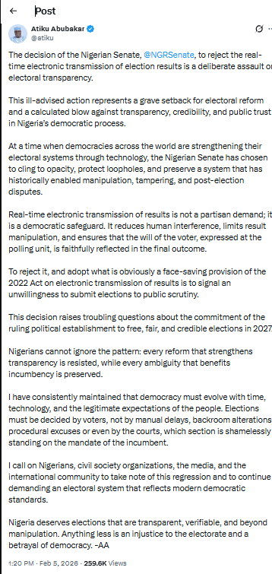

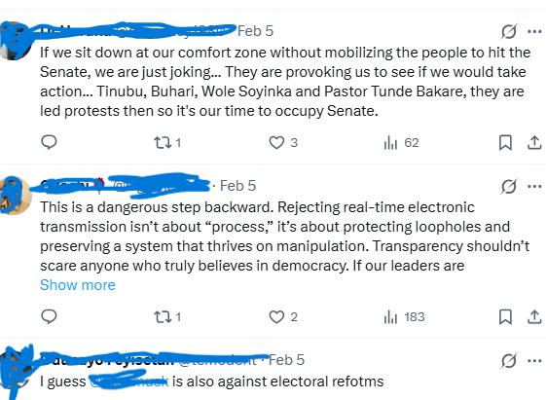
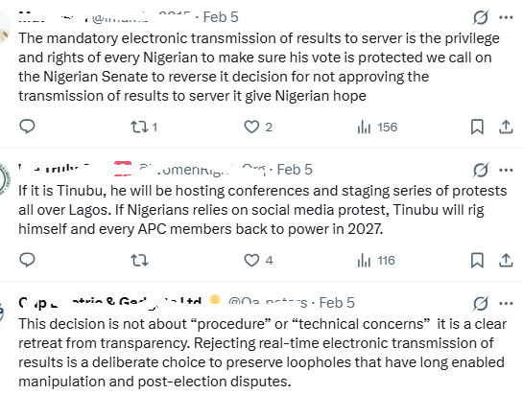

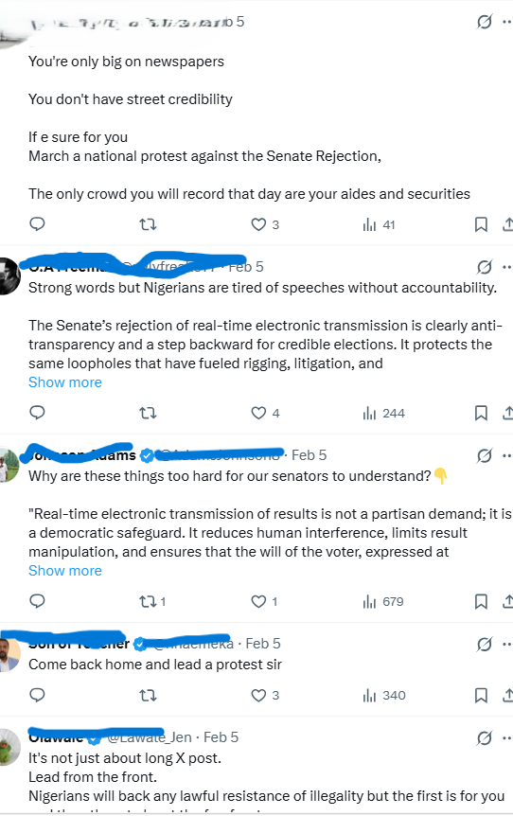

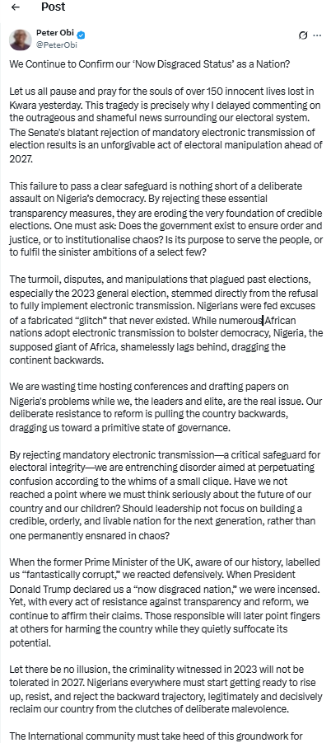

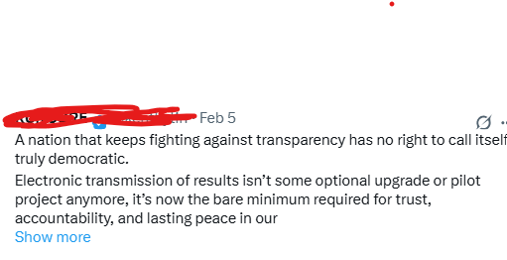
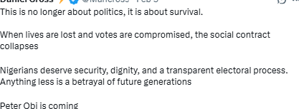

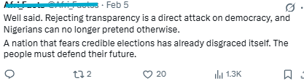
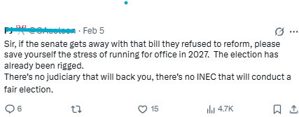
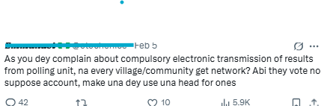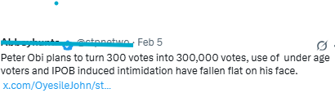
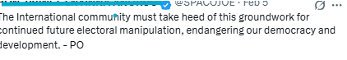
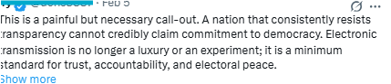
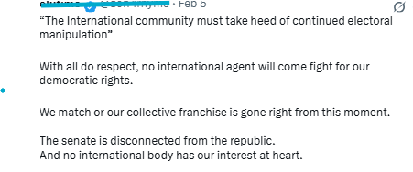
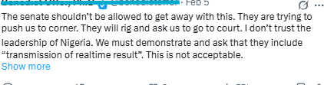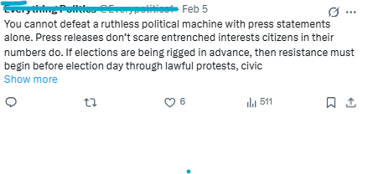
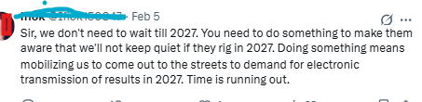
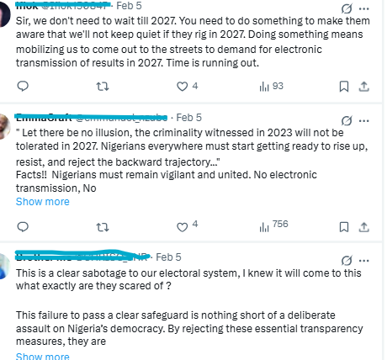
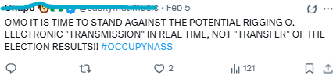
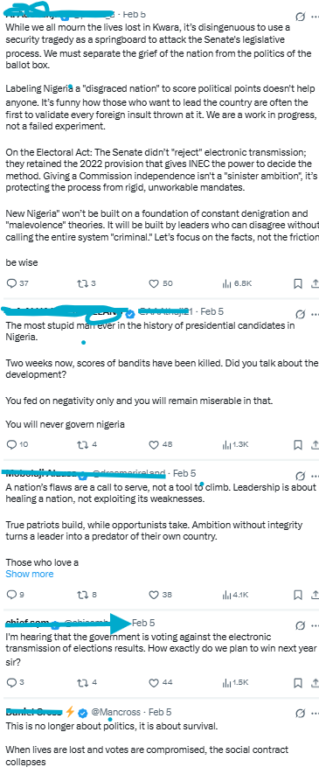
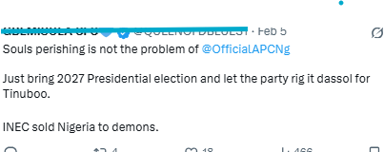
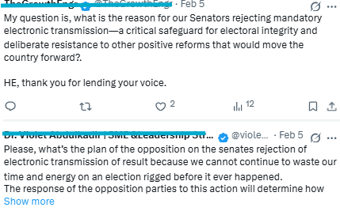
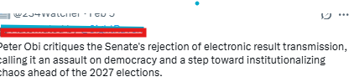
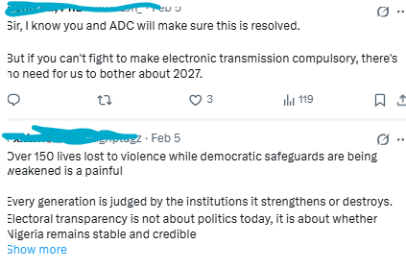
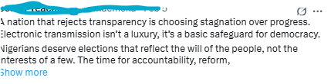
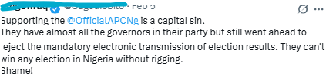
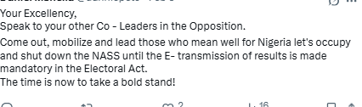
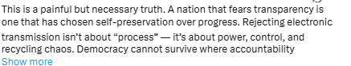

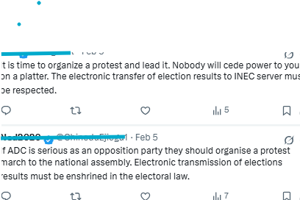
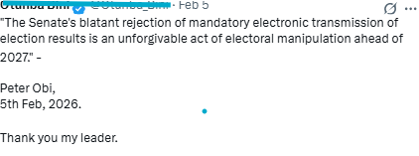
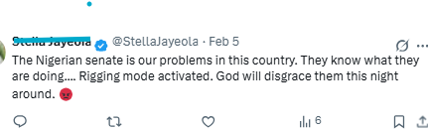
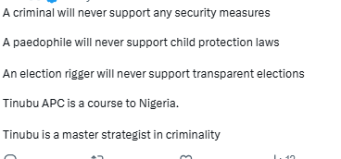
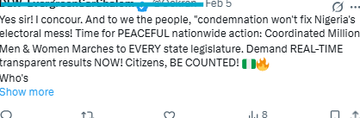
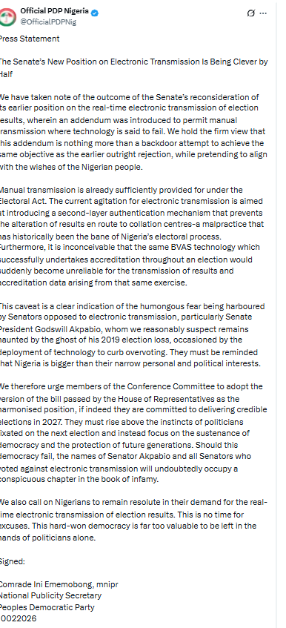
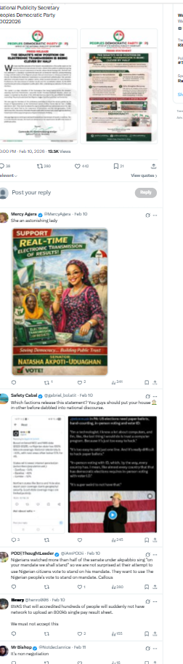
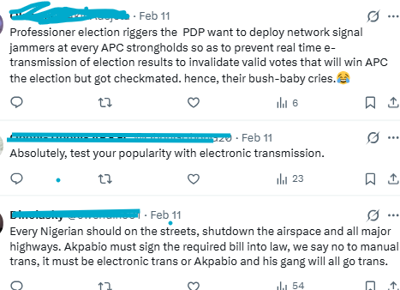
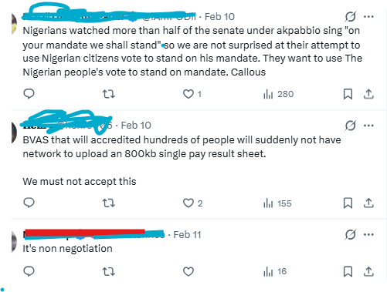
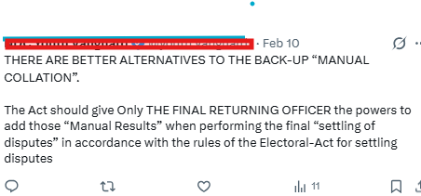7
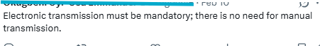
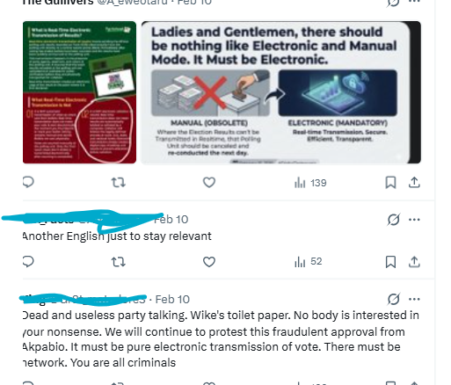
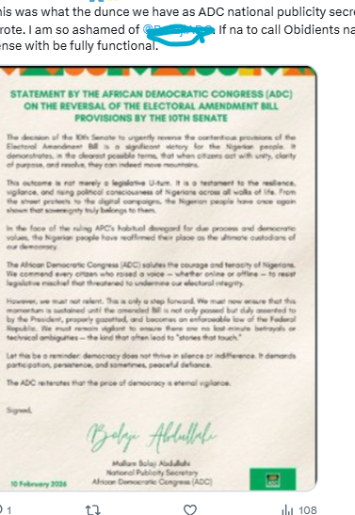
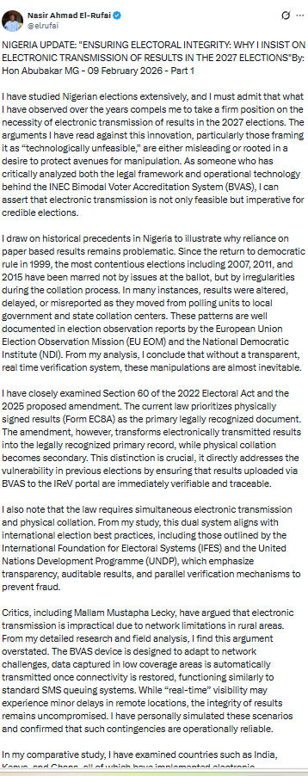
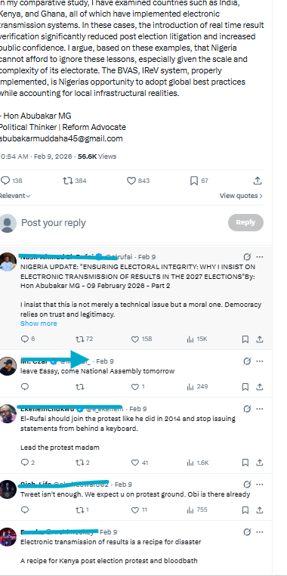
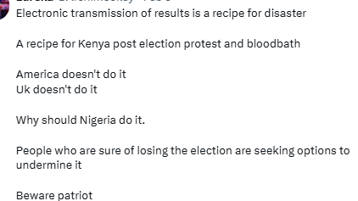
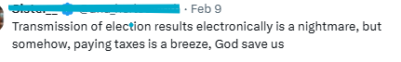
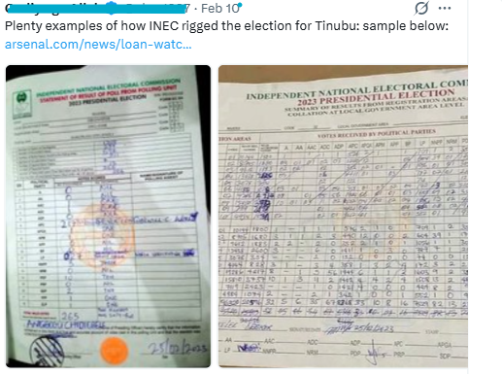
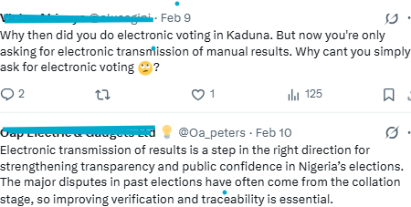
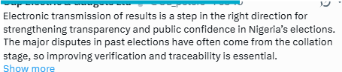
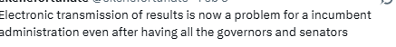

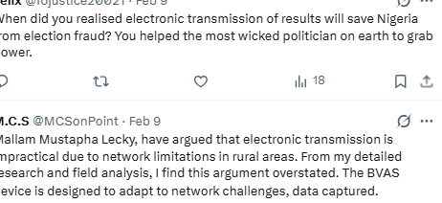
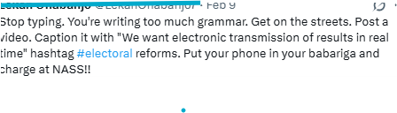
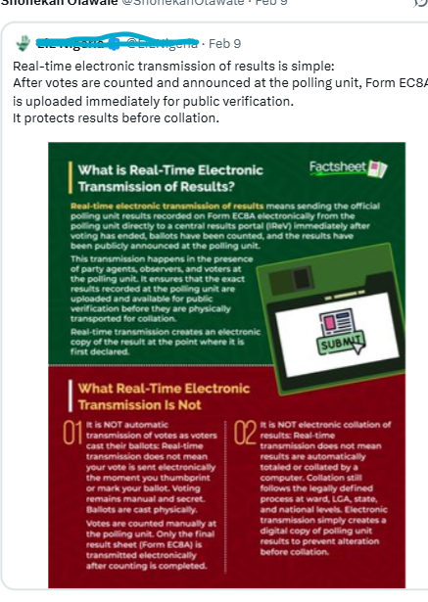
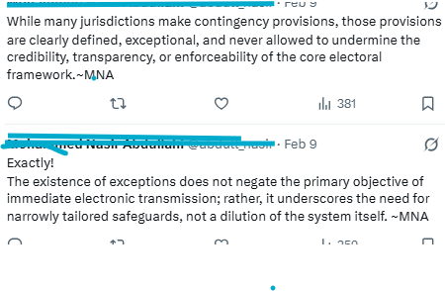
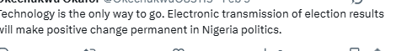
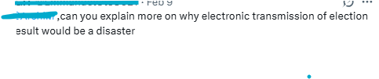
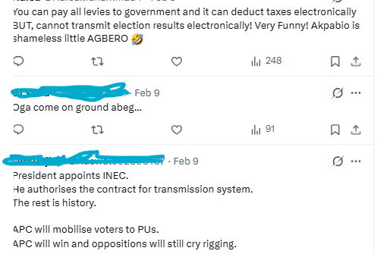
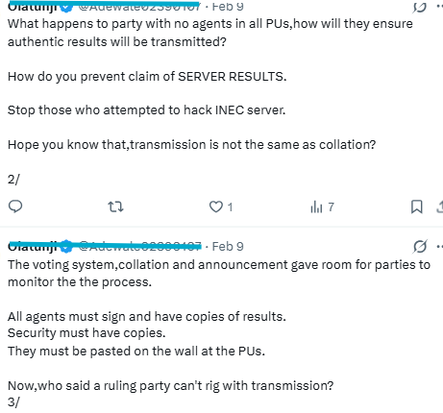
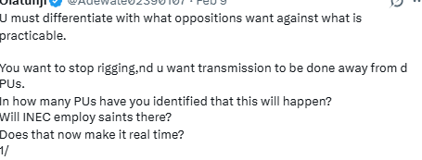
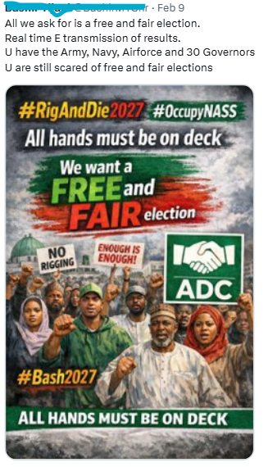
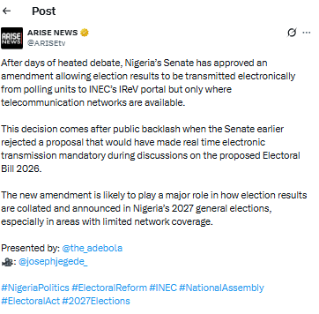
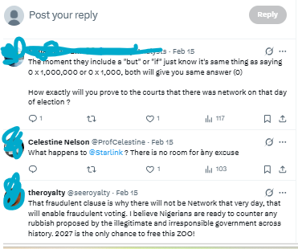
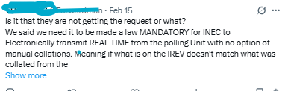
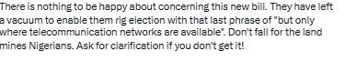
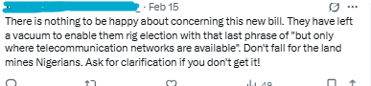
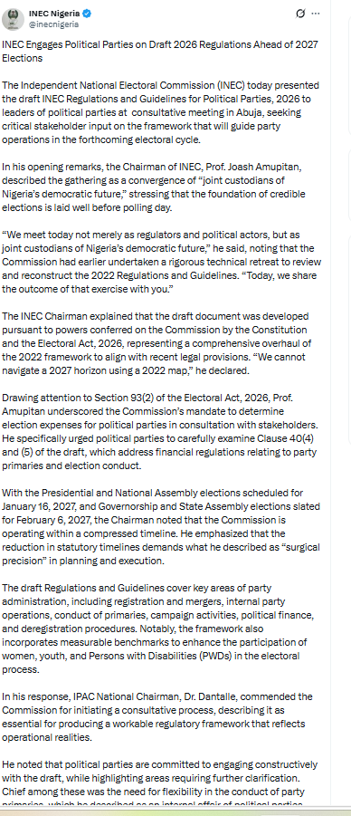
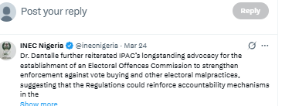
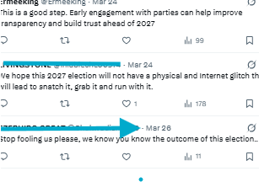
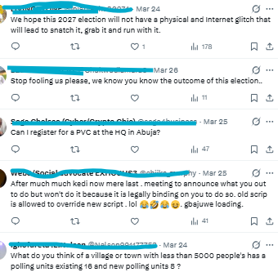
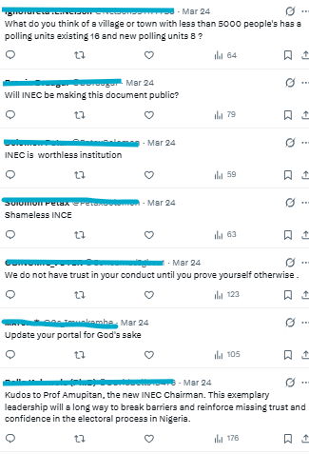
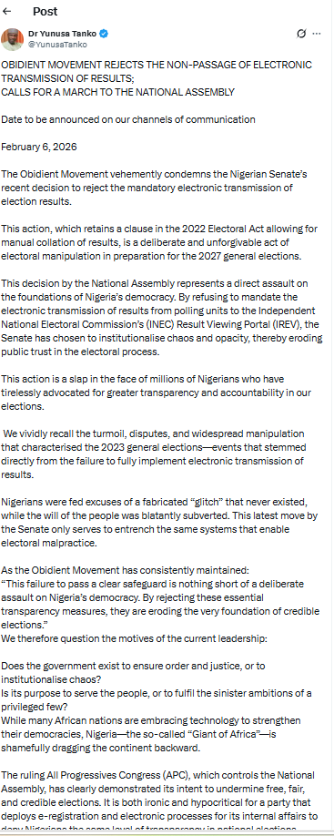
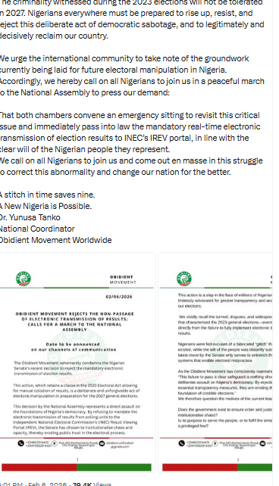
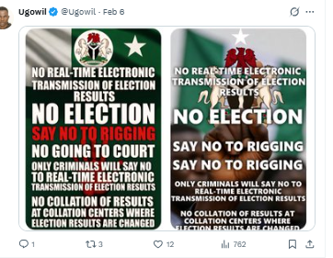
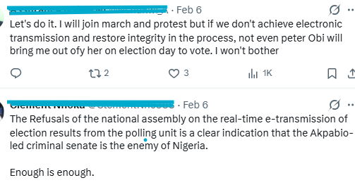
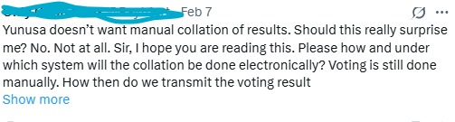
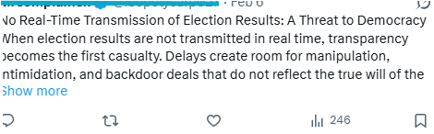
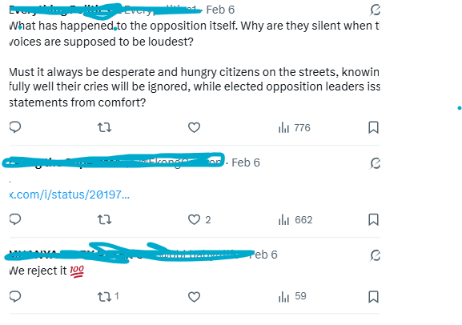
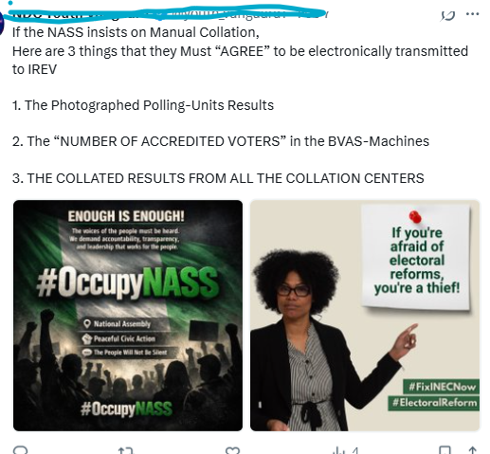
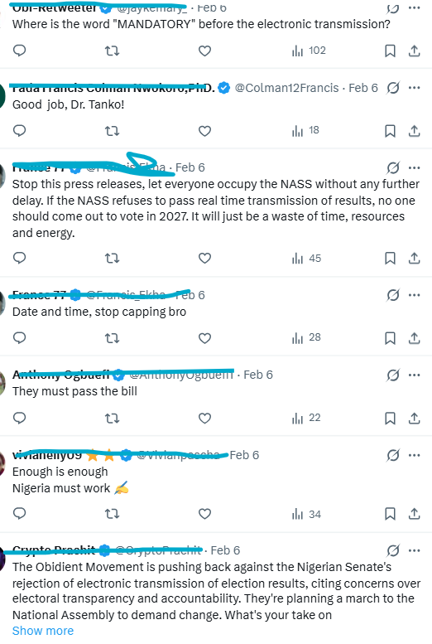
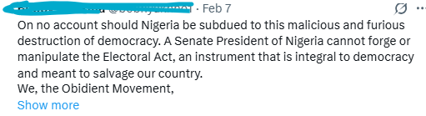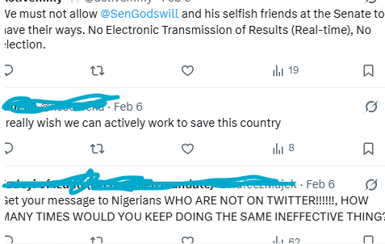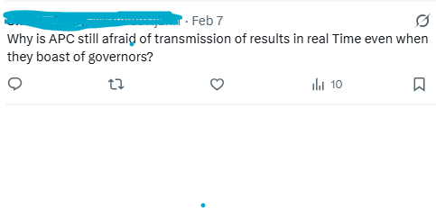
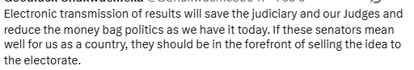
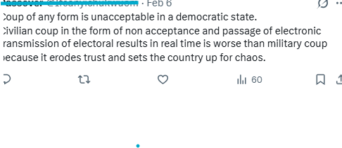
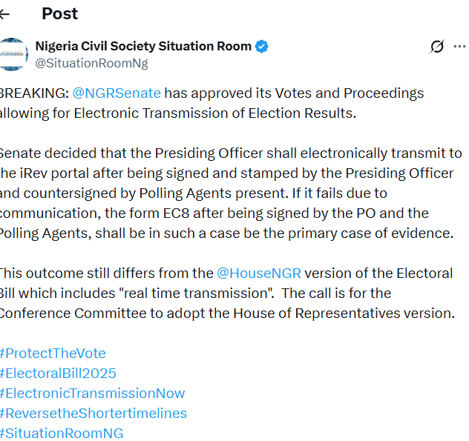
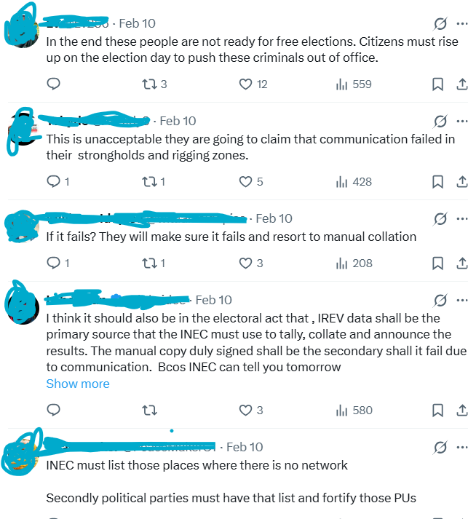
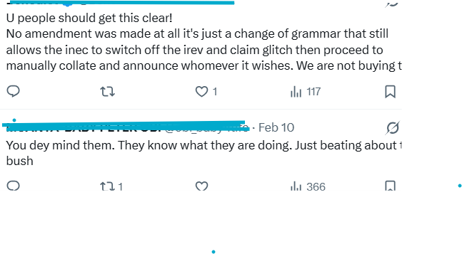
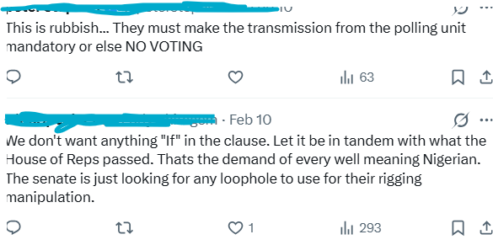
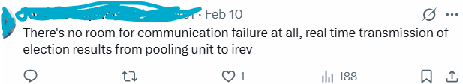
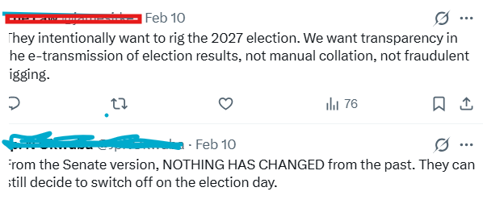
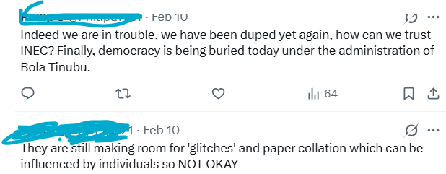

DIGITAL MOBILISATION VS YOUTH APATHY: A DOCUMENTARY ANALYSIS OF INEC’S STRATEGIC SOCIAL MEDIA ENGAGEMENT AHEAD OF THE 2027 NIGERIAN ELECTION

Hassan Biodun Suleiman, Ph.D.
Department of Journalism and Media Studies
Faculty of Communication and Media Studies
Lagos State University
Ojo, Lagos. Email: Hassan.suleiman@lasu.edu.ng

Abstract
Youth participation in Nigerian elections remains a persistent challenge: turnout fell from 69.08% in 2003 to 26.71% in 2023, although citizens aged 18–34 made up about 39.65% of registered voters. This study examined how the Independent National Electoral Commission’s (INEC) Department of Voter Education and Publicity (VEP) has used social media to engage youth ahead of 2027. Anchored on Technological Determinism Theory, it used a qualitative documentary design with two data sets: scholarly studies (2014–2026), analysed thematically, and 19 news reports (1 January–10 October 2026), analysed through qualitative content analysis. The scholarly studies show reliance on Facebook and Twitter/X and largely non-interactive content. The news reports show voter education reported mainly as community outreach (9 reports) and training and stakeholder meetings (11); social media featured in 6 reports, and none described interactive or platform-specific content. Reported challenges were misinformation (11 reports), apathy (10) and trust deficits (9); only one acknowledged limited digital access. VEP’s reported engagement is audience-targeted but not platform-specific. The study recommends interactivity metrics, platform-specific content, youth-influencer partnerships and attention to access barriers.

Keywords: INEC, 2027 Nigerian elections, Social media, Voter education, Youth apathy, Technological determinism.

Introduction
Elections confer legitimacy on leadership and let citizens choose leaders and hold government to account (Diamond, 2002). Since 1999, Nigeria’s Independent National Electoral Commission (INEC) has been charged with organising elections and with voter registration, civic education and sustained engagement with the electorate (INEC, 2023). Yet turnout has eroded, particularly among youth: it fell from 69.08 percent in 2003 to 26.71 percent in 2023 (International IDEA, n.d.), even though citizens aged 18–34 formed about 39.65 percent of the 93.4 million registered voters (Okeregbe, 2023). Scholars attribute the 2023 slump to distrust in INEC, fraud, violence and hardship (Akindele et al., 2026), and youth apathy to corruption, marginalisation and broken promises (Mumuni & Abdulyakeen, 2024; Nyitse & Dogo, 2024; Putnam, 2020; Verba et al., 1995).

INEC’s Department of Voter Education and Publicity (VEP) sits at the centre of addressing this. It has historically relied on advocacy visits, market outreaches and periodic media campaigns designed for an electorate reached through radio, television and town halls (INEC, 2026c). That sits uneasily against a youth electorate that turns to Instagram, TikTok, WhatsApp, X and LinkedIn for information and community (Nyitse & Dogo, 2024).

Statement of the Problem
Studies of INEC’s social media practice point to a gap between presence and engagement. Ibanga et al. (2020) found that only 12 percent of INEC’s Facebook and Twitter posts between August 2018 and January 2019 carried direct voter information and 78 percent were non-interactive. Nwoke et al. (2021) found INEC’s large followings under-engaged, and Ayeni and Aweh (2025) reported follower growth between 2018 and 2023 but recommended more interactive, audience-specific content.

Yet apathy appears to respond to deliberate, platform-specific communication. Two quasi-experimental studies in South-East Nigeria found that structured engagement content on Facebook reduced youth apathy more than equivalent content on X (Achebe et al., 2025; Ngwu et al., 2025). They came from the same team, region and journal issue and tested constructed content rather than INEC’s own, so they show what platform-specific engagement can achieve, not what VEP does.

Three gaps follow. Studies of INEC’s practice end in 2023 and pre-date both the 2027 cycle and the 2026 call for voter education to become “continuous, strategic, targeted, and measurable” (Lashem, 2026). The experimental evidence has not been set against INEC’s documented practice. And the INEC-focused work is largely descriptive and, where theory is used, draws on Actor–Network Theory (Ibanga et al., 2020) rather than a communication theory that explains why platform characteristics matter. This study therefore asks whether VEP’s social media engagement ahead of 2027, as documented in scholarship and reported in the press, uses the technological characteristics of the platforms in ways that can counter youth apathy.

Research Questions (RQ)
- What primary communication channels does VEP use to engage voters, particularly youth?
- In what style of communication has VEP packaged its youth-targeted messages?
- To what extent has VEP’s social media engagement been strategic and platform-specific, as opposed to generic and periodic?
- What challenges limit VEP’s adoption of sustained, platform-specific social media engagement?

Electioneering, Elections and INEC
Elections are the central mechanism by which democratic societies confer legitimacy on leadership and are expected to be periodic, free, fair and inclusive (Dahl, 1971, as cited in Okafor, 2025). They are an intrinsic aspect of democratic rule (Khan et al., 2021) and are meant to be competitive, open and equal (Blokker, 2021). Electioneering, the campaigning and mobilisation of a nation’s population (Adebayo et al., 2024), does not displace the electoral commission’s own role (Akubor, 2020). INEC has organised federal elections since 1999 under the 1999 Constitution and the Electoral Act 2022, despite persistent electoral violence, vote buying and declining turnout (INEC, 2023; Okafor, 2025).

Nigeria’s election management follows the independent model, with INEC responsible for federal and state elections and State Independent Electoral Commissions for local government elections (Akinduro, 2026; Namo et al., 2024). INEC is entrenched in Section 153 of the 1999 Constitution (INEC, 2026a), and voter and civic education is one of its eight core functions (Channels Television, 2019).

The Roles of INEC's VEP in Audience Participation
VEP is the interface between the Commission and the electorate, charged with informing citizens of their rights and responsibilities to encourage participation and reduce apathy (Ibanga et al., 2020), and it works alongside the media, which, with voters, are indispensable to a credible election (Nigerian Guild of Editors, 2023). Its role covers disseminating accurate information through traditional and digital platforms (INEC, 2026c), countering misinformation, which INEC names as a central challenge ahead of 2027 (Omolaoye, 2026), and building audience participation through interactive content and trained social media staff (Ayeni & Aweh, 2025). VEP’s role therefore extends from publicity, the broadcasting of messages, to engagement, interaction that invites the audience to respond.

Youth Apathy and Social Media
Political apathy denotes disengagement from civic processes, often rooted in powerlessness (Achebe et al., 2025; Ekwenchi & Udenze, 2014), and in Nigeria it stems from disillusionment, corruption, violence and marginalisation (Nyitse & Dogo, 2024). Other causes cited include bad governance, unfulfilled campaign promises, rigging, thuggery and poverty, and in Ebonyi State the Resident Electoral Commissioner reported that only about 30 percent of eligible voters took part in the 2015 general elections (Ngene et al., 2024).

Social media are Web 2.0 applications that enable user-generated content and two-way interaction, unlike the one-way model of traditional mass media (Kaplan & Haenlein, 2010, as cited in Ibanga et al., 2020), and in Nigeria platforms such as Facebook, X, Instagram, WhatsApp and TikTok are primary sources of political news among youth (Nyitse & Dogo, 2024).

Youth themselves rate these platforms highly: in a survey of 200 youths aged 18–35 in Kwara State, over 70 percent named social media networks as the tools with the greatest potential to mobilise young people, yet much of this activity stayed online and did not become offline participation, a pattern the study calls slacktivism (Maxwell, 2025).

Audience engagement refers to the depth and quality of interaction rather than mere exposure, a distinction between presence and engagement that anchors this study. Access conditions shape it: high data costs, poor connectivity, network fluctuations, inadequate electricity and the 2021 Twitter/X suspension limited online participation (Bassey et al., 2026; Maduagugbuo, 2026).

Theoretical Framework
This study is anchored on Technological Determinism Theory, which holds that communication technologies are a primary force shaping how societies organise, perceive and act (McLuhan, 1964). It draws on Innis’s (1951) idea that media carry biases and McLuhan’s (1964) proposition that the medium, more than its content, shapes the scale and form of human interaction.

Applied to political communication, it directs attention to what a platform makes possible: its reach, speed, interactivity and format. Three ideas guide the study. First, the characteristics of a medium shape the form of the message, so the styles of communication VEP uses (RQ2) are partly a function of its channels (RQ1). Second, the benefits of a technology depend on whether its distinctive characteristics are used: a platform built for two-way interaction but used for one-way announcements delivers reach without engagement (Ibanga et al., 2020), the concern of RQ3.

Third, conditions such as connectivity, data costs, electricity and platform availability enable or constrain participation, which makes them central to RQ4 (Bassey et al., 2026; Maduagugbuo, 2026). A strong form of determinism understates human agency, so the study adopts a soft form, in which technology shapes what is possible but institutional choices determine how far possibilities are used. Trust, capacity and political context are treated as conditions that interact with technology.

Methodology
The study used a qualitative documentary research design, in which existing documents are located, selected and interpreted to answer research questions (Bowen, 2009). Evidence came from three sources handled as two separate data sets: scholarly studies on INEC’s social media practice, youth political apathy and platform-specific engagement, published between 2014 and 2026, and news reports on INEC’s voter education and publicity activities, published between 1 January and 10 October 2026, the date of data collection.

INEC’s own documents, such as its National Voter Education Manual and voter education guidelines, established the Commission’s stated policy and were not coded (INEC, 2026b, 2026c). Scholarly studies were analysed thematically with Braun and Clarke’s (2006) six-phase framework, and news reports through qualitative content analysis, a systematic method for describing the manifest and latent meaning of texts and drawing replicable inferences from them (Krippendorff, 2018).

The findings are reported separately and compared only in the discussion, so that news reports are not treated as research evidence.

Scholarly studies were purposively selected if they were journal articles, theses or academic manuscripts directly addressing voter education, youth political apathy or social media engagement in Nigeria; opinion pieces, blogs, irrelevant non-Nigerian studies and sources without clear authorship were excluded.

News reports were purposively selected through web searches combining “INEC”, “voter education”, “social media”, “youth”, “apathy”, “misinformation”, “manual”, “radio” and “2027”. A report was retained if it was published within the study period, reported an INEC official’s statement or activity on voter education or publicity, and was a straight news report or interview. Editorials, opinion columns, non-news event write-ups and paid advertorials were excluded, and where several outlets covered the same event only the fullest account was kept. Of 30 reports screened, 19 were included.

The individual report was the unit of analysis, and the manifest statement referring to a channel, communication style, strategy or challenge was the coding unit, coded against a scheme derived deductively from the research questions and theoretical framework (Table 1). Coded statements were counted and grouped by research question. Statements were coded as stated, and no claim was treated as evidence of practice unless the report described an action rather than an intention.

Table 1
Coding Scheme for the Content Analysis of News Reports
Research question (RQ) | Coding category (what is recorded) | Technological Determinism concept
RQ1: Channels | Platform or channel named (Facebook, X, Instagram, YouTube, WhatsApp, TikTok, radio, television, print, in-person) | Medium as the carrier that shapes reach
RQ2: Style of Communication | Type of message (explainer video, short video, poll, live Q&A, activity report, announcement, manual, skit or meme) | Medium characteristics shape message form
RQ3: Strategy | Interactivity (one-way or two-way); platform-specific or generic; continuous or election-season only; evidence of measurement | Whether affordances are exploited
RQ4: Challenges | Barrier named (trust, connectivity, data cost, electricity, capacity, political or platform restriction, misinformation) | Technological conditions that enable or constrain

To strengthen reliability, the 19 reports were coded with AI assistance (Anthropic Claude, Version 1.260914.19) applying the codebook in Table 1, and the lead author (Suleiman) reviewed the coding decisions against the source reports. A second coder, the research assistant (Eletu), blind to the first coder’s decisions, independently coded four reports (N01 to N04, about 21% of the sample), scoring each category as present (1) or absent (0). Agreement was complete across all 116 coding decisions (percent agreement = 100%; Cohen’s κ = 1.00), though the small subsample and manifest codebook mean this shows consistent application of the rules and not a full reliability test.

Triangulating scholarly studies, news reports and INEC’s documents strengthened validity. The study used only public documents and no human participants, so informed consent and ethical approval were not required. Limitations include the absence of INEC’s internal documents and real-time social media data, a thin empirical base on INEC’s practice, and reliance on researcher judgement in source selection, constrained by explicit criteria.

Presentation of Results According to Research Questions
This section reports results for each research question: first what the scholarly studies show (Table 2), then what the 19 news reports show, coded against Table 1. In the news-report tables, n is the number of reports in which a category appeared. The two sets are compared in Section 5. Appendix A lists the sample.

Table 2
Summary of Scholarly Evidence on INEC’s Voter Education by Research Question
Study and method | RQ | Finding
Ibanga et al. (2020); content analysis of INEC’s Facebook and Twitter, 2018–2019 | 1–3 | Facebook and Twitter were the two active channels. Posts: voter information 12%, electoral system education 24%, offline voter education reports 38%, other matters 26%. 78% non-interactive, 22% reactive, none conversational.
Nwoke et al. (2021); cyber-ethnography, 2019 cycle | 1–4 | Facebook (about 400,000 followers) and Twitter (1.8 million) were primary; YouTube was largely dormant. Explainer videos were used; citizen hashtags and skits (#GetYourPVC, #PVCisagoal) amplified INEC’s message. Content was under-engaged. Barriers: distrust, indifference to non-sensational content, poor rural connectivity, propaganda framing.
Ayeni & Aweh (2025); audit, 2018–2023 | 1–4 | Facebook, X, Instagram and YouTube tracked; INEC had the largest follower count among the election bodies of Nigeria, South Africa, Kenya and Ghana. Posts mostly static; Facebook followers grew 205%; interactive posts earned about twice the engagement. Gaps: no regular handler training, no audience-specific strategy, limited paid promotion.
Maduagugbuo (2026); youth survey | 3–4 | Two-way communication scored lowest (M = 2.38). Data costs, poor connectivity, the 2021 Twitter/X suspension (63.5%), hate speech and peer indifference limited participation.
Bassey et al. (2026); Akwa Ibom survey | 1, 4 | WhatsApp (25.0%) and Facebook (22.4%) were most used for electoral education content; network fluctuations (35.5%) and inadequate electricity (32.0%) were leading constraints. Not specific to INEC.
Achebe et al. (2025); Ngwu et al. (2025); quasi-experiments | 3 | Sustained, platform-specific, interactive content, especially on Facebook, significantly reduced apathy; a benchmark, not evidence of VEP practice.
Ekwenchi & Udenze (2014); NOA e-polling survey | 4 | 66% were unaware of the platform; 53% of those aware saw it as propaganda.
Okafor (2025); documentary analysis | 4 | Apathy is one of several interlocking capacity challenges (with funding, staffing and security) needing sustained civic-education investment.
Note. Findings are as reported in the cited studies.

Research Question One: What Primary Communication Channels Does VEP Use to Engage Voters, Particularly Youth?
Between 2018 and 2023, Facebook and Twitter/X were INEC’s main channels, with Instagram and YouTube secondary and YouTube largely dormant (Ayeni & Aweh, 2025; Ibanga et al., 2020; Nwoke et al., 2021). The one electorate survey found WhatsApp and Facebook most used for electoral education content (Bassey et al., 2026), suggesting a gap between where INEC posted and where audiences received content, although that sample was local and not specific to INEC.

Table 3
Channels Reported in News Reports on INEC’s Voter Education, 1 January–10 October 2026
Category | n (%) | Reports
Community and in-person outreach (markets, motor parks, campuses, religious and traditional institutions, town halls, town criers) | 9 (47.4%) | N03, N05, N08, N09, N13, N14, N15, N17, N19
Social media and digital platforms | 6 (31.6%) | N04, N10, N13, N14, N16, N17
Mass media (radio, television, print, media partnerships) | 6 (31.6%) | N01, N02, N07, N14, N15, N18
Partner agencies and influencers | 6 (31.6%) | N03, N06, N09, N16, N18, N19
No public-facing channel described | 2 (10.5%) | N11, N12
Note. n = 19 reports. A report can appear in more than one category, so percentages do not sum to 100. Report IDs are listed in Appendix A.

Community and in-person outreach was the most frequently reported channel (9 of 19 reports, 47.4%), for example directing Osun officers to markets, motor parks and religious centres (N08) and urging Sokoto officers to use town criers (N17). Social media, mass media, and partner agencies and influencers each appeared in 6 reports (31.6%). Only one platform, X, was named, in one report (Akhimien, 2026); Facebook, Instagram, YouTube, TikTok and WhatsApp were named in none. Two reports (Ogunseyin, 2026; Omolaoye, 2026) described internal meetings and named no public-facing channel.

Research Question Two: In What Style of Communication Has VEP Packaged Its Youth-Targeted Messages?
INEC’s output leaned towards institutional activity reports rather than direct voter instruction, with offline voter education reports the largest category (38%) (Ibanga et al., 2020). Where instruction appeared, it took the form of explainer videos, and the content that amplified INEC’s message most effectively was citizen-generated skits, memes and hashtags (Nwoke et al., 2021). Posts were largely static, and interactive posts earned about twice the engagement (Ayeni & Aweh, 2025).

Table 4
Styles of Communication Reported in News Reports on INEC’s Voter Education, 1 January–10 October 2026
Category | n (%) | Reports
Training workshops and stakeholder meetings | 11 (57.9%) | N01, N02, N07, N08, N09, N11, N12, N13, N14, N17, N19
Community sessions, public events and sensitisation campaigns | 7 (36.8%) | N03, N04, N05, N08, N14, N15, N16
Radio or television programme | 2 (10.5%) | N15, N18
No message style described | 2 (10.5%) | N06, N10
Print manuals | 1 (5.3%) | N04
Social media post or announcement | 1 (5.3%) | N04
Interactive digital content (explainer or short videos, polls, live Q&A, memes) | 0 (0.0%) | None
Note. n = 19 reports. A report can appear in more than one category, so percentages do not sum to 100. Report IDs are listed in Appendix A.

The reported styles were overwhelmingly institutional events: training workshops and stakeholder meetings (11 reports) and community sessions, public events and sensitisation campaigns (7). Only 3 reports described a message produced for a particular medium: a statement on X (Akhimien, 2026) and radio programmes (Leonard, 2026; Idakwo, 2026a). No report described explainer or short videos, polls, live question-and-answer sessions or memes. This is a limit of the data as well as a finding, because a news report is more likely to be written about a workshop than about a post.

Research Question Three: To What Extent Has VEP’s Social Media Engagement Been Strategic and Platform-Specific, as Opposed to Generic and Periodic?
Between 2018 and 2023, VEP’s presence expanded in reach but stayed largely non-interactive: Ibanga et al. (2020) found no conversational posts, Nwoke et al. (2021) concluded that online activity was a poor predictor of election outcomes, Ayeni and Aweh (2025) reported follower growth alongside calls for interactive, targeted content, and youth ranked two-way communication lowest (Maduagugbuo, 2026). The quasi-experimental studies (Achebe et al., 2025; Ngwu et al., 2025) offer a benchmark that none of the studies of INEC’s own practice showed it meeting, but, as noted in Section 1.1, it is a benchmark and not evidence of what VEP achieved.

Table 5
Strategy Features Reported in News Reports on INEC’s Voter Education, 1 January–10 October 2026
Category | n (%) | Reports
Partnerships with agencies, media, civil society or community leaders | 14 (73.7%) | N01, N02, N03, N04, N06, N07, N08, N09, N14, N15, N16, N17, N18, N19
Audience targeting (youth, women, persons with disabilities, rural communities) | 13 (68.4%) | N03, N04, N06, N07, N08, N10, N11, N13, N14, N15, N16, N17, N19
Counter-misinformation as an aim | 10 (52.6%) | N07, N08, N09, N11, N12, N14, N15, N16, N17, N19
Digital engagement intention or instruction stated | 5 (26.3%) | N04, N10, N13, N16, N17
Continuous education stated | 3 (15.8%) | N03, N09, N17
Dialogic or two-way engagement | 2 (10.5%) | N03, N14
Evaluation or measurement | 2 (10.5%) | N11, N17
Platform-specific content | 0 (0.0%) | None
Note. n = 19 reports. A report can appear in more than one category, so percentages do not sum to 100. Report IDs are listed in Appendix A.

Partnerships (14 of 19 reports, 73.7%) and audience targeting (13, 68.4%) were the most frequently reported features, followed by counter-misinformation as an aim (10). A stated intention or instruction to engage digitally appeared in 5 reports, continuous education in 3, dialogic engagement in 2 and evaluation in 2. No report described platform-specific content. These are statements of intention reported by journalists from INEC officials, and none gave results, budgets or measures of reach, so none allows the claimed strategy to be verified.

Research Question Four: What Challenges Limit VEP’s Adoption of Sustained, Platform-Specific Social Media Engagement?
The studies identify four kinds of constraint. At the trust level, youth often distrust official platforms and dismiss them as propaganda (Ekwenchi & Udenze, 2014; Nwoke et al., 2021). At the infrastructure level, poor connectivity, high data costs and unreliable electricity limit access, particularly for rural and low-income groups (Bassey et al., 2026; Maduagugbuo, 2026). At the capacity level, there is a lack of training, tailored content and paid promotion (Ayeni & Aweh, 2025; Okafor, 2025). At the political-environment level, the 2021 suspension of Twitter/X discouraged youth participation (Maduagugbuo, 2026).

Table 6
Challenges Reported in News Reports on INEC’s Voter Education, 1 January–10 October 2026
Category | n (%) | Reports
Misinformation and disinformation | 11 (57.9%) | N07, N08, N09, N11, N12, N13, N14, N15, N16, N17, N19
Voter apathy or low turnout | 10 (52.6%) | N03, N04, N07, N08, N09, N10, N11, N12, N13, N14
Trust deficit or credibility doubts | 9 (47.4%) | N03, N07, N08, N09, N11, N12, N13, N15, N19
Low civic knowledge | 4 (21.1%) | N03, N04, N08, N09
Reach and logistics | 4 (21.1%) | N11, N12, N14, N17
Vote buying, violence or misuse of youth | 3 (15.8%) | N14, N15, N16
Limited access to digital sources (including connectivity, data costs, electricity) | 1 (5.3%) | N17
Platform or political restrictions on social media | 0 (0.0%) | None
No challenge stated | 5 (26.3%) | N01, N02, N05, N06, N18
Note. n = 19 reports. A report can appear in more than one category, so percentages do not sum to 100. Report IDs are listed in Appendix A.

INEC’s reported challenges were mainly attitudinal and informational: misinformation or disinformation (11 reports, 57.9%), voter apathy or low turnout (10, 52.6%) and a trust deficit (9, 47.4%). Low civic knowledge and reach and logistics each appeared in 4 reports, and vote buying, violence or misuse of youth in 3. One report (Lashem, 2026) acknowledged citizens with limited access to digital sources of electoral information, but no report named connectivity, data costs or electricity, and none mentioned platform restrictions. Five reports named no challenge.

Discussion of Findings
The finding that INEC works through a mix of channels agrees with the scholarly record and adds to it. Earlier studies show a large but largely one-directional social media presence (Ayeni & Aweh, 2025; Ibanga et al., 2020; Nwoke et al., 2021), while the 2026 reports show social media as one channel among several, with the weight on community contact and partner networks. Community channels reach people who are offline but cannot supply the speed, scale or traceable two-way interaction of social media. That only 6 of 19 reports mention social media, and only one names a platform, suggests that platforms are discussed as places to be present rather than as technologies with particular capabilities, the presence without engagement identified by Ibanga et al. (2020). This fits the soft form of the theory adopted here: technology offers possibilities, but institutional choices decide how far they are used.

The reported styles of communication follow the same pattern. Offline activity reports were the largest category of INEC’s posts in 2018–2019 (Ibanga et al., 2020), and the 2026 reports are themselves mostly accounts of workshops, meetings and events. No report described explainer videos, short videos, polls, live question-and-answer sessions or memes, the styles Ayeni and Aweh (2025) recommend and that Nwoke et al. (2021) found citizens using to amplify INEC’s message. News reports are written about events, so their silence does not prove that VEP does not use such styles. What they show is that, in the public record of 2026, voter education is presented as institutional activity rather than content designed for a platform, whereas under Technological Determinism a platform that rewards short, visual and interactive content calls for content of that kind.

On strategy, INEC’s reported approach is relational and targeted. Partnership appeared in 14 reports and audience targeting in 13, and the youth ambassador scheme (Adesina, 2026) is the clearest move towards the influencer-based communication that Nwoke et al. (2021) found effective when it came from citizens. The features that Achebe et al. (2025) and Ngwu et al. (2025) associate with reduced apathy (sustained, platform-specific, interactive content) were reported rarely or not at all: continuous education in 3 reports, evaluation in 2 and platform-specific content in none. The report that came closest set such aims as an expectation placed on officers (Lashem, 2026) and reported no results. By that benchmark the reported strategy is incomplete, and digital engagement appears only as an intention (5 reports), so presence can still be mistaken for engagement, as Ibanga et al. (2020) cautioned.

Trust is common ground between INEC and the scholars: 9 reports name a trust deficit or doubts about credibility, and Ekwenchi and Udenze (2014) and Nwoke et al. (2021) found the same barrier among youth. The difference lies in what is missing. Bassey et al. (2026) and Maduagugbuo (2026) found that network fluctuations, electricity, data costs and the 2021 Twitter/X suspension limited online participation, yet no report names any of these; the nearest is a Sokoto briefing urging officers to reach citizens with limited digital access (Lashem, 2026). INEC’s account is attitudinal and informational, whereas the scholarly account adds technological and structural conditions. For Technological Determinism these are central, because a platform can shape participation only for those who can reach it.

Three limits qualify these points. The news reports are indirect evidence of what officials said and journalists chose to report. The sample was drawn by purposive web search and is not an exhaustive archive of 2026 coverage. And the scholarly studies cover 2018 to 2023 while the news reports cover 2026, so differences may reflect change over time as well as method. The comparison is between two records of INEC’s practice, not two measurements of the same thing.

Implications of the Study
Theoretically, the study applies Technological Determinism in its soft form to an institution’s communication practice, showing the difference between a platform’s presence and the use of its characteristics, and shows the theory’s limit here, since the barriers that matter most (trust, capacity and access) are institutional and social. For policy, VEP should measure engagement beyond follower counts, publish platform-specific plans and results, and extend its existing staff training (John, 2026; Lashem, 2026; Osoteku, 2026) to interactive content design. For scholarship, the study adds a systematic content analysis of 2026 news reports tied to a communication theory; future work should analyse INEC’s actual 2026–2027 posts and test whether the South-East experimental findings hold for INEC’s own content and other regions.
Conclusion
This study asked whether INEC’s Department of Voter Education and Publicity has adapted its social media engagement to counter youth apathy ahead of 2027. The scholarly studies show a large but largely one-directional presence between 2018 and 2023. The 19 news reports from 2026 show an approach that relies on community outreach, training and partnerships, with social media mentioned in a minority of reports, no interactive styles of communication or platform-specific content described, and one passing acknowledgement of limited digital access. On the available evidence, the reported strategy is targeted but not platform-specific, though because the evidence is indirect this applies to what VEP has made public.

Recommendations
The study makes six recommendations:
- Adopt interactivity metrics, judging social media work by response rates, comment activity and completion of interactive content rather than follower counts, and publish the results (Ibanga et al., 2020; Nwoke et al., 2021).
- Shift content towards direct voter information and interactive content such as short videos, live question-and-answer sessions and polls (Achebe et al., 2025; Ayeni & Aweh, 2025; Ngwu et al., 2025).
- Formalise youth-influencer partnerships and evaluate the youth ambassador scheme (Adesina, 2026), building on citizen-led campaigns such as #GetYourPVC and #PVCisagoal (Nwoke et al., 2021).
- Choose platforms by where young voters are. Facebook outperformed X in the South-East experiments (Achebe et al., 2025; Ngwu et al., 2025) and WhatsApp was among the most used in Akwa Ibom (Bassey et al., 2026), yet no 2026 report names WhatsApp, so VEP should pilot content on both.
- Keep a hybrid outreach model and plan for access barriers, pairing digital work with radio, community and in-person channels (Lashem, 2026; Leonard, 2026; Osoteku, 2026) so that rural and low-income youth are not excluded (Bassey et al., 2026; Maduagugbuo, 2026).
- Extend staff training to interactive content design and platform-specific strategy for those who handle social media (Ayeni & Aweh, 2025; John, 2026; Lashem, 2026; Osoteku, 2026).

References
Achebe, C. A., Onuoha, J. C., Eneogu, N. D., & Ugwonna, G. O. (2025). Effectiveness of social media messages in reducing political apathy among youths in South-East, Nigeria. AJSTME, 11(4), 172–182.
Adebayo, O. A., Ikuomola, A. D., & Adeoye, B. D. (2024). Electioneering process and manifestation of violence and criminality: A case study of Oye Ekiti in Ekiti State, Nigeria. Annals of the University of Craiova for Journalism, Communication and Management, 10, 74–81. https://doi.org/10.5281/zenodo.15250681
Adesina, M. (2026, October 2). 2027: 9.3m young Nigerians join voter roll — INEC. P.M. News. https://pmnewsnigeria.com/2026/10/02/2027-9-3m-young-nigerians-join-voter-roll-inec/
Adewole, S. (2026, June 1). Osun 2026: INEC charges electoral officers on grassroot voter education. The Guardian Nigeria. https://guardian.ng/?p=2851513
Agboluaje, R. (2026, January 15). INEC, NUJ forge alliance to deepen voter education in Oyo. The Guardian Nigeria. https://guardian.ng/politics/inec-nuj-forge-alliance-to-deepen-voter-education-in-oyo/
Akhimien, N. (2026, March 26). 2027: INEC launches new voter education manuals to combat apathy. Channels Television. https://www.channelstv.com/2026/03/26/2027-inec-launches-new-voter-education-manuals-to-combat-apathy/
Akindele, E. P., Ibrahim, S. A., Ebini, K. A. A., & Ibor, B. I. (2026). Electoral and voter apathy in the 2023 general elections in Nigeria. International Journal of Humanities Social Science and Management, 6(3), 502–516.
Akinduro, O. (2026). Nigeria: Independent National Electoral Commission. ACE Project. https://aceproject.org
Akinwale, A. (2026, February 3). INEC urges media to intensify voter education ahead of FCT Area Council elections. ThisDay. https://www.thisdaylive.com/2026/02/03/inec-urges-media-to-intensify-voter-education-ahead-of-fct-area-council-elections/
Akubor, E. O. (2020). Campaigns and electioneering: Reflecting on the 2015 general elections in Nigeria. Polish Political Science Yearbook, 49(4), 72–86.
Ayeni, T. P., & Aweh, O. M. (2025). The impact of social media on election management bodies in Nigeria, 2019–2023. The Information Technologist: An International Journal of Information and Communication Technology, 22(1), 44–53.
Bassey, S. E., Umoren, P. E., & Iwok, U. (2026). Social media and electoral education of the electorate in Ikot Ekpene Local Government Area, Akwa Ibom State, Nigeria. Direct Research Journal of Social Science and Educational Studies, 14(2), 103–111.
Blokker, P. (2021). The democracy and the rule of law crises in the European Union and its member states. European Commission.
Bowen, G. A. (2009). Document analysis as a qualitative research method. Qualitative Research Journal, 9(2), 27–40. https://doi.org/10.3316/QRJ0902027
Braun, V., & Clarke, V. (2006). Using thematic analysis in psychology. Qualitative Research in Psychology, 3(2), 77–101. https://doi.org/10.1191/1478088706qp063oa
Channels Television. (2019, February 7). Eight functions of INEC every Nigerian should know. https://www.channelstv.com/2019/02/07/eight-functions-of-inec-every-nigerian-should-know/
Diamond, L. (2002). Elections without democracy: Thinking about hybrid regimes. Journal of Democracy, 13(2), 21–35.
Ekwenchi, O. C., & Udenze, S. (2014). Youth and political apathy: Lessons from a social media platform. International Journal of Social Sciences and Humanities Reviews, 4(4), 1–8.
Ibanga, O. T., Arugu, C. I., & Ucheobi, U. A. (2020). Voter education through social media: An analytical study of Independent National Electoral Commission’s Twitter and Facebook platforms. SSRG International Journal of Humanities and Social Science, 7(3), 28–33. https://doi.org/10.14445/23942703/IJHSS-V7I3P107
Idakwo, A. (2026a, February 20). INEC, NOA step up radio sensitisation for FCT polls. Leadership. https://leadership.ng/inec-noa-step-up-radio-sensitisation-for-fct-polls/
Idakwo, A. (2026b, July 25). 2027: Youths dominate new voter registration, account for 67.4 percent. Leadership. https://allafrica.com/stories/202607270388.html
Independent National Electoral Commission. (2023). 2023 general election voting procedures. https://inecnigeria.org/documents/guidelines/2023-Election-Procedure-1.pdf
Independent National Electoral Commission. (2026a). About us. https://inecnigeria.org/about
Independent National Electoral Commission. (2026b). National voter education manual. Kimpact Development Initiative. https://kimpact.org.ng/storage/publications/inec/National%20Voter%20Education%20Manual.pdf
Independent National Electoral Commission. (2026c). Voter education and guidelines. https://inecnigeria.org/voters/education
Innis, H. A. (1951). The bias of communication. University of Toronto Press.
International IDEA. (n.d.). Voter turnout database: Nigeria. Retrieved October 13, 2026, from https://www.idea.int/data-tools/country-view/231/40
John, S. (2026, September 14). INEC trains personnel to boost voter confidence ahead of 2027 elections. News Agency of Nigeria. https://nannews.ng/inec-trains-personnel-to-boost-voter-confidence-ahead-of-2027-elections/
Khan, A., Khan, B., & Alamo, M. (2021). Functional democracy: An analysis of the key elements of a democratic system. Journal of Humanities Social and Management Sciences, 2(2), 181–188.
Krippendorff, K. (2018). Content analysis: An introduction to its methodology (4th ed.). SAGE Publications.
Lashem, F. (2026, September 14). 2027: INEC tasks officers on continuous, strategic voter education. NewsDiaryOnline. https://newsdiaryonline.com/2027-inec-tasks-officers-on-continuous-strategic-voter-education/
Leonard, S. (2026, September 17). Ogun: INEC records 15,777 voter transfers, 6,063 PVC collections. The Legal Observer. https://thelegalobserver.com.ng/2026/09/17/ogun-inec-records-15777-voter-transfers-6063-pvc-collections/
Maduagugbuo, C. I. (2026). The impact of social media in enhancing socio-political mobilization among the Nigerian youths, 2018–2023 [Unpublished bachelor’s project]. Godfrey Okoye University.
Maxwell, T. D. (2025). The decline in youth participation in Nigeria politics: Causes, consequences, and pathways to engagement [Master’s thesis, Linnaeus University]. DiVA. https://www.diva-portal.org/smash/get/diva2:1971189/FULLTEXT01.pdf
McLuhan, M. (1964). Understanding media: The extensions of man. McGraw-Hill.
Mumuni, N. A., & Abdulyakeen, A. (2024). Effects of youths’ political apathy on the democratization process in Nigeria: Katsina State in focus. Journal of Political Discourse, 2(1), 84–102.
Namo, I. B., Danbala, I. N., & Naomi, A. L. (2024). Election management bodies and elections in Nigeria. ResearchGate. https://www.researchgate.net/publication/382175820_Election_Management_Bodies_and_Elections_in_Nigeria
Ngene, I. A., Otu, E. C., Nicholas, B. T., Obiukwu, C. I., & Igwe, J. C. (2024). Political apathy in Nigeria, causes and implications: The Ebonyi State experience. South East Journal of Political Science, 10(1), 187–206.
Ngwu, L. C., Onuoha, J. C., Eneogu, N. D., & Ugwonna, G. O. (2025). Leveraging social media platforms to enhance voter education and mitigate voter apathy among youths in South East Nigeria. AJSTME, 11(4), 138–147.
Nigerian Guild of Editors. (2023). Media, INEC, voters and path to credible election. https://guildofeditors.org.ng/media-inec-voters-and-path-to-credible-election/
Nwoke, C. C., Oyiga, S. C., & Ihuoma, C. H. (2021). Social media, civic vitality and Nigeria’s 2019 general elections. Covenant Journal of Communication, 8(1), 22–44.
Nyitse, G. T., & Dogo, J. S. (2024). Social media as a tool for changing political apathy amongst youth in Nigeria. Journal of Multi-Disciplinary Studies, 7(9), 134–149.
Nze, E. (2026, July 2). 2027 elections: INEC, NOA move to rebuild public trust, boost voter education. Blueprint. https://blueprint.ng/?p=823886
Ogundare, F. (2026, March 13). INEC calls for grassroots mobilisation to boost voter participation in Lagos. ThisDay. https://www.thisdaylive.com/2026/03/13/inec-calls-for-grassroots-mobilisation-to-boost-voter-participation-in-lagos/
Ogunseyin, O. (2026, August 18). 2027 election: No eligible Nigerian must be left behind, says INEC. The Guardian Nigeria. https://guardian.ng/?p=2900957
Okafor, C. C. (2025). 2027 Nigerian general elections and Nigeria’s national unity: Policy challenges and post-election scenarios [Unpublished manuscript]. Department of Political Science, Nnamdi Azikiwe University.
Okeregbe, F. (2023, January 11). 2023: 93.4 million Nigerians to vote, says INEC. Channels Television. https://www.channelstv.com/2023/01/11/2023-93-4-million-nigerians-to-vote-says-inec/
Omolaoye, S. (2026, September 7). 2027: INEC identifies voter apathy, disinformation as threats. The Guardian Nigeria. https://guardian.ng/politics/2027-inec-identifies-voter-apathy-disinformation-as-threats/
Onuado, C. (2026, June 25). INEC warns against misinformation, seeks stronger voter education. Leadership. https://leadership.ng/inec-warns-against-misinformation-seeks-stronger-voter-education/
Osoteku, O. (2026, September 15). 2027 election: INEC intensifies grassroots voter education. Voice of Nigeria. https://von.gov.ng/2027-election-inec-intensifies-grassroots-voter-education/
Peoples Gazette. (2026a, April 1). INEC launches voter enlightenment drive in Kano. https://gazettengr.com/inec-launches-voter-enlightenment-drive-in-kano/
Peoples Gazette. (2026b, April 16). INEC reaffirms commitment to youth inclusion. https://gazettengr.com/inec-reaffirms-commitment-to-youth-inclusion/
Putnam, R. D. (2020). Bowling alone: The collapse and revival of American community (Rev. ed.). Simon & Schuster.
Sodeinde, G. (2026, May 28). Ekiti: INEC enlists media against fake news, says poll critical to 2027 credibility. ThisDay. https://www.thisdaylive.com/2026/05/28/ekiti-inec-enlists-media-against-fake-news-says-poll-critical-to-2027-credibility/
Verba, S., Schlozman, K. L., & Brady, H. E. (1995). Voice and equality: Civic voluntarism in American politics. Harvard University Press. https://doi.org/10.2307/j.ctv1pnc1k7.

Appendix A
Sample of News Reports on INEC’s Voter Education (N = 19), 1 January–10 October 2026
ID | In-text citation | Outlet | Date | Headline
N01 | (Agboluaje, 2026) | The Guardian Nigeria | 15 Jan 2026 | INEC, NUJ forge alliance to deepen voter education in Oyo
N02 | (Akinwale, 2026) | ThisDay | 3 Feb 2026 | INEC urges media to intensify voter education ahead of FCT Area Council elections
N03 | (Ogundare, 2026) | ThisDay | 13 Mar 2026 | INEC calls for grassroots mobilisation to boost voter participation in Lagos
N04 | (Akhimien, 2026) | Channels Television | 26 Mar 2026 | 2027: INEC launches new voter education manuals to combat apathy
N05 | (Peoples Gazette, 2026a) | Peoples Gazette | 1 Apr 2026 | INEC launches voter enlightenment drive in Kano
N06 | (Peoples Gazette, 2026b) | Peoples Gazette | 16 Apr 2026 | INEC reaffirms commitment to youth inclusion
N07 | (Sodeinde, 2026) | ThisDay | 28 May 2026 | Ekiti: INEC enlists media against fake news, says poll critical to 2027 credibility
N08 | (Adewole, 2026) | The Guardian Nigeria | 1 Jun 2026 | Osun 2026: INEC charges electoral officers on grassroot voter education
N09 | (Nze, 2026) | Blueprint | 2 Jul 2026 | 2027 elections: INEC, NOA move to rebuild public trust, boost voter education
N10 | (Idakwo, 2026b) | Leadership | 25 Jul 2026 | 2027: Youths dominate new voter registration, account for 67.4 percent
N11 | (Ogunseyin, 2026) | The Guardian Nigeria | 18 Aug 2026 | 2027 election: No eligible Nigerian must be left behind, says INEC
N12 | (Omolaoye, 2026) | The Guardian Nigeria | 7 Sep 2026 | 2027: INEC identifies voter apathy, disinformation as threats
N13 | (John, 2026) | News Agency of Nigeria | 14 Sep 2026 | INEC trains personnel to boost voter confidence ahead of 2027 elections
N14 | (Osoteku, 2026) | Voice of Nigeria | 15 Sep 2026 | 2027 election: INEC intensifies grassroots voter education
N15 | (Leonard, 2026) | The Legal Observer | 17 Sep 2026 | Ogun: INEC records 15,777 voter transfers, 6,063 PVC collections
N16 | (Adesina, 2026) | P.M. News | 2 Oct 2026 | 2027: 9.3m young Nigerians join voter roll — INEC
N17 | (Lashem, 2026) | NewsDiaryOnline | 14 Sep 2026 | 2027: INEC tasks officers on continuous, strategic voter education
N18 | (Idakwo, 2026a) | Leadership | 20 Feb 2026 | INEC, NOA step up radio sensitisation for FCT polls
N19 | (Onuado, 2026) | Leadership | 25 Jun 2026 | INEC warns against misinformation, seeks stronger voter education
Note. N01 to N16 are in date order. N17 to N19 were added later and followed in the order they were screened.

CURATED MEDIA: BROADCAST NEWS EDITORS' VIEWS OF POLITICAL MEDIA BRIEFINGS ON 2027 ELECTION COVERAGE IN AKWA IBOM STATE, NIGERIA

Precious Ihunanya Ukeje
ORCID ID: https://orcid.org/0009-0003-1990-5694
Department of Mass Communication
Faculty of Communication and Media Studies, University of Uyo, Uyo
Email: pukeje@yahoo.com

Abstract
Political media briefings are a common feature during election periods, bringing together journalists, who are expected to listen to political candidates, who in turn, take questions. It appears, however, that political media briefings are simply curated, with organisers controlling and gatekeeping the flow of information. This reality raises concerns about whether election reporting is increasingly being dependent on curated political communication. At the centre of this are broadcast news editors, whose duty includes probing proceeds of briefings. This study aimed to ascertain the views of broadcast editors in Akwa Ibom State on political media briefings regarding the 2027 general elections, paying particular attention to their perception; editorial disposition towards political briefings; the challenges and opportunities political briefings present for electoral journalism; and how they balance access to political sources with editorial independence. With the gatekeeping theory as a framework, the study adopted a qualitative approach, drawing respondents scheduled for interview from select broadcast outfits, including NTA Uyo, ADBN TV, and for radio, XL FM and Inspiration FM. A thematic analysis was employed for data analysis, with findings organised thematically, too. The findings showed that political press briefings were considered an important source of political information given during elections, but also lays a burden on news editors, who rely on diverse pillars to determine what is eventually broadcast. Hence, the study concluded that political press briefings, especially ahead of the 2027 general elections in Nigeria, presents a two-edged situation, but remains important for electoral journalism. It recommended that broadcasting organisations should strengthen newsroom protocols for handling political briefings, particularly through systematic verification, clear separation of paid political communication from editorial content, balanced sourcing and documentation of attempts to obtain competing perspectives.

Keywords: Curated media, Political media briefings, Election coverage, News editors, Broadcast journalism

Introduction
Journalism – print or broadcast, in its purest form, takes the responsibility of informing society of events around it. In addition to information, other functions include education, entertainment, correlation, etc. Through these functions, Shi (2023) notes that journalism, within the context of public affairs, holds power to account. Yet, none of these functions is performed based simply on a journalist’s imagination; they are characterised by reliance on sources, some of which could be human, while others are documents, all of which lend credence and trustworthiness to news reports and several other media contents.
Moreover, among the news sources are press statements and media briefings. According to De Semir, Ribas and Revuelta (1998), press statements serve as publicity materials for science journals, extending findings from scientific studies. Such is the case with political and electoral press statements; politicians and electoral bodies, such as Nigeria’s Independent National Electoral Commission, make their activities public through press statements. The expectation, usually, is that journalists will write and publish news reports based on the content of the statements, and while at it, Mellado, et. al., (2020) observe that they express professional ideals into which they are socialised.

While Mellado, et al., (2020) further report gaps in the role conception and actual performance among journalists, Nwodu, Ekwunife and Ikegbunam (2025) opine that the image of journalism practice is long-damaged over gratifications. However, an even deeper question exists regarding how journalists – broadcast news editors in the case of this study – treat content of media briefings, which have been conceptualised as curated media. The concept, apart from underscoring the disablement of exclusivity to information (Nwankpa, Umoren & Utuk, 2021), highlights the reality of arranging journalists and supplying them with pre-arranged information that they are expected to publish, sometimes, with little or no questioning. This development makes the process more or less curated, given that organisers of media briefings direct the flow of events, and sometimes, tactically avoid probing questions from journalists considered unfriendly.

Similarly, this reality further manifests during electoral and political seasons, such as the pending 2027 election, with media briefings being a common feature. Political parties, aspirants and candidates, as well as electoral bodies at all levels frequently convene media briefings, usually designed as media relations. Moreover, Pang, Chiong & Hassan (2014, p. 273), citing other sources, conceive media relations as “all types of initiatives – including maintaining and updating media contacts, disseminating news releases, organising press conferences, offering content and responding to media queries”. An important aspect of this mix is its identification of response to media queries as a component of media relations. It suggests that media briefings should, as a matter of principle, allow journalists to probe presentations made by political organisations, support groups, candidates and the Independent National Electoral Commission, rather than wholly absorbing and uncritically publishing proceeds of media briefings with little scrutiny.

However, it appears, from observations, that while regular press briefings aimed at promoting products, events, services, or an individual usually allow for robust interaction with pressmen, political press briefings are characterised by actors planted among journalists to deflect rather important issues through praise-singing and largely irrelevant questions. Often, situations also appear engineered to weary those who may have genuine questions to ask, thereby, protecting political actors from “difficult” questions, and leaving participating journalists with only pieces of information that are favourable to the media briefing organisers.

Whereas a journalist may proceed for further investigations, seeking to unearth further details (Ismail, Ahmad & Mustaffa, 2014), reference is usually made, primarily, to data realised from the press briefing, unintendedly yielding to the whims of the curators. This reality appears prevalent during electioneering and may put news editors in uncomfortable corners in view of how to deal with the stories, because according to Ibrahim, Pawanteh, Kee, Basri, Hassan and Mahmud (2011), the press always aims for news values, ethics and professionalism. This, however, could be argued otherwise owing to the findings from several Nigerian studies that report endemic bias within the Nigerian press.

Meanwhile, the 2027 general elections in Nigeria present an opportunity to interrogate this issue; how broadcast news editors perceive and treat political media briefings in their news production. The reality of the political landscape makes it quite interesting, particularly given the International Republican Institute (2026) statement of findings and recommendations, which suggested that Nigeria is bedeviled by a weakening opposition, economic hardship, insecurity, and declining confidence in political institutions. These situations, among other things, generate an avalanche of questions that should be answered.

Moreover, in Akwa Ibom State, where the government of the day has often repeatedly accused of opaqueness with the state’s finances, silence over compensation disputes (Imukudo, 2026), and the Independent National Electoral Commission (INEC) sued by the Socio-Economic Rights and Accountability Project (SERAP) (Premium Times, 2026), political media briefings may be expected to address questions tied around these. Yet, the media – reporters and editors – do not determine the content of the briefings. They are, therefore, guided or believed to be guided by journalistic ethics, which could impinge on their perception and attitudes towards political media briefings, as well the treatment they give to information from the briefings in their production and dissemination of news.

Statement of the Problem
With elections around the corner, political communication is heightened, with political actors including political parties, candidates seeking offices, electoral bodies, etc. interested in engaging with the electorates through the media. They take advantage of the several offerings of the media: from jingles on radio and television, newspaper and magazine adverts, online interactions, among others, they are afforded several means of communication through which they could reach the electorates. Among these, media briefings stand out owing to their amenability to interaction with journalists. They may also provide editors with direct access to political actors and their perspectives, thereby potentially broadening the range of information available for election reporting.

However, the increasing prominence of political media briefings during election periods raises important questions about their implications for editorial decision-making and the independence of news organisations. Understandably, political actors organise media briefings for diverse reasons including communicating particular issues, defending their interests, responding to opponents or influencing public discourse. This author’s observation shows, also, that beyond arranging what they say at press briefings, there is a possibility of animating the engagement in ways that swing the tide to their favour, leaving several questions unanswered and grey areas uncovered. This poses a challenge to the media, who have the responsibility of reporting all sides of the story.

Thus, news editors occupy a critical position in the journalistic process, determining, among other things, the issues that receive attention, and how stories are framed for audiences. Consequently, the information supplied during briefings have the tendency to become part of the pool from which editorial decisions are made. Hence, a persistent issue becomes how editors interpret, select, verify and incorporate the data obtained from political media briefings into their bulletins. Editors are, therefore, left to determine whether a piece of information is publishable, and in what frame it should be published; also, whether it requires additional verification, and whether competing perspectives should be sought before broadcast amid meeting the news value of timeliness.

This issue is further exacerbated given the strange bed-fellow relationship between journalists, who seek access to political actors for the purpose of getting information, and the political sources, who want their interest continuously protected. This is because sustained access may create professional tensions, particularly where news organisations depend on political actors for information during periods when political events are unfolding rapidly, leaving editors to negotiate a delicate relationship between maintaining access and preserving the autonomy necessary to determine editorial priorities independently, which may appear in news editors’ perception and treatment of such data. The study, therefore, leans on the foregoing to examine political media briefings from the perspective of news editors: understand editors’ perception of them; and the extent to which data from political briefings may influence editorial decisions.

Research Questions
The study was guided by the following research questions:
- In what ways do news editors perceive political media briefings during election periods?
- To what extent do political media briefings influence editorial decisions regarding election coverage?
- What opportunities and challenges do political media briefings present for electoral journalism?
- In what ways do editors balance access to political sources with editorial independence?

Press Briefings as News Sources in Journalism
Unlike spontaneous encounters with political actors, briefings create a structured setting in which officials announce positions, explain policies, respond to criticism and answer journalists’ questions. Hayek (2024) observes that government press conferences are principally designed to inform journalists and influence media coverage, even when they are simultaneously directed towards the wider public. Similarly, press conferences contribute to the salience of governmental issues in subsequent media discourse.

The news value of press briefings consequently derives partly from their ability to focus authoritative political information in a single journalistic encounter (Mañoso-Pacheco, 2020). At press briefings, political reporters and editors encounter announcements, explanations, quotations, clarifications and also have opportunities for follow-up questioning within a limited period. This makes the briefing a practical source for generating immediate stories. Yet, journalists, according to Cazzamatta (2026), still interpret, select, and verify the material.

Political actors, through press briefings, may determine the occasion, establish the opening narrative and decide which issues to foreground, while journalists retain some control through questioning, selection and subsequent framing. This interaction is evident in Sharra (2020), which reported that question time provided journalists with an opportunity to perform a watchdog function, but that political interests, inducements and unequal power relations could compromise journalistic independence.

The quality of briefing as a news source, therefore, is also affected by the behaviour of political actors. Shahbaz and Arif (2023) observe that journalists encounter evasive responses and, in some cases, are pressured to ask questions favourable to politicians. Hayek (2024) further notes that government actors have historically used press conferences as mechanisms for leading news coverage, with particularly strong effects where the subject matter is considered highly relevant.
Press briefings thus show usefulness, and perhaps, too, a trap to journalism. While they bring journalists close to politically consequential information, the risk of source dependence is also a possible outcome. A briefing can facilitate accountability when reporters ask probing questions, but can also become a vehicle through which political actors promote preferred narratives. Nonetheless, they are significant sites of news production, allowing journalists to seek information, while editors ultimately determine what deserves broadcast.

Opportunities and Challenges of Political Media Briefings to Journalism
Political media briefings offer journalists access to political actors, official information, as well as the opportunity to clarify government policies and question decision-makers on issues of public concern. Damissah, Isiaka, Adejare and Ogunlana (2025) suggest that they could engender timely information gathering, provide explanations of government decisions and enable reporters to obtain responses to allegations or controversies. Also characterised by question-and-answer sessions, political media briefings make room for the strengthening of journalism’s watchdog role through the challenge of official narratives. Ndukwu et al. (2024) observe that they also demand accountability and expose inconsistencies between political promises and actual performance.

While news editors may have valuable material for political reporting, particularly during election periods when public interest in candidates, parties, policies and governance intensifies, Waisbord and Guazina (2024) suggest that political media briefings may conversely present significant challenges, particularly because they are often organised to advance political interests, promote favourable narratives and manage public perceptions. Moreover, access to political sources can further create unequal power relations (Malling, 2021), where journalists may depend on continued invitations, exclusive information or privileged access, which may discourage critical questioning and encourage self-censorship, especially how they may shape editorial decisions and electoral news coverage in Akwa Ibom State ahead of the 2027 general elections.

Theoretical Framework
The Gatekeeping Theory was adopted for the study. First postulated by Kurt Lewin in 1947 within the field of social psychology, it explains how information or items move through channels controlled by decision-makers. Lewin's original formulation was introduced into journalism by David Manning White in 1950, who applied the gatekeeping concept to the decisions of a newspaper wire editor. The major argument of the theory is that not all available information reaches an audience. Information encounters points at which decisions are made concerning selection, exclusion, modification, prioritisation and presentation.
In journalism, these decisions are at the foundation of which events become news and how they are presented to the media audience. Gatekeeping, therefore, places considerable importance on the actors who control these decisions. Bro and Kristensen (2024) describe contemporary gatekeeping as involving multiple interconnected forms and actors, reflecting the transformation of journalism from the relatively linear model associated with the traditional editor to a more complex digital environment. Yet, Scheffauer, Goyanes and Gil de Zúñiga (2024) found that audiences continued to value professional journalistic selection, demonstrating that editorial judgement remains important even in the face of increasing algorithmic selection.

Moreover, the continuing importance of the editor is particularly significant. Political media briefings are an important source of information for the newsroom, but the information supplied by political actors does not automatically become election news. The onus lies on editors to consider a briefing newsworthy, perhaps, based on its provision of timely information, direct access to political sources or capability to generate further stories. Editors may equally question its value because political briefings can represent carefully constructed attempts to promote particular interests, interpretations or political narratives.

From the foregoing, the Gatekeeping Theory makes it possible to understand the editor’s intermediary role as a process of editorial judgement, a process that allows them to accept, reject, modify, verify, contextualise or use the briefings as a starting point for independent reporting. Meanwhile, present-day applications of the theory further suggest that editorial decisions are shaped by both organisational and professional environments. In light of this, Ndukwu et al. (2024) found that editorial policy influenced political reporting, while ownership interests could also affect the application of editorial policy; this reinforces the argument that gatekeeping is understood as an individual's personal decision, and also embedded in organisational and institutional structures.

The theory provides a framework for examining whether political information is reproduced largely as supplied, subjected to additional scrutiny, balanced with competing perspectives, or transformed into independent journalism, thus accommodating both the opportunities and challenges presented by political briefings to broadcast news editors.

Method
The qualitative design was considered appropriate and, therefore, adopted for the study, given its nature, which “seeks to understand and interpret the meanings and experiences of individuals in their natural settings” (Regmi, 2024, p. 37). The study involved collecting interview data from broadcast news editors’ lived experiences, particularly on how they perceive and treat political media briefings in their production of news in Akwa Ibom State ahead of the coming 2027 elections.

News editors covering the political desk were purposively sampled in the following broadcast outfits in Akwa Ibom State: NTA Uyo, ADBN TV, and for radio, XL FM, and Inspiration FM. In addition to balancing the number of television and radio stations, these stations were selected because of their concentration on news content rather than other types of programmes. The editors and heads of news units that interviewed have interfaced with several political media briefings ahead of the upcoming elections, and possessed sufficient knowledge to attend to the questions. In total, six (6) respondents participated in the study, consisting of three heads of news and three editors.

Data were collected through structured physical interviews, where the objectives of the study were explained to each of the participants following the instructional guide of Millum & Bromwich (2021). In addition, the questions were well-explained to the participants to ensure that they understood them before responding. Consequently, follow-up questions were asked, where necessary, to substantiate or clarify some of the comments made by the respondents.

To complete the data analysis, the Braun and Clarke six-phase framework was adopted, allowing a thematic analysis that according to Naeem, Ozuem, Howell & Ranfagni (2023), yields itself to identifying and reporting patterns hidden in a dataset. The analysis was, therefore, presented in themes that make clear the direction of thoughts of the participants in the study. Consequently, the interview data were transcribed, followed by the identification of keywords, selection of codes, development of theme, review of themes, and eventual expression of the codes. Based on these, the findings were determined and discussed.

Thematic Data Analyses
Theme One: Editors’ Perceptions Of Political Media Briefings During Election Periods
The interviews reveal that respondents generally perceive political media briefings as important platforms for political communication, electoral enlightenment and access to political information. However, this positive perception is accompanied by an awareness that briefings are also strategic instruments through which political actors promote themselves, their candidates and their parties.

OEO described political briefings as “very, very key”, particularly because they provide opportunities for electorates to understand candidates, interact with them and question their plans. He associated the briefings with creating an interface between political actors and the people they seek to represent. The respondent particularly put it this way: "Press briefings are good, providing opportunities for the electorate to make informed decisions where they know what to do, how to vote, and who they want to vote for." Similarly, DFI considered political briefings “critical to 2027 elections”, explaining thus "I think political media briefings are critical to 2027 elections because they provide opportunities for political parties to inform citizens on issues; agendas that the political parties are promoting to the masses… in such a way that once candidates emerge, they manifest those ideologies that they sold out to the people." DFI said they enable political parties to enlighten citizens about their agendas and proposed programmes.

For BBI, political briefings provide an avenue through which parties can “sell and educate” voters about their candidates and programmes. OO, however, placed greater emphasis on the promotional dimension, describing briefings as occasions through which political parties and support groups “market or sell” the candidates they support. Thus, "When I'm invited to a political press briefing... I just know, okay, this political party or this support group has a candidate and they want me to launder the image or to project the image of the candidate... it's basically PR..."

Interpretation
The respondents, therefore, perceive political media briefings as legitimate and potentially valuable sources of electoral information, but they also recognise their strategic character. The briefing is simultaneously an information encounter and an opportunity for political actors to promote particular candidates, programmes and narratives.

Theme Two: Political Media Briefings Influence on Editorial Decisions
Data show that the briefing does not automatically determine the content of what is eventually broadcast by the outfits. Rather, its material is subjected to editorial selection, verification and, in some cases, further contextualisation. Hence, editors engage in editorial gatekeeping and selection.

BBI explicitly described the media as the “gatekeeper”, explaining that political information should be assessed before being transmitted to the public. They particularly emphasised the need to avoid propaganda, hate speech and statements capable of “heating up the polity,” adding "The NBC code has given us a direction to what should be done, what should be aired, and what shouldn't be aired... Information given out must be factual. Information given out must address issues and not personalities. It must not be propaganda. They must not contain hate speech... they must not contain inflammable statements that are capable of, you know, heating up the polity." Similarly, DFI explained that partisan claims are expected during political periods but indicated that the newsroom attempts to avoid material that could be defamatory or damaging.

Furthermore, data show that verification appears as a determinant of editorial treatment; a major mechanism through which briefing information is converted into news. Thus, BBI noted that political actors sometimes “overpromise”, suggesting that their claims require scrutiny before being presented as factual information. Likewise, DFI maintained that information is checked before transmission and that journalists should hold a story where reliable confirmation cannot be obtained. OO similarly indicated that information found to be inconsistent with reality could be excluded following fact-checking. However, the respondent also added another angle, noting "...if it's not a good story per se, there has to be a reason we are indulging in the first place, and that's where the financial parts come in... where you work on it because the station has been paid for it." But, OEO emphasised comparing political claims with evidence and authoritative sources.

Interpretation
The data indicate that political briefings influence the pool of information available for editorial consideration without necessarily determining the final news product. Their influence is mediated through gatekeeping processes such as selection, verification, contextualisation and editorial judgement.

Theme Three: Opportunities and Challenges Presented by Political Media Briefings for Electoral Journalism
The third theme brings together the positive and negative consequences of political briefings identified by the respondents, with the opportunities largely centering on access and information, while the challenges involve commercialisation, propaganda, misinformation and deadline pressure. BBI described direct interaction with political actors as a “big opportunity for electoral journalism in Akwa Ibom”. He explained that journalists could use the opportunity to ask questions, seek clarification and obtain information about candidates and their programmes. In a similar response, DFI emphasised the opportunity to obtain information “firsthand” and establish relationships with political actors. This respondent said journalists could exchange contacts with political actors and subsequently invite them for interviews or other programmes.

While OO highlighted another dimension of access, noting that informal conversations outside the formal briefing can enable journalists to obtain additional information and develop useful source relationships, data nonetheless, indicate commercialisation and political promotion as challenges, with respondents highlighting that access may be accompanied by commercial considerations. Thus, OO described political briefings as essentially “PR” and stated that briefings involving electronic media are “normally paid for”. BBI likewise acknowledged that many political briefings are paid for, although they maintained that payment does not eliminate the newsroom's responsibility to verify information. Furthermore, the challenge of political influence was also expressed by OEO, who warned that resources received from political actors can “shape your opinion and shape the way you think and the way you want to act on the job”.

Further challenges have to do with time pressure and verification. Respondents acknowledged that deadline pressure constitutes another challenge. DFI said that information emerging from briefings may be time-sensitive but maintained that it should still be verified before transmission. BBI expressed the same principle through the maxim, “when in doubt, leave out”.

Interpretation
Political media briefings produce a dual effect for electoral journalism. They make political information more accessible, facilitate interaction with sources and generate story opportunities; at the same time, they expose journalists to political promotion, commercial pressures, misinformation and the practical constraints of broadcast deadlines.

Theme Four: Negotiating Political-Source Access and Editorial Independence
In the fourth theme, the study’s final research question is answered, as interviews reveal different perceptions of the extent to which relationships with political sources affect editorial independence. Firstly, source access is considered a potential influence, as OO acknowledged that political access and resources can influence reporting. The respondent’s account suggests that where political communication becomes financially connected to media production, the distinction between editorial content and political promotion may become less clear. OEO similarly acknowledged that political resources “can influence” reporting, although they maintained that journalists' professional conscience should determine how they ultimately perform their responsibilities.

DFI introduced another dimension: unequal access, explaining that where one political party is accessible and another is unavailable, the difference in access can affect what the newsroom is able to publish. Hence, journalists may have to indicate that attempts were made to obtain the other side.

Moreover, editorial safeguards and professional independence further emerged as an intersecting negotiation point, with BBI presenting a stronger position on editorial independence. The respondent maintained that political access does not determine editorial decisions because stories are considered at editorial meetings and are guided by professional standards and Nigeria Broadcasting Commission (NBC) requirements. Furthermore, they indicated that the newsroom attempts to provide opportunities for different political parties, including less influential ones.

Interpretation
The interviews data suggest that editorial independence is not experienced as an absolute condition but as something that editors and journalists must actively negotiate. Access to political sources is professionally valuable, yet excessive dependence on particular sources, financial relationships or unequal access can create pressures that potentially affect editorial judgement. Professional ethics, editorial meetings, verification, balance and regulatory requirements consequently function as mechanisms for maintaining independence. The figure below summarises the content of respondents’ data.
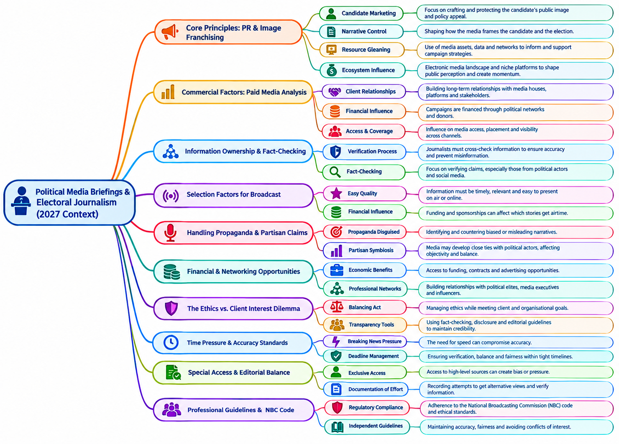
Figure 1: Broadcast Editors’ Perception and Treatment of Political News Briefing
Discussion
Taken together, the interviews reveal a considerably more complex picture than a simple perception that political media briefings are either useful or problematic. The respondents largely recognise their informational and access value, particularly their ability to connect journalists directly with political actors and provide information about electoral developments. This is in tandem with findings in the study of Sparks & Wagner (2025), who reported the perceived credibility of elite and government sources in news reports, in addition to having a higher information adequacy than other sources. At the same time, they recognise that briefings are often strategic political communication, as equally underscored by Macnamara (2025), who described this strategy as linear; and in some cases commercially organised activities, a position that is not widely recognised by Minggirovna (2023) and Olariu, I., & Nichifor, B. (2015), but introduces questions about propaganda, source dependence, verification and editorial independence.

The most significant finding for the study is the tension between access and autonomy. The respondents' accounts suggest that political briefings can simultaneously strengthen journalism by improving access to sources and complicate journalism by introducing political, commercial and relational pressures. This tension is recognised by Malling (2021), who agrees that political news sources have some influence on journalists and journalism, although the author classifies interaction with political news sources into formal invisible and informal invisible, with the former serving as gatekeepers and the latter as agenda setters. Furthermore, some respondents’ description of strong safeguards based on objectivity, editorial meetings, professional ethics and NBC regulations, is indicative that broadcast news editors still recognise the guardrails of journalism. However, in line with Charles (2025), others acknowledge that access, payment and source availability can affect the eventual publication of political information. Charles identifies, among other things, commercial pressures and an outfit’s leaning as part of factors responsible for media bias in political coverage.

Data’s consequent pointing towards a central interpretive proposition tilts towards a clear deduction: political media briefings are perceived as valuable sources of electoral information, but their journalistic value is mediated by editorial gatekeeping, verification practices, commercial considerations and the newsroom's attempt to preserve professional independence.

Conclusion
The findings of the study indicated several related points, showing that political media briefings ahead of the 2027 elections in Akwa Ibom State are considered veritable sources for information from which broadcast editors could generate interesting news stories that are expected to answer questions that would help the electorates make informed decisions. This takes root in the interactions with political actors that cut across parties, candidates, support groups, and even the electoral body. Hence, the respondents generally perceived them as useful for political communication and public enlightenment, but not as neutral information channels. Political media briefings’ value to journalism largely depends on post-briefing activities, including the selection, verification and contextualisation of information that become news.

Moreover, the findings revealed a tension between access to political actors and editorial independence, feared to attract political and financial relationships, unequal access to competing political actors, partisan claims, misinformation and broadcast deadlines create pressures that can complicate editorial judgement. However, journalistic significance of political media briefings lies in the editorial processes through which that information is negotiated before it reaches the electorate.

Recommendation
Consequently, the recommendation in this study follows that news organisations should strengthen newsroom protocols for handling political briefings, particularly through systematic verification, clear separation of paid political communication from editorial content, balanced sourcing and documentation of attempts to obtain competing perspectives.

AI Disclosure
A number of artificial intelligence tools were employed to aid some aspects of the study. For instance, audioconvert.ai and elevenlabs.io were used to process the transcription of the recorded interviews. Likewise, ChatGPT and Gemini were used to extract the quotes that buttress the developed themes for the study, and ChatGPT alone was used to generate the infographic labelled as Figure 1.

References
Bro, P., & Kristensen, L. M. (2024). Digital gatekeeping: New platforms, producers and complexities. In S. A. Eldridge II, D. Cheruiyot, S. Banjac, & J. Swart (Eds.), The Routledge companion to digital journalism studies (2nd ed., pp. 207–215). Routledge. https://doi.org/10.4324/9781003334774-25

Cazzamatta, R. (2026). The truth game: Verification factors behind fact-checkers’ selection decisions. Journalism, 27(8), 2292-2311. https://doi.org/10.1177/14648849251371952
Charles, A. (2025). Media Bias in Political Coverage: Analyzing the Sources and Effects. Journal of Mass Communication & Journalism, 15(1), 1-2.
Damissah, Isiaka, Adejare and Ogunlana (2025). Media independence and democratic accountability in modern governance systems and public administration frameworks. GSC Advanced Research and Reviews, 23(1), 12-23. https://doi.org/10.30574/gscarr.2025.23.1.0102
De Semir, V., Ribas, C. & Revuelta, G. (1998). Press releases of science journal articles and subsequent newspaper stories on the same topic. JAMA, 280(3), 294-295.
Hayek, L. (2024). Media framing of government crisis communication during Covid-19. Media and Communication, 12, Article 7774. https://doi.org/10.17645/mac.7774
Ibrahim, F., Pawanteh, L., Kee, C. P., Basri, F. K. H., Hassan, B. R. A. & Mahmud, W. A. W. (2011). Journalists and News Sources: Implications of Professionalism in War Reporting. The Public Sector Innovation Journal, 16(3), 1-12.
Imukudo, S. (2026). Akwa Ibom govt silent as compensation disputes swirl around N117.5bn Medical City project. Premium Times, September 19.
International Republican Institute (2026, August 21). Statement of Findings and Recommendations | IRI Pre-Election Assessment Mission to Nigeria’s 2027 General Elections. Iri.org. Retrieved September 19, 2026, from https://www.iri.org/resources/statement-of-findings-and-recommendations-iri-pre-election-assessment-mission-to-nigerias-2027-general-elections/
Ismail, A., Ahmad, M. K. & Mustaffa, C. S. (2014). Conceputalization of Investigative Journalism: The Perspectives of Malaysian Media Practitioners. Procedia - Social and Behavioral Sciences, 155, 165-170.
Macnamara, J. (2025). Strategic Communication and public policy: a major gap and opportunity for research, practice, and democracy. International Journal of Strategic Communication, 1–27. https://doi.org/10.1080/1553118x.2025.2572076
Malling, M. (2021b). Reconstructing the informal and invisible: interactions between journalists and political sources in two countries. Journalism Practice, 17(4), 683–703. https://doi.org/10.1080/17512786.2021.1930571

Mañoso-Pacheco, L. (2020). News values and the information source: the discourse of eliteness and personalisation in the digital press. Texto Livre: Linguagem e Tecnologia, 13(1), 1-19.
Mellado, C., Mothes, C., Hallin, D. C., Humanes, M. L., Lauber, M., Mick, J., Silke, H., Sparks, C., Amado, A., Davydov, S., & Olivera, D. (2020). Investigating the Gap between Newspaper Journalists’ Role Conceptions and Role Performance in Nine European, Asian, and Latin American Countries. The International Journal of Press/Politics, 25(4), 552–575. https://doi.org/10.1177/1940161220910106.
Millum, J., & Bromwich, D. (2021). Informed consent: What must be disclosed and what must be understood? The American Journal of Bioethics, 21(5), 46–58. https://doi.org/10.1080/15265161.2020.1863511

Minggirovna, M. G. (2023). The importance of the press conference in organizing and conducting public events. Journal of Multidisciplinary Innovations, 15, 12-14.
Naeem, M., Ozuem, W., Howell, K., & Ranfagni, S. (2023). A Step-by-Step process of thematic analysis to develop a conceptual model in qualitative research. International Journal of Qualitative Methods, 22, 1-18. https://doi.org/10.1177/16094069231205789
Ndukwu, M., Anyanwu, J. C., Eregbu, S. M., Anyanwu, B., & Onwukwe, A. C. (2024). Influence of editorial policy on media reportage of political personalities during the 2023 general elections in Imo State, Nigeria. International Journal of Social Sciences and Academic Research, 5(1), 197-209.
Nwankpa, N. N., Umoren, P. & Utuk, P. A. (2021). Nigerian journalism in the information and communication technologies-driven world. Pakistan’s Multidisciplinary Journal for Arts & Science, 2(3), 64-74.
Nwodu, G. E., Ekwunife, S. C. & Ikegbunam, P. C. (2025). Understanding the fate of journalism practice without the brown envelope: Views from practicing journalists in Anambra state. International Journal of Research and Innovation in Social Science, IX(XIII), 507–518. https://doi.org/10.47772/ijriss.2025.913com0044.
Olariu, I., & Nichifor, B. (2015). A Conceptual Approach on Press Conference. Studies and Scientific Researches Economics Edition, 21, 120-126. https://doi.org/10.29358/sceco.v0i21.317
Pang, A., Chiong, V. H., & Hassan, N. B. B. A. (2014). Media relations in an evolving media landscape. Journal of Communication Management, 18(3), 271–294.
Premium Times (2026). 2027: SERAP sues INEC over alleged failure to disclose political donation limits, party finances. Premium Times, September 20.
Regmi, B. P. (2024). Qualitative Research Design: A Discussion on its Types. Research Journal, 9(1), 37-45.
Scheffauer, R., Goyanes, M., & Gil de Zúñiga, H. (2024). Social media algorithmic versus professional journalists' news selection: Effects of gate keeping on traditional and social media news trust. Journalism, 25(4), 755–778. https://doi.org/10.1177/14648849231179804
Shahbaz, S. H., & Arif, M. (2023). Practicing journalism in challenging political environment of press conferences: A qualitative study of political news reporters. Journal of Asian Development Studies, 12(4), 968–979. https://doi.org/10.62345/jads.2023.12.4.77
Sharra, A. (2020). Eyes of the society: How Malawian journalists utilise question time during political press briefings. African Journalism Studies, 41(3), 49–64. https://doi.org/10.1080/23743670.2020.1834425
Shi, Y. (2023). The Role of Journalism in Public Affairs: Informing, Educating and Holding Power to Account. Journal of Mass Communication & Journalism 13(3), 1-2.
Sparks, J. F., & Wagner, A. J. (2025). Audience perceptions of government documents as news sources. The International Journal of Press/Politics, 0(0). https://doi.org/10.1177/19401612251396661
Waisbord, S. and Guazina, L. (2024). Journalism and the challenges of political communication and contemporary democracies. Brazilian Journalism Research, 20(3), e1809. https://doi.org/10.25200/bjr.v20n3.2024.1809

SINGING TRUTH TO POWER: MUSICAL SKITS, DIGITAL PERFORMANCE, AND POLITICAL ACCOUNTABILITY IN NIGERIA'S MEDIA SOCIETY

Jude Ndubuisi Nwabuokei, Ph.D.
Teesside University
Digital Media and Public Relations
School of Arts and Creative Industries
Email: J.Nwabuokei@tees.ac.uk
ORCID: 0000-0002-7769-5715

Abstract
As Nigeria prepares for the 2027 General Elections, digital media have become increasingly important sites for political participation and democratic accountability. Among the most influential yet underexplored forms of online political expression are short musical skits and satirical performances disseminated across platforms such as TikTok, Instagram, Facebook, X, and YouTube. This paper argues that such performances constitute an emergent form of participatory political communication, enabling ordinary citizens, comedians, musicians, and digital creators to scrutinise political actors, expose governance failures, and influence public discourse in ways that often rival conventional news media. The study's theoretical orientation draws on participatory culture (Henry Jenkins), affective publics (Zizi Papacharissi), and performance as political communication; it examines how musical skits function as alternative media within Nigeria's digital public sphere. Methodologically, this study uses qualitative digital ethnography and multimodal discourse analysis of selected viral political performances produced before the 2027 elections; the paper investigates how rhythm, lyrical composition, satire, visual symbolism, and platform affordances combine to construct narratives of accountability, mobilise civic engagement, and shape political consciousness. It pays particular attention to how these performances circulate across multiple social media ecosystems and how they generate public debate, challenge official narratives, and sustain political memory beyond the news cycle. The study contends that short musical performances represent more than entertainment; they are emerging forms of digital civic intervention that blur the boundaries between journalism, artistic expression, and political activism. In a society increasingly characterised by declining trust in traditional institutions and growing digital participation, these performances provide netizens with innovative spaces for scrutinising political leadership, contesting official narratives and negotiating the meaning of political accountability.

Keywords: Musical skits, Digital performance, Political Satire, Political Accountability, Digital Media, Media and Society.

Introduction
Digital platforms increasingly shape Nigeria’s political communication environment, where citizens encounter, interpret, and respond to political issues. While conventional news media remain important to electoral communication and public accountability, social media have expanded the range of actors and expressive forms through which political discourse is produced and circulated (Jacobs, 2016; Bruns et al., 2026). TikTok, Instagram, Facebook, X, and YouTube have enabled comedians, musicians, skit makers, and other digital creators to participate in political conversation alongside journalists, politicians, and established media organisations. Within this expanding digital public sphere, short musical and satirical performances have emerged as particularly accessible ways to translate political concerns into humour, parody, music and performance. Such content complicates conventional distinctions between entertainment and political communication because performances produced primarily for popular consumption can simultaneously comment on political leadership, governance failures and the conduct of public officials. Thus, this article argues that political commentary in Nigeria’s media society increasingly takes culturally familiar, entertaining forms. The study examines these performances as an emergent form of participatory political communication and asks how their aesthetic and platform-specific characteristics enable political critique to circulate beyond conventional journalistic spaces. It contends that musical and satirical skits create an alternative communicative space in which political dissatisfaction can be rendered visible, emotionally resonant and culturally intelligible. Through rhythm, lyrics, parody, characterisation, gesture and visual symbolism, creators can transform complex political grievances into performances that audiences can watch, interpret, comment upon and share (Rose, 2025; Garg & Rai, 2025).

This circulation can extend political discussion beyond the immediate performance and allow particular political narratives, jokes, and criticisms to gain persistence within popular digital culture. Such performances raise an important question for scholarship on digital political communication: It draws on Henry Jenkins’s concept of participatory culture, Zizi Papacharissi’s theorisation of affective publics, and scholarship on performance as political communication, conceptualising these performances as affective participatory interventions. It examines how musical skits combine participatory and affective dimensions with platform circulation to produce alternative forms of political visibility and accountability. Through a qualitative multimodal analysis of selected digital performances, including the Facebook videos that form the article’s primary empirical corpus, the study considers how music and performance mediate political criticism and how audiences are incorporated into its circulation.

The research questions that animate this study ask: how do Nigerian musical skits use music, humour, parody and multimodal performance to construct political critique and narratives of accountability? It also examines how social media platforms facilitate the circulation, visibility and audience engagement of these political performances. Together, these questions enable the study to examine both the representational strategies through which political meanings are constructed and the digital infrastructures through which those meanings acquire visibility, circulate across networked publics, and generate engagement. This dual focus positions musical skits simultaneously as multimodal cultural performances and as digitally mediated forms of political communication within Nigeria’s evolving digital public sphere

Thesis and Argument
Nigerian musical and satirical skits constitute an emergent form of participatory political communication in which humour, music, performance, and platform affordances transform political dissatisfaction into affectively charged and highly shareable forms of civic discourse (Ajaegbu & Ajaegbu, 2024; Toumaras, 2025). This argument challenges conventional distinctions between political communication and entertainment by recognising that political critique need not occur exclusively through journalism, electoral campaigns or explicitly political speech. Within Nigeria’s increasingly platformised media environment, comedians, musicians and digital creators can enter political discourse through cultural forms that are simultaneously entertaining and politically expressive. Musical skits can therefore expose contradictions in political leadership, ridicule official narratives and articulate popular grievances while remaining accessible to audiences who may not ordinarily engage with conventional political content. The political significance of these performances lies not simply in what they communicate, but in how political meanings are produced, experienced and circulated. Humour can make political authority available for ridicule; music introduces rhythm, repetition, and emotional intensity; and performance enables political figures and behaviours to be impersonated, exaggerated, and reimagined (Rai, 2015; Salukvadze, 2026).

Once disseminated through social media, these performances become potentially participatory texts whose meanings can be extended through commenting, sharing, remixing and response. The audience is consequently not merely a consumer of political messages but can become part of the process through which political meanings acquire visibility and circulation. Nevertheless, one should avoid equating participation or virality with political efficacy. A widely circulated skit does not necessarily produce political mobilisation, alter voting behaviour or generate institutional accountability. Its democratic significance is better understood through its capacity to make political critique memorable, affective, participatory and publicly discussable. This distinction matters because digital political satire operates within commercial platforms structured around attention, engagement and visibility. The same affordances that enable creators to challenge political narratives can also encourage prioritising humour, spectacle, and emotional intensity. Digital satire consequently occupies a productive but contested space between civic intervention and entertainment, political critique and commodification, and participation and platform dependency. The article therefore conceptualises Nigerian musical and satirical skits as affective participatory interventions: cultural performances that make political critique emotionally resonant, publicly visible, and capable of networked circulation. Their significance lies not in virality alone, but in how performance and platformed participation create alternative spaces for political interpretation, public discussion, and accountability discourse.

Social Media and Nigerian Political Communication
The expansion of social media has fundamentally altered the communicative environment within which Nigerian politics is produced, circulated and contested. Political communication, once mediated predominantly through newspapers, radio and television, now operates within a more decentralised and interactive digital ecology in which political parties, journalists, activists, influencers and ordinary citizens can participate in producing and circulating political discourse. Research on Nigeria’s 2023 General Elections, for example, identifies Facebook, X, Instagram, TikTok and WhatsApp as important spaces for disseminating political messages, mobilising supporters, countering competing narratives and facilitating real-time audience engagement (Aideloje et al., 2024; Okon et al., 2025; Chukwu, 2025). This transformation, however, extends beyond substituting one set of communication channels for another. Social media alter the conditions under which political visibility, participation and public discourse are produced. This shift has encouraged a more participatory conception of political communication. Citizens can respond to political claims, produce counter-narratives and circulate interpretations without requiring access to institutional media organisations. Recent scholarship consequently identifies social media as creating more decentralised and interactive forms of civic engagement in Nigeria, while also acknowledging persistent limitations, including misinformation, digital exclusion and forms of online participation that do not necessarily translate into sustained civic action (Iloh et al., 2026; Onayinka et al., 2026).

This latter qualification matters: increased digital expression should not automatically be equated with democratic empowerment. Indeed, the apparent disjunction between high levels of online political activity and offline electoral participation during the 2023 elections demonstrates the limits of assuming a straightforward relationship between digital engagement and political action. The contemporary Nigerian digital political sphere should therefore be understood as simultaneously participatory, affective and contested. Social media provide opportunities for political actors and citizens to shape public agendas, but they also intensify emotional appeals, polarisation and competing claims to political legitimacy. In this unsettled communicative environment, musical skits and political satire take on new significance. Their importance lies not simply in providing another channel for political messages, but in introducing popular cultural performance as a mode of political expression. By combining entertainment with commentary, such performances can expand political discourse beyond conventional news formats and create alternative routes through which political grievances become visible, affectively experienced, and publicly circulated.

Participatory Culture
Henry Jenkins’s concept of participatory culture provides an important starting point for understanding how digital audiences have moved beyond the conventional position of passive media consumption (Jenkins, 2006; Jenkins, Ito & boyd 2016). For Jenkins, participation is not reducible to the technical interactivity enabled by digital technologies; rather, it is a cultural practice through which people acquire the capacity and confidence to create, circulate and attach meaning to media (Jenkins, 2006). He distinguishes participation from interactivity precisely because the latter describes a technological property, whereas participation describes a cultural relationship to media. Jenkins’s formulation is particularly significant for political communication because it recognises civic engagement as one domain in which participatory culture can operate (Jenkins, Ito & boyd 2016). Participatory cultures are characterised by relatively low barriers to artistic expression and civic engagement, support for creating and sharing content, and a sense among participants that their contributions matter (Jenkins, 2006).

Applied to Nigeria’s digital media environment, this framework shifts one’s attention away from the political message as a finished product and towards the social processes through which political meaning is produced and circulated. A musical skit, for example, does not conclude its communicative life when its creator uploads it. Its subsequent trajectory may involve users commenting on its political implications, sharing it with their networks, reproducing its jokes, quoting its lyrics or catchphrases, creating responses and parodies, tagging other users, or incorporating elements of the original performance into new content. In this sense, the audience becomes part of the communicative infrastructure through which political discourse acquires visibility. Jenkins and his collaborators’ later concept of spreadability is useful here because it replaces the relatively passive notion of distribution with a model of circulation in which audiences make active decisions about what content to pass along, how to frame it and which networks it should reach (Jenkins, Ford & Green 2013).

This perspective is particularly productive for understanding the political potential of entertainment. Participation does not necessarily require membership of a political organisation, attendance at a rally or direct engagement with formal political institutions. Within platformed environments, political participation can occur through apparently mundane cultural practices: sharing a satirical video, adding a political interpretation in the comments, reproducing a politician's caricature, or using a creator's catchphrase to comment on a subsequent political event. Such practices can be understood as forms of vernacular political expression, in which citizens appropriate popular cultural forms to interpret political realities (Papacharissi, 2015; Howard, 2011). The musical skit's significance therefore lies partly in its ability to lower the symbolic and cultural barriers separating political discourse from everyday entertainment.

However, Jenkins's participatory model requires critical qualification when transferred to the Nigerian platform environment. Participation should not be romanticised as an automatic redistribution of communicative power. The ability to produce or circulate content does not mean all participants have equal visibility, influence, or access to audiences. Platform algorithms, commercial incentives, moderation practices and unequal digital resources continue to structure whose contributions become visible and whose remain marginal (Gillespie, 2018; Noble, 2018). Indeed, Jenkins's later account of spreadability recognises that contemporary circulation involves a mixture of bottom-up and top-down forces rather than a simple displacement of institutional power by empowered users (Jenkins, Ford & Green 2013). The Nigerian context therefore requires understanding participation as enabled but also conditioned by platform infrastructures.

This qualification is crucial to the present study. The political significance of a musical skit cannot be inferred simply from the number of views, shares or comments it attracts. Nor should every act of sharing be interpreted as evidence of political commitment. A user may circulate a skit because it is humorous, because it expresses an existing frustration, because it is culturally recognisable, or because sharing it strengthens a social relationship. Political meaning may consequently emerge indirectly through practices whose immediate motivation is entertainment. The focus should be on how entertainment-oriented participation can create conditions in which political interpretations, emotions and criticisms are collectively produced and circulated. Furthermore, it complicates the conventional opposition between consumer and producer. In the context of Nigerian musical satire, the creator may produce the initial political performance, but audiences shape its subsequent cultural life. They can reinforce its interpretation, contest it, detach its language from the original context, or transform it into a reusable cultural reference. A catchphrase can become political shorthand; a comic character can become a way to interpret real political actors; and a musical refrain can acquire meanings beyond the original performance. What circulates, therefore, is not simply a political message but a culturally adaptable resource for political interpretation (Jenkins, 1992; Jenkins, Ito & boyd 2016).

Participatory culture thus provides this article with more than a description of social-media engagement. It offers a way of reconceptualising political communication as a process of collective cultural production and circulation. Nigerian musical and satirical skits are significant precisely because they bring political discourse into forms of participation already embedded in everyday digital culture. This provides the conceptual bridge to the article's central concern with musical skits as affective and potentially consequential forms of digital civic intervention. Jenkins's framework is valuable here because it enables an examination of how audiences participate, what they do with political performances after encountering them, and the technological and cultural conditions under which those practices become forms of political communication. It provides the conceptual bridge to the article's central concern with musical skits as affective and potentially consequential forms of digital civic intervention.

Political Satire as Alternative Media
Political satire has a long intellectual and cultural lineage as a mode through which power can be questioned, mocked and rendered open to public scrutiny (Gray, Jones & Thompson 2009; Test 1991). By relying on irony, parody, exaggeration, humour and indirect expression, satire creates a communicative space in which political authority can be challenged without necessarily adopting the formal language of political journalism or institutional criticism (Day 2011). Its significance therefore lies in its ability to make political actors, institutions and practices available for reinterpretation and ridicule. In this sense, satire has historically operated as a form of alternative political communication, particularly where direct criticism may be constrained or where conventional media fail to capture the vernacular ways through which citizens experience political life (Hariman & Lucaites, 2007; Baym, 2015).

Digital platforms, however, alter the communicative conditions within which satire operates. In conventional performance contexts, the relationship might be understood relatively simply as performance → audience: a satirical performance is produced and presented to an audience whose principal role is to watch, interpret and respond. Digital satire introduces a more complex and recursive structure: performance → platform → audience → comments → sharing → remix → renewed circulation. The platform therefore becomes part of the communicative process through which the meaning, visibility and subsequent life of the satirical performance are negotiated (Jenkins, Ford & Green 2013; Gillespie, 2018).

This distinction matters for understanding Nigerian musical and comedic skits. Once uploaded, a performance can acquire communicative trajectories beyond those anticipated by its creator. Audiences may comment upon its political implications, tag other users, reproduce its phrases, create responses, modify its audio or visual elements, or circulate it across different platforms. The audience consequently becomes implicated in the ongoing production and redistribution of political meaning. Satire becomes networked and recursive, rather than transmitted from performer to spectator (Jenkins, 2006; Baym, 2015). The political significance of this transformation should nevertheless not be equated automatically with democratic empowerment. Participation can expand the circulation of political critique while remaining shaped by platform algorithms, commercial incentives and unequal visibility (Noble, 2018; Gillespie, 2018). Digital satire is therefore best understood not simply as satire relocated online, but as a form of networked alternative media in which political critique can be continually reproduced, reframed and contested through participatory circulation (Jenkins, Ito & boyd 2016; Highfield, 2016).

Affect and Political Communication
The relationship between emotion and political communication is particularly important to understanding the circulation of digital satire. Rather than treating emotion as the opposite of rational political communication, this article treats affect as one means through which political communication acquires social force. (Papacharissi, 2014) Papacharissi’s concept of affective publics is useful here because it highlights digitally networked publics that emerge and sustain themselves through shared feelings, expressions, and storytelling. (Papacharissi, 2014; Papacharissi, 2015) Affective publics do not necessarily form around stable political organisations or coherent ideological programmes; rather, they can materialise through the circulation of emotionally charged expressions that allow individuals to “feel their way” or “vibe” with political events and issues.

This perspective is particularly relevant to musical skits, where political meanings are rarely communicated through propositional argument alone. Humour, rhythm, gesture, facial expression, parody and repetition can generate amusement, anger, frustration, recognition, embarrassment, solidarity, cynicism or hope. These effects can make political commentary socially memorable and give audiences reasons to respond to, reproduce, or circulate particular performances. Papacharissi’s work on networked storytelling similarly demonstrates how digital political communication can combine information, opinion and emotion, making their separation analytically less useful than approaches that recognise their hybridity (Papacharissi, 2012; Candon, 2016).

Affect can therefore be constitutive of the communicative process itself. A humorous performance may transform frustration into laughter; recognition may prompt a viewer to tag another person; anger may motivate commentary; solidarity may encourage sharing; and embarrassment may make a satirical representation particularly memorable. In this sense, affect can make political communication socially sticky: it gives users reasons to remain attentive to, respond to and circulate particular messages. However, effective circulation should not be equated automatically with political mobilisation or democratic change. A widely circulated performance may generate laughter without producing sustained political engagement. The analytical significance of affect lies in examining how particular feelings facilitate the movement of political meanings across networked publics. Digital musical satire can thus be understood as an effective form of political communication in which feeling becomes part of the infrastructure through which critique travels, connects audiences and acquires public visibility.

Methodology
This study adopts a qualitative multimodal digital analysis of selected digitally circulated Nigerian political performances; it examines how political meanings are constructed through the interaction of musical, visual, verbal and performative elements within digital environments. The approach draws on multimodal discourse analysis (MDA), a concept that investigates how multiple communicative codes construct meaning beyond language (Jones, 2012), while remaining attentive to the platform contexts through which performances are encountered, circulated, and discussed. The analysis focuses on selected political musical skits and satirical performances circulated on social media platforms, with particular attention to their use of lyrics, rhythm, humour, parody, gesture, costume, visual symbolism and characterisation. It also considers the digital contexts surrounding these performances, including audience comments, sharing practices and observable patterns of recirculation. These elements are examined not as separate communicative components but as interconnected resources through which political critique is produced and made meaningful.

The study therefore treats the performances as networked cultural texts whose significance extends beyond their original moment of production. Attention to circulation is particularly important because digital platforms allow audiences to respond to, reinterpret, reproduce and redistribute performances. The methodological objective is to examine how their multimodal and affective characteristics create possibilities for political commentary, audience participation and public discussion. The selected performances are analysed comparatively to identify recurring patterns in the representation of political authority, governance, accountability and citizen experience. This approach enables the study to connect the formal characteristics of musical satire with the broader communicative conditions of Nigerian digital media, while recognising that visibility, circulation and participation remain shaped by the affordances and constraints of platforms themselves.

Empirical Analyses
The participatory possibilities of musical satire are particularly visible in the two Facebook performances examined in this study. The first skit, Skit 1 – Facebook video, features a reggae artist whose performance uses reggae's musical conventions to comment on President Bola Tinubu. The lyrics question aspects of the President’s educational background, identity, wealth and age. These claims are presented through musical performance rather than conventional political commentary, transforming potentially complex and contentious political questions into an accessible, performative form. The post attracted 224 comments, sparking exchanges between users who supported the President, opposed him, or were drawn primarily by the performance's musical quality.

The comments demonstrate that participation extends beyond simply viewing the performance. One commenter describes the political leadership in highly critical terms, stating that:

“A criminal cartel hijacked the country's leadership and the masses are paying for it” (sic).

Another commenter, apparently defending the President, invokes the 2022 election campaign and argues that, despite previous criticism, Tinubu:

“floored all his opponents and the naysayers” and is now “globally recognised and respected” (sic).

The significance of these contrasting responses lies less in determining which position is correct than in demonstrating how the musical performance becomes a discursive object around which competing political interpretations are articulated. The skit therefore does not end when the song ends; its political meaning extends and is contested through the comment section.

The second performance by a musical artist called Big Lion (Skit 2), spelt as Biqlion, offers a somewhat different form of political musical intervention. Here, Biqlion uses song to enumerate the problems and anxieties Nigerians face, including insecurity, hunger, inadequate infrastructure, and limited access to basic amenities. The performance drew 196 comments, many praising both the musical quality and the political message. One commenter succinctly observes:

“Great music, great message, good job.”
Another expresses admiration for the performer while simultaneously voicing concern about his safety:

“I love your courage…I am afraid if this guy will not send assassins for you…but really don’t want to lose you please be careful somehow” (sic).

This latter response is particularly revealing because it demonstrates the affective complexity of political participation. Admiration, fear and concern coexist within a single response to the performance. The commenter’s apparent reference to being “assassinated” indicates that political musical expression is perceived not merely as entertainment but as potentially consequential dissent. At the same time, the response constructs a relationship between performer and audience based on recognition and emotional attachment. Taken together, the two skits illustrate the recursive structure of digital political satire identified earlier: performance → platform → audience → commentary → contestation → renewed circulation. Their comment sections function as spaces in which political meanings are affirmed, challenged and emotionally negotiated. Importantly, the volume of comments should not itself be treated as evidence that the performances produced political mobilisation or changed political attitudes. Rather, the exchanges demonstrate a more specific form of participation: audiences use the performances as prompts for political expression, disagreement, affiliation and affective response. Musical satire thus becomes a participatory form of political communication, in which entertainment provides the cultural form through which political questions enter everyday digital conversation.

Analytical Framework
The analytical framework for this study develops five coding dimensions that bridge theory and the empirical analysis of Nigerian musical skits, grounding abstract concepts in the concrete practices visible in the two cases‑study performances. Firstly, political representation examines how politicians and state institutions are depicted, focusing on the symbolic and narrative strategies that frame, contest, or ridicule authority. In Skit 1, for example, the reggae performer’s lyrical references to President Bola Tinubu’s alleged lies about his education, identity, and wealth foreground satire as a mode of political scrutiny, while audience comments such as “A criminal cartel hijacked the country leadership…” reveal how viewers extend and reinterpret these representations.

Secondly, performance attends to multimodal features: music, rhythm, gesture, vocal style, parody through which it produces political meaning. Both skits rely heavily on musical form: Skit 1 uses reggae beats to animate political critique, while Skit 2 deploys a melodic lamentation to catalogue insecurity, hunger, and infrastructural decay. These aesthetic choices shape how audiences perceive and emotionally engage with political content.

Thirdly, affect analyses the emotional textures mobilised by the skits, recognising how humour, frustration, recognition, ridicule, or fear contribute to the social force of political commentary. The comments on Skit 2, including expressions of admiration (“Great music, great message”) and fear (“…am afraid if this guy will not send assassins for you”), demonstrate how affective responses can amplify or complicate political interpretation.

Fourthly, platform circulation investigates how sharing, commenting, tagging, and cross‑platform movement shape the visibility and iterative reproduction of meaning. The 224 comments on Skit 1 and 196 on Skit 2 exemplify how audiences become active participants in the communicative process, transforming satire into a networked, recursive form of political discourse.

Finally, civic intervention examines how these skits facilitate accountability, awareness, critique, or political memory. Audience discussions about Nigeria’s political future, concerns about dissent, and reflections on governance indicate that musical satire can create conditions for civic reflection even when motivated by entertainment. Together, these dimensions provide a coherent methodological structure for analysing how musical skits operate as culturally embedded, affectively charged, and digitally mediated forms of political communication.

Performing Political Accountability
Digital musical satire in Nigeria performs political accountability by transforming political critique into humorous, affective, and participatory practices that circulate widely across social platforms. Across the skits analysed, humour, performance, affect, circulation, and civic intervention converge to produce a distinctive communicative form that differs markedly from conventional political journalism. Rather than presenting political information through formal reporting, these skits make power laughable, emotionally resonant, and socially shareable, enabling audiences to participate in political discourse through everyday cultural engagement.

Humour is central to this process. Satire destabilises authority by reversing the symbolic order through which politicians ordinarily maintain seriousness, ceremony, and respectability (Gray, Jones & Thompson, 2009; Day, 2011). Characters such as Governor Amuneke (Kevinblak) exemplify this reversal: through exaggeration, caricature, and comic incompetence, Amuneke embodies the stereotypical Nigerian politician boastful, corrupt, and performatively inept. Skit 1 deploys similar mechanisms. The reggae performer mocks President Bola Tinubu by singing about alleged lies concerning his education, identity, and wealth. The humour lies in the juxtaposition of reggae’s relaxed rhythm with accusations of political dishonesty, producing a comic incongruity that destabilises presidential seriousness. Audience comments extend this humour into explicit critique: “A criminal cartel hijacked the country leadership…” reframes the skit’s satire as a broader indictment of governance. Laughter here becomes a civic resource, enabling critique that is emotionally accessible and socially distributed in ways conventional journalism rarely achieves (Hariman & Lucaites, 2007).

Music and performance intensify this political critique by transforming political information into affective experience. In Skit 1, rhythm and repetition embed political accusations within musical pleasure, allowing audiences to internalise critique through melody rather than argument. Tone, facial expression, gesture, and comic timing further shape the performance's emotional texture, making political meaning felt rather than merely understood (Auslander, 2008). Skit 2 operates through a different affective register: its plaintive melody and sombre tone evoke frustration, sorrow, and recognition of Nigeria’s hardships. The singer’s strained voice and expressive gestures communicate emotional burden, while lyrics listing insecurity, hunger, and infrastructural decay produce a shared affective landscape. Audience responses reflect this intensity, admiration (“Great music, great message”) coexists with fear for the performer’s safety (“…am afraid if this guy will not send assassins for you”), revealing how effective engagement can generate protective publics. Drawing on Papacharissi’s concept of affective publics, these skits demonstrate how political issues become emotionally charged events: political issue → aesthetic performance → emotional response → circulation (Papacharissi, 2014; Papacharissi, 2015).

Platform circulation further shapes how these skits perform accountability. The 224 comments on Skit 1 and 196 on Skit 2 illustrate how audiences become active participants in meaning‑making. Sharing, tagging, remixing, and cross‑platform movement turn satire into a recursive communicative process in which users continually reframe political critique. Platforms are not neutral channels; they are infrastructures that amplify certain voices, intensify affective responses, and enable dialogic exchanges that extend the life of the performance (Gillespie, 2018; Jenkins, Ford & Green, 2013). The comment threads reveal political disagreement, humour, fear, and speculation about Nigeria’s future, demonstrating how circulation produces publics that are emotionally and politically invested.

Ultimately, these skits facilitate civic intervention by enabling informal forms of accountability, awareness, and political memory. Audience discussions about governance failures, concerns about dissent, and reflections on Nigeria’s political direction indicate that musical satire can prompt civic reflection even when motivated by entertainment. This aligns with scholarship on everyday political engagement, which argues that informal media practices can contribute meaningfully to civic awareness and democratic critique (Highfield, 2016; Dahlgren, 2009). The skits do not necessarily mobilise political action, but they create conditions in which critique becomes visible, memorable, and collectively negotiated. Through humour, affect, performance, and circulation, digital musical satire becomes an alternative mode of political communication, one that renders authority laughable, makes political issues emotionally resonant, and invites audiences to participate in the ongoing production of political meaning.

Discussion of Findings
The findings reveal several tensions that complicate the democratic possibilities of digital musical satire. The relationship between virality and political efficacy remains uncertain. A skit may attract hundreds of comments, shares, and cross‑platform circulation, yet such visibility does not necessarily translate into behavioural change or sustained civic engagement. As Jenkins and Shresthova argue elsewhere, participatory visibility can create “thin” forms of engagement that feel politically expressive without producing institutional impact (Tufekci, 2017). Virality may amplify critique, but it can also dissipate into fleeting affective attention.

Digital satire must also balance entertainment with political seriousness. Humour makes politics accessible, lowering the cognitive and emotional barriers to participation, yet it also risks trivialising complex issues. Scholars of political comedy note that satire can oscillate between critique and entertainment, producing what Baym elsewhere calls “discursive integration,” where political information is blended with humour in ways that may obscure structural analysis (Jones, 2010). The skits analysed here demonstrate this tension: audiences laugh, comment, and share, but the comedic framing may soften the gravity of corruption, insecurity, or economic hardship. Furthermore, the skits reveal a tension between participation and algorithmic dependence. While creators appear autonomous, opaque platform logics shape their visibility. As Bucher notes, algorithms act as “sensory infrastructures” that determine what becomes perceptible online (Bucher, 2018). The circulation of Skit 1 and Skit 2 is therefore not solely a function of audience engagement but also of algorithmic amplification, ranking, and recommendation. Moreover, digital satire exists within the creator economy, producing a tension between civic intervention and monetisation. As Abidin’s work on influencer cultures shows, creators often navigate commercial pressures alongside expressive or political goals (Abidin, 2018). Political critique may coexist with revenue generation, sponsorship, or platform incentives, complicating the authenticity or independence of civic messaging.

Finally, satire risks partisan appropriation. Political actors may court, co-opt, or weaponise popular creators to harness their visibility. As Marwick and Boyd argue, networked influence is vulnerable to strategic manipulation (Marwick & Boyd, 2011). The same affective publics that enable critique can also be mobilised for partisan ends. These tensions underscore that digital musical satire is neither inherently emancipatory nor trivial; it is a contested communicative form shaped by humour, affect, platforms, and political interests.

Conclusion
Political communication in Nigeria increasingly unfolds through cultural and entertainment forms, where citizens encounter political issues not only through news media but through music, humour, and everyday digital creativity. Musical and satirical skits exemplify this shift by transforming political critique into affective, participatory, and highly shareable performances that invite audiences to laugh, feel, debate, and reinterpret political authority. Their democratic significance lies in their capacity to create alternative spaces of visibility, interpretation, and accountability, spaces where political behaviour becomes open to scrutiny through vernacular, emotionally resonant modes of expression. As Nigeria approaches the 2027 elections, these skits offer an important lens for understanding how citizens may engage with political issues within an increasingly platformised electoral environment. Rather than predicting their impact, this article suggests that musical satire will remain a meaningful cultural interface through which Nigerians process, negotiate, and make sense of political life. The paper recommends greater scholarly and institutional attention to digital performance as an important component of Nigeria’s evolving democratic communication ecology. Researchers, media organisations, and civic institutions should recognise musical skits and other forms of participatory digital expression not merely as entertainment but as significant spaces in which citizens interpret political events, contest official narratives, and negotiate accountability

References
Abidin, C. (2018). Internet celebrity: Understanding fame online. Emerald Publishing.

Aideloje, S., Sylvester, D., & Jacintha, A. (2024). The role of social media in voter mobilization in Nigeria’s 2023 general elections'. Ayika: Journal of Environment and Politics in Africa. https://doi.org/10.69778/2664-3022/4.1/a3

Ajaegbu, O., & Ajaegbu, C. (2024). The new democratisation: social media impact on the political process in Sub-Saharan Africa. Frontiers in Communication. https://doi.org/10.3389/fcomm.2024.1394949

Auslander, P. (2008). Liveness: Performance in a mediatized culture (2nd ed.). Routledge.

Baym, G. (2005). The daily show: Discursive integration and the reinvention of political journalism. Political Communication, 22(3), 259–276.

Baym, N. K. (2015). Personal connections in the digital age (2nd ed.). Polity Press

Bruns, A., Enli, G., Larsson, A., Robinson, J. Y., Bosch, T., & Kasianenko, K. (2026). The Routledge Companion to Social Media and Politics. https://doi.org/10.4324/9781315716299

Bucher, T. (2018). If... then: Algorithmic power and politics. Oxford University Press.

Candon, P. (2016). Digital publics: Re-defining ‘the civic’ and re-locating ‘the political’. New Media & Society, 18, 2133–2138. https://doi.org/10.1177/1461444816652600

Chukwu, O. (2025). Impact of social media on political communication: A comparative review of 2015, 2019 and 2023 election campaigns in Nigeria. Journal of Management and Science. https://doi.org/10.26524/jms.15.20

Dahlgren, P. (2009). Media and political engagement: Citizens, communication, and democracy. Cambridge University Press.

Day, A. (2011). Satire and dissent: Interventions in contemporary political debate. Indiana University Press.

Garg, G., & Rai, S. (2025). More than a laugh: examining the role of parody songs on Indian political discourse. Comedy Studies. https://doi.org/10.1080/2040610x.2025.2590862

Gillespie, T. (2018). Custodians of the Internet: Platforms, content moderation, and the hidden decisions that shape social media. Yale University Press.

Gray, J., Jones, J. P., & Thompson, E. (Eds.). (2009). Satire TV: Politics and comedy in the post-network era. NYU Press.

Hariman, R., & Lucaites, J. L. (2007). No caption needed: Iconic photographs, public culture, and liberal democracy. University of Chicago Press.

Highfield, T. (2016). Social media and everyday politics. Polity Press.

Howard, R. G. (2011). Digital Jesus: The making of a new Christian fundamentalist community on the Internet. New York University Press.

Iloh, M.C., Saint, E.J., Maiwada, A.A., & Onyejelem, T. E. (2026). Social Media and Political Communication in the 2023 Campaign in Nigeria. BIRCI Journal. Vol. 9 (2), pp. 29-36

Jacobs, S., & Schillemans, T. (2016). Media and public accountability: Typology and exploration. Policy and Politics, 44, 23–40. https://doi.org/10.1332/030557315x14431855320366

Jenkins, H. (2006). Confronting the challenges of participatory culture: Media education for the 21st century. MacArthur Foundation.

Jenkins, H. (2012). Textual poachers: Television fans and participatory culture. Routledge. (2nd edition)

Jenkins, H., Ford, S., & Green, J. (2013). Spreadable media: Creating value and meaning in a networked culture. New York University Press.

Jenkins, H., Ito, M., & boyd, d. (2016). Participatory culture in a networked era: A conversation on youth, learning, commerce, and politics. Polity Press.

Jenkins, H., Puroshotma, R., Weigel, M., Clinton, K., & Robinson, A. J. (2006). Confronting the challenges of participatory culture: Media education for the 21st century. MacArthur Foundation.

Jones, J. P. (2010). Entertaining politics: Satiric television and political engagement (2nd ed.). Rowman & Littlefield.

Jones, R. H. (2012). Multimodal Discourse Analysis. The Encyclopedia of Applied Linguistics. https://doi.org/10.1002/9781405198431.wbeal0813

Marwick, A., & boyd, d. (2011). To see and be seen: Celebrity practice on Twitter. Convergence: The International Journal of Research into New Media Technologies, 17 (2), 139–158.

Noble, S. U. (2018). Algorithms of oppression: How search engines reinforce racism. New York University Press.

Okon, E. A., Ojedor, D.-R. O., & Owolabi, B. O. (2025). The Role of Social Media in the 2023 Nigerian General Elections: An Analytical Appraisal of Selected Platforms. American Journal of Arts and Human Science. https://doi.org/10.54536/ajahs.v4i1.3226

Onayinka, T., Oluwasola, O., & Oyedele, O. (2026). Strategic Political Metamorphosis? Organised EndSARS Protest and the Online Obidient Movement as Mediated Political Activism Shaping Nigeria’s Deliberative Democracy. Journal of Asian and African Studies, 61, 5013 - 5029. https://doi.org/10.1177/00219096261440544

Papacharissi, Z. (2012). Affective News and Networked Publics: The Rhythms of News Storytelling on #Egypt. Journal of Communication, 62, 266–282. https://doi.org/10.1111/j.1460-2466.2012.01630.x

Papacharissi, Z. (2015). Affective publics: Sentiment, technology, and politics. Oxford University Press.
Rai, S. (2015). Political Performance: A Framework for Analysing Democratic Politics. Political Studies, 63, 1179–1197. https://doi.org/10.1111/1467-9248.12154

Rose, A. (2025). Digital comedy as democratic participation: reimagining public discourse through humour in India’s digital age. The Voice of Creative Research, 7(3), 359–369.

Salukvadze, G. (2026). Digital World as a Theatre of War: Political Performativity and Digital Strategies under Authoritarianism. International Journal of Research Publication and Reviews, 7 (8), 1928- 1937. https://doi.org/10.55248/gengpi.07.0826.2510

Test, G. A. (1991). Satire: Spirit and art. University of South Florida Press.

Toumaras, N. (2025). Networked Hyperlocal Activists: Digital Democracy and Engagement in Sub-Saharan Africa. Social Media + Society, 11. https://doi.org/10.1177/20563051251345945

Tufekci, Z. (2017). Twitter and tear gas: The power and fragility of networked protest. Yale University Press.

Empirical Data Sources
Biqlion. (2026). It’s time [Facebook reel]. Facebook. https://www.facebook.com/reel/851923714653071

Egbujo, U. (2026, July 26). DSS, you have to arrest this one… he says our president has no siblings, no school [Facebook reel]. Facebook. https://www.facebook.com/ugo.egbujo/videos/dssyou-have-to-arrest-this-one-he-says-our-president-has-no-siblings-no-school-m/1405842884781189/?rdid=0dQA2v9xv8yCAQQh

ELECTORATES’ RESPONSES TO AI-GENERATED AND HUMAN-CREATED CAMPAIGN MESSAGES IN SOUTH-SOUTH NIGERIA AHEAD OF THE 2027 GENERAL ELECTIONS: AN EXPLORATORY QUALITATIVE STUDY

Uka Nwagbara
Department of Advertising and Marketing Communications, Faculty of Communication and Media Studies, University of Uyo, Uyo
Email: uunwagbara@gmail.com

Precious Ukeje
Department of Mass Communication, Faculty of Communication and Media Studies, University of Uyo, Uyo
Email: pukeje@yahoo.com

Daramfon Okon
Department of Information and Media Studies, Faculty of Communication and Media Studies, University of Uyo, Uyo
Email: daramfon.ime.okon@gmail.com

Abstract
Artificial intelligence is reshaping how political campaigns are produced and circulated. In Nigeria, parties, candidates, and supporters now rely heavily on digital tools to create adverts, images, and voice messages, yet little is known about how ordinary electorates in South-South Nigeria read such content. This exploratory study therefore examined how registered voters in South-South Nigeria distinguish AI-generated from human-created campaign messages, explain their trust or distrust in them, and describe their emotional responses and possible voting intentions ahead of the 2027 elections. A qualitative exploratory design was used. Nineteen registered voters aged 18–40 who actively use social media were purposively selected for maximum variation. Data were collected through online semi-structured interviews using six campaign messages, along with observation notes, and analysed with reflexive thematic analysis. Participants identified AI mainly through unnatural movement, implausible settings and contextual inconsistencies. Human-created messages were generally trusted more, although emotionally relevant AI content could also appear credible. Emotional reactions included humour, hope, confusion and worry, but these rarely translated directly into voting intention. Within this sample, recognition, trust and voting responses depended on realism, relevance, prior knowledge and candidate credibility. As exploratory findings, these are not statistically generalisable but offer propositions for larger, representative studies.

Keywords: Generative AI, Political communication, Campaign messages, Electorates, Trust, Recognition, Credibility, Emotions, Voting intention, Nigeria

Introduction
Generative artificial intelligence (AI) is reshaping political communication by enabling campaigns to produce persuasive text, images, audio and video quickly and cheaply (Hassim & Nasir, 2025; Beacken et al., 2026). Globally, experiments show that large-language-model messages can shift political attitudes, but effects vary by issue, audience, and message design; persuasive capacity, therefore, does not automatically imply greater influence than human communication (Bai et al., 2025; Jungherr et al., 2026). Research further shows that citizens judge deceptive AI uses more negatively than routine campaign applications, while many people struggle to distinguish AI- from human-generated information (Jungherr et al., 2026; Stefkovics & Gere, 2026).

Across Africa, digitally networked elections combine wider participation with greater exposure to misleading political content (Gadjanova et al., 2022; Abboud et al., 2024). However, literature has largely examined social-media campaigning, misinformation, digital literacy and the wider democratic consequences of internet use rather than directly comparing electorates’ responses to AI-generated and human-created campaign messages (Cariolle et al., 2024; Muringa & Adjin-Tettey, 2024; Mustapha et al., 2024). Emerging research has begun to document the use and risks of generative-AI propaganda in African elections (Wack & Parry, 2025; Wack & Prochaska, 2026), including Nigeria (Uzuegbunam, 2026; Beacken et al., 2026), but remains primarily concerned with disinformation threats, governance and countermeasures rather than how electorates recognise message origin, form trust judgements, experience emotional responses or translate such responses into voting intentions.

The studies reviewed above leave three specific gaps. First, on recognition, Nigerian studies have examined WhatsApp campaigning (Fisher et al., 2024), influencer-led influence operations (Uwalaka et al., 2025) and campaign responses to disinformation (Ibrahim & Ekdale, 2026), but none asked electorates to distinguish AI-generated from human-created messages. International evidence on this question is mixed: AI messages can persuade (Bai et al., 2025), people often cannot tell AI-generated from human-written content (Stefkovics & Gere, 2026), and deceptive AI use attracts public disapproval (Jungherr et al., 2026). Second, on trust, the Nigerian studies closest to this topic examined consumer trust in AI-generated advertising (Ekanem & Nwagbara, 2024), the role of AI-generated videos in one candidate’s social identity (Nwaoboli & Ojete, 2025) and South-South voters’ trust in algorithm-curated political messages (Abdulazeez et al., 2026); none compared trust in AI-generated and human-created campaign messages from the electorate’s perspective. Third, on emotions and voting intention, Nigerian evidence comes from a single university’s students (Ngoka et al., 2026) or from campaign actors rather than voters (Ibrahim & Ekdale, 2026), and does not address AI-generated content. Because the phenomenon is new and these questions have not been mapped in this region, an exploratory approach that builds in-depth understanding and generates propositions for later testing is more appropriate than a confirmatory one (Stebbins, 2001).

Given these gaps, this exploratory study examined how electorates in South-South Nigeria perceive and respond to AI-generated and human-created campaign messages ahead of the 2027 general elections. Specifically, it sought to:

- Identify the cues electorates use to distinguish AI-generated from human-created campaign messages.
- Explore the reasons electorates give for trusting or distrusting each type of campaign message.
- Describe the emotional responses that the campaign messages evoke among electorates.
- Explore how electorates perceive the campaign messages as shaping their voting intentions for the 2027 general elections.

Conceptual Clarification: Electorates, Responses and Campaign Messages
In legal terms, electorates are people qualified to vote; in Nigeria, these are citizens aged 18 or above who have registered with the Independent National Electoral Commission (INEC). Beyond this legal status, digital-election research treats electorates as audiences whose readings of campaign messages are shaped by identity, experience, media exposure and prior attitudes, rather than as uniformly persuadable voters (Kleinnijenhuis et al., 2019; Venus et al., 2025). In this study, electorates are registered voters resident in the six South-South states (Akwa Ibom, Bayelsa, Cross River, Delta, Edo and Rivers) who actively use social media and belong to Generation Z (born 1997–2012; aged 18–29 at the time of the study) or the Millennial cohort (born 1981–1996; aged 30–45). Electorates’ responses are broader than persuasion: exposure to a campaign message may produce recognition, scepticism, humour, distrust or emotion without any change in voting preference (Conrad et al., 2025; Gondwe, 2025; Gallegos et al., 2026). Responses are therefore operationalised as electorates’ recognition, interpretations, trust judgements, emotions and stated voting intentions following exposure.

AI-generated campaign messages are better conceptualised by production process, not falsity: generative systems can create or substantially transform political text, images, audio and video, whether truthful, satirical or deceptive (Goldstein et al., 2024; Łabuz & Nehring, 2024). Operationally, they are study stimuli generated or materially synthesised using generative-AI tools.

Human-created campaign messages cannot simply mean “authentic”: humans also manipulate, selectively frame and strategically persuade. Their analytical value is therefore comparative authorship rather than presumed truthfulness, especially because AI labels themselves can alter credibility judgements (Gallegos et al., 2026; Goldstein et al., 2024; Schiff et al., 2025). In this study, they are campaign stimuli produced through conventional human recording, photography or design without generative-AI synthesis.

Recognition and Interpretation of Campaign Messages
Experimental research suggests that the key question is not whether electorates can “spot AI”, but which cues they rely on to assess authorship and meaning (Groh et al., 2022; Stefkovics & Gere, 2026). Groh et al. (2022) observed, in five experiments, that audio-visual cues, more than content alone, determined whether deepfake political videos were recognised. In contrast, across 27 European countries, Stefkovics and Gere (2026) found little difference in how respondents reacted to human- and AI-generated headlines when authorship was undisclosed, suggesting that text-based synthetic content is hard to distinguish. This is further complicated in Africa by fragile information environments, as evidenced by high levels of perceived exposure to disinformation and low trust in social and national media in Kenya (Wack & Prochaska, 2026), Nigeria (Ngoka et al., 2026) and South Africa (Mtsweni et al., 2023). Thus, in Sub-Saharan Africa, recognition is likely to occur under general suspicion rather than confident, positive identification. During the 2023 presidential election, misinformation in Nigeria involved the dissemination of fabricated information, as well as the use of “fake-news” labels, prebunking and debunking terms to challenge rival statements by campaign actors (Ibrahim & Ekdale, 2026). Thus, South-South electorates might use partisan identity, pre-existing beliefs, language, platform cues, and perceived authenticity, rather than just the technology being used, to interpret a message as AI-generated.

Trust in AI-Generated and Human-Created Campaign Messages
Trust is shaped less by whether a message is objectively AI-generated than by what voters believe its source and production process imply. In US–UK experiments, Altay and Gilardi (2024) found that an “AI-generated” label reduced perceived accuracy and sharing intentions even when content was true or human-written. Further, internet use has been associated with lower institutional trust and weaker perceptions of democracy, suggesting that digital distrust predates generative AI and may condition reactions to it (Wang et al., 2023; Wen et al., 2025). Adeleke (2025) documents the circulation of deepfake audio during the 2023 elections, showing how synthetic media can weaken confidence not only in false content but also in authentic recordings. More locally, Abdulazeez, Anthony and Iwegbue (2026) found that South-South voters’ trust in algorithm-curated political messages varied with exposure and demographic factors. However, their cross-sectional design cannot establish causality. This exploratory study therefore attends to whether participants distinguish distrust of AI authorship from distrust of parties, platforms, candidates and Nigeria’s political information system.

Emotional Responses and Voting Intentions
Evidence cautions against technological determinism, even though AI-generated campaign messages can engage voters through emotional and personalised persuasion. Conrad et al. (2025) note that politically produced AI images may be more likely to induce attention and emotional processing, and reactions to them may be largely attributable to their perceived humanness and trustworthiness. But emotional arousal does not necessarily lead to lasting change in voting behaviour; most experiments report shifts in attitudes rather than behaviour at the polls. In Africa, the 2024 South African election offers a warning: Gondwe (2025) analysed 22,384 messages from politically engaged WhatsApp groups and found that AI-generated deepfakes interacted with emotional manipulation and group ideology to construct false narratives, showing that AI content works relationally through partisan communities, platform dynamics, and grievances.

However, such results cannot be transferred wholesale to Nigeria, where ethnic, religious, regional and party identities shape political choice. Nigerian studies of the 2023 presidential election show that religion and party politics influenced candidate choice alongside social-media engagement, with variation across regions (Morah & Nwafor, 2024; Salahu, 2023; Baba & Jibril, 2023), while Ngoka et al. (2026) reported that WhatsApp campaigns affected the turnout of University of Nigeria students, although this single-university study has limited transferability. The open question for South-South Nigeria is whether AI shapes emotional intensity and voting intention beyond source identity, partisanship, and social-media exposure.

Theoretical Framework
Source Credibility Theory, developed by Hovland et al. (1953) from Hovland and Weiss’s (1951) experiments on communicator credibility, holds that messages influence audiences more when the source is perceived as knowledgeable (expertise) and honest (trustworthiness). It has since been widely applied in advertising, journalism, health and political communication, although a review of five decades of evidence shows that credibility effects are conditional: they weaken when audiences are highly involved with the issue, hold strong prior attitudes, or learn the source only after the message (Pornpitakpan, 2004). Two further limitations matter here. First, credibility is perceived rather than fixed and can be distorted by beliefs, partisanship and context. Second, the theory assumes an identifiable human communicator. Generative AI unsettles this assumption, because audiences may judge a message by cues about the technology itself, sometimes applying a “machine heuristic” that treats machine-made content as more objective (Sundar, 2008), even as AI labels can lower perceived accuracy (Altay & Gilardi, 2024). Consistent with the exploratory design, the theory is used as a sensitising rather than a testing framework: it directs attention to how participants judge the expertise, honesty and authenticity behind AI-generated and human-created messages, and whether these judgements relate to their trust, emotional responses and voting intentions, while leaving room for explanations the theory does not anticipate.

Method
This study adopted a qualitative exploratory design. Exploratory research suits new phenomena about which little is known, where the aim is to discover how people understand an issue and to generate propositions for later testing, rather than to measure prevalence or test hypotheses (Stebbins, 2001). Because AI-generated campaign messages are new in Nigerian elections and no prior study had examined how South-South electorates read them, the study did not seek to estimate how the region’s millions of registered voters respond, which would require a large probability-based survey. Instead, it sought an in-depth account of how electorates understood, trusted and emotionally responded to AI-generated and human-created campaign messages, allowing participants to explain why particular messages appeared credible, artificial or persuasive (Braun & Clarke, 2022; Keen et al., 2022).

Participants and Sampling
Nineteen participants (see Table 1) were purposively recruited from active political groups across social media. Inclusion criteria were that participants were aged 18 or above, were registered voters with INEC, resided in one of the six South-South states, used social media daily and were regularly exposed to political content online. Participants were spread evenly across all six states, with three or four from each. Maximum-variation sampling was used to capture differences in age, gender, occupation and experience with AI-generated content. Online recruitment and interviewing made it possible to reach participants across the region, a recognised strength of virtual qualitative research (Keen et al., 2022). Sample size was guided by information power rather than statistical representativeness: a focused aim, a specific participant group, rich dialogue and an established analytic strategy reduce the number of participants needed (Malterud et al., 2016), and empirical tests show that interview studies with relatively homogeneous groups often reach saturation within 9–17 interviews (Hennink & Kaiser, 2022). Participants are identified by letter codes.

Table 1: Characteristics of Participants
Characteristic | Category | Frequency (n) | Percentage (%)
Total respondents |  | 19 | 100.0
Gender | Female | 11 | 57.9
 | Male | 8 | 42.1
Age profile | 18–22 years | 5 | 26.3
 | 23–27 years | 4 | 21.1
 | 28–32 years | 4 | 21.1
 | 33–36 years | 3 | 15.8
 | 37–40 years | 3 | 15.8
Primary occupational status | Student | 4 | 21.1
 | Student with additional employment/business activity | 4 | 21.1
 | Employed professional | 3 | 15.8
 | Trader/self-employed | 3 | 15.8
 | Model/affiliate marketer | 3 | 15.8
 | Other skilled/self-employed occupation | 2 | 10.5
Social media use | Daily/frequent users | 19 | 100.0
Interaction with AI-generated content | Deliberately seeks/uses AI-generated content | 12 | 63.2
 | Encounters AI mainly through algorithms/social media feeds | 7 | 36.8

Data Collection
Data were collected through online semi-structured interviews. Each participant was presented with six campaign messages, labelled CM1 to CM6, comprising both AI-generated and human-created materials in video and still-image formats. The researcher observed participants as they watched the materials and noted immediate reactions such as laughter, hesitation, surprise and confusion. Follow-up questions explored what they noticed, believed, trusted, felt and whether the messages could affect their voting intentions.

Data Analysis
The data were analysed using Braun and Clarke’s (2022) six-phase reflexive thematic analysis, an approach suited to exploring patterns of meaning in small, in-depth datasets. First, transcripts and observation notes were read repeatedly for familiarisation. Second, relevant statements were coded. Third, related codes were grouped into possible themes; thus, the themes emerged from the data rather than being predetermined. Fourth, the themes were checked against the full dataset. Fifth, they were refined and clearly named. Finally, the findings were written using representative quotations. Consistent with the exploratory design, the analysis aimed at transferable insight and theoretical propositions rather than statistical generalisation.

Results
Three themes were developed from the data. Consistent with the exploratory design, they describe patterns within this sample of 19 participants and are not intended to estimate how widely these views are held among South-South electorates.

Theme 1: Recognition and Interpretation of Campaign Messages
Among the 19 participants, recognition of AI-generated campaign materials was largely anchored in perceived departures from normal human movement, facial expression, voice, setting and political reality. QR, for instance, claimed complete confidence, identifying “a watermark in the video that clearly shows that it was made with an AI tool… the body movements, they were not realistic”. Similarly, AB rated his ability 10/10 because “AI itself, no matter how good it is, currently doesn’t capture [human behaviour and tone] to its best.” CM, CD and AC also cited appearance, body movement, intonation, video quality, facial expression and background as diagnostic cues.

The most frequently identified example was CM1, the politicians’ race. FG judged it artificial because “I don’t think our president is young enough to be sprinting”, DD pointed to the exaggerated leg split, and AP, PM and MN to unnatural speed and movement. MN was particularly attentive to behavioural consistency, noting that “Peter Obi was laughing to the end and Tinubu wasn’t laughing from the beginning to the end… there should be signs that shows that there is something going on.” Recognition was thus not only technical: participants compared what they saw with their knowledge of normal bodies and of the candidates.

Contextual plausibility also shaped interpretation. The communion video was repeatedly challenged: TA described “different celebrities receiving communion from a presidential aspirant as a priest” as an obvious impossibility, while CG stated simply: “I have not seen a Muslim in church taking Holy Communion before.” These accounts indicate that participants identified AI not only through visual aberrations, but also through breaches of social, religious and political norms.

In contrast, CM3 and CM6 were typically seen as human-made because they resembled familiar campaign environments in Nigeria. AY explained that CM3 “shows the normal campaign settings… many, many voters and then she’s talking to the crowd,” while RA described CM3 and CM6 as “natural… realistic.” For CG, CD and AC, visible crowds, recognisable campaign practices and spontaneous reactions signalled human production, while NA looked for correspondence between voice and emotion, and CF for source credibility and factual traceability.

Yet recognition was not universal. FG, AY, QB, PG, TA, RA, AC and CF all struggled with at least one static image, particularly the flag image, suggesting that static AI imagery was harder to classify than moving video. CF captured this ambiguity: “the picture was not factual… there were faces on the Nigerian flag, and we all know there are no faces on the Nigerian flag.” Likewise, NA rated himself only 6/10 because “sometimes AI… looks more real,” while RA rated herself 4/10 due to the increasingly advanced generation. For these participants, recognition was a layered process that became less reliable as the technology improved.

Theme 2: Trust and Credibility of Campaign Messages
Participants’ perceptions of authenticity, realism, source plausibility, emotional connection, and perceived human presence were primary drivers of trust, and human-created materials were generally trusted more than AI-generated ones. PG expressed this clearly: “the human-generated political material… looked real, authentic, I could easily connect to it”, whereas the AI materials appeared “very fake… it did not look real.” DD similarly trusted the human-created videos because “you could actually relate to what was happening.” Credibility was thus often established by perceived human realism rather than by the message itself.

This preference was especially noticeable for CM3 and CM6. AY trusted CM3 because “it shows a normal voting system, normal election process, normal campaign settings”, RA trusted CM3 and CM6 simply “because they are real”, and CD explained that CM3 “looked so real and the environment was very natural.”

However, trust did not depend solely on human production. AP found AI-generated CM4 convincing because “the message passed through that material is very genuine and clear” and spoke directly to Nigeria’s present circumstances. PM trusted CM4 because it conveyed grief and sadness, while CF trusted the same content because of its emotional resonance: “it kind of told a story… it was emotionally connecting… I was moved by it.” These responses blur a clear-cut division between AI and human content: where AI content depicted recognisable social realities, its message could outweigh its production method.

Distrust of AI nonetheless remained common. QA questioned the race material because “it looked very unreal and untrue”, while TA stressed that looking believable did not mean political acceptance: “Credible in terms of, do I, would I vote for these people? No.” NA doubted even CM2 and CM3, showing that realistic-looking scenes could prompt verification rather than automatic acceptance.

Several participants also linked credibility to AI’s distortion of known reality. QR rejected CM2 because “we all know Tinubu is a Muslim… that would be unbelievable,” while CG similarly distrusted the communion scenario. CF further distinguished emotional believability from factual credibility, noting that some materials were “believable, but… not factual.” Overall, credibility was built from visual realism, familiarity, emotional appeal, factual consistency, perceived source authenticity and alignment with participants’ experience of political life.

Theme 3: Emotional and Behavioural Influence of Campaign Messages
The campaign materials produced markedly different emotional responses, which did not always translate into voting intentions. Humour, confusion, hope, interest, worry and indifference were all evident, with AI-generated materials more often provoking amusement or scepticism, and human-created materials more often eliciting interest and connection. PG described the AI-generated race video as “very funny because it’s not something I would usually see”, but the human-generated campaign event produced “a little bit of excitement” because of the visible turnout, suggesting that some AI content functioned more as political entertainment than as persuasion.

Yet humour could weaken behavioural influence. DD said that if a candidate used AI-generated videos, “I would take the person as not being serious”, because elections should involve “bringing people together for a common purpose.” CG asked: “why not do it real time?” For these participants, artificiality signalled insufficient political seriousness.

Other participants experienced more substantive emotions. AP felt hopeful because CM4 addressed current national conditions: “if we do what is right, we elect, we vote for the good candidates, there will still be hope in our country.” AC also felt hopeful, while RA said the materials increased her “interest in politics because of the way the APC campaigned.” CF was moved by the bloodstained flag, indicating that even AI-generated material could generate affective engagement where its symbolism resonated with participants’ understanding of national hardship.

Conversely, confusion and worry arose where messages were ambiguous or exaggerated. MN said CM1 left him confused because “the campaign portrays everybody to be active”, making it difficult to determine “who is good for the job.” PM doubted the campaign's sincerity: “I don’t want a situation where they will make all these things and still turn their back on us.” NA worried that images of candidates pushing one another suggested political hostility.

However, emotional engagement did not uniformly produce persuasion. TA remained “indifferent” because “if this is a campaign video, there should be a message. There was no message,” adding that the materials made the candidates appear “not very serious.” QR said the materials had no political effect because “they are not persuasive,” and CF explained: “videos will not change my view”; she would instead assess candidates through “the way you speak and your past performances.”

In contrast, AY, QB, AB, RA, AC and CD indicated that campaign materials could influence their electoral judgement. AY said a meaningful manifesto delivered before a crowd would make her “listen… and be looking forward to seeing what you accomplish when you get into the office.” AB acknowledged that even AI-generated portrayals influenced his perception of President Tinubu because they “draw a parallel line to what we are facing in Nigeria.” Within this sample, behavioural influence depended less on emotion alone than on whether emotion was reinforced by message relevance, perceived authenticity, candidate credibility and prior political judgement.

Discussion
On the first objective, the findings suggest that recognition was contextual and embodied rather than purely technical. Participants flagged unnatural movements, mismatched laughter and breaches of known religious or political facts, as when CG questioned a Muslim aspirant administering Communion. This aligns with Groh et al. (2022), who showed that audio-visual anomalies, not just content, drive deepfake detection. It appears to contrast with Stefkovics and Gere’s (2026) 27-country survey, which found little difference in judgements of undisclosed AI and human content; however, their stimuli were text headlines lacking the embodied cues participants here relied on. Consistent with this, participants such as CF struggled most with still images, suggesting that recognition confidence declines as AI content offers fewer cues to check against lived experience.
On the second objective, participants generally trusted human-created content more, rejecting AI content as unreal (PG, DD). This echoes Altay and Gilardi (2024), whose participants discounted content labelled as AI-generated even when it was accurate. However, AP and PM judged the AI-generated CM4 credible because it reflected Nigeria’s current challenges. This complicates reliance on labelling: where the source is unclear, emotional relevance can act as a credibility cue. In terms of Source Credibility Theory (Hovland et al., 1953), source characteristics appeared to matter most when the source was clear, while relevance substituted for them when it was ambiguous. Moreover, whereas Abdulazeez et al. 's (2026) cross-sectional data could not separate believability from willingness to vote, TA explicitly distinguished distrust of AI from distrust of politicians.

On the third and fourth objectives, AI-generated content more often evoked humour or scepticism (as in DD’s reaction to the race video), while human-generated content evoked interest or excitement (PG, RA). Emotion seldom translated into voting intention: TA, QR and CF reacted emotionally yet found the material unpersuasive, consistent with Conrad et al. (2025), who warn that increased emotional processing does not necessarily produce lasting behaviour change. This differs from Gondwe (2025), who found AI deepfakes actively spread through partisan WhatsApp groups in South Africa. The contrast may reflect method rather than context: Gondwe examined organic network diffusion, while these interviews captured reflective judgement within a Nigerian identity politics in which religion and party already shape choice (Morah & Nwafor, 2024; Salahu, 2023; Baba & Jibril, 2023).

Taken together, these exploratory results suggest an extension of Source Credibility Theory, which assumes an identifiable source: participants first determined whether a human source was present, then evaluated its honesty and expertise. Recognition, trust and emotional response therefore appear sequential rather than parallel, a layering that the literature on AI and African elections, largely concerned with disinformation risk (Wack & Prochaska, 2026; Ibrahim & Ekdale, 2026), does not fully theorise. These are propositions to be tested in larger, representative studies rather than conclusions about South-South electorates as a whole.

Implications
Although exploratory, the findings suggest that AI-generated political campaign content can influence electorates, even when they are aware of its artificial nature. This is relevant to Nigeria’s 2027 elections, particularly for young electorates, political parties, electoral bodies, journalists and fact-checkers. Participants detected AI content through errors, unrealistic behaviour and violations of familiar political or religious contexts, but these cues will become less reliable as AI improves. Convincing synthetic videos or images could damage reputations, erode trust and deepen existing political and religious divisions. Political parties should therefore use AI transparently, while INEC, media organisations and civil society groups should strengthen voter education and fast fact-checking.

Limitations and Directions for Future Research
As an exploratory qualitative study, this research has limitations that define how its findings should be read. The sample of 19 purposively selected, social-media-active registered voters aged 18–40 is not statistically representative, and the findings should not be generalised to all South-South electorates; they offer transferable insights and propositions instead. The participants also responded to selected campaign materials in an interview setting rather than during an actual campaign, where party allegiance, peer pressure and repeated exposure may shape responses differently. Future research should test the propositions generated here through larger, probability-based surveys of registered voters across all six states, experiments comparing AI-generated and human-created messages, and studies conducted during the campaign season.

Conclusion
This exploratory study suggests that the South-South electorates interviewed did not judge campaign messages by technology alone. They recognised AI through embodied and contextual cues, trusted messages that felt real and relevant, and rarely allowed emotional reactions to override prior political judgement. As AI-generated content becomes harder to detect, these patterns warrant confirmatory research ahead of the 2027 general elections.

References
Abboud, E., Ajwang, F., & Lugano, G. (2024). Social media and politics as usual? Exploring the role of social media in the 2022 Kenyan presidential election. Journal of Eastern African Studies, 18(2), 321–343.

Abdulazeez, I., Anthony, O. U., & Iwegbue, G. U. (2026). Exposure and trust in online political messages in the age of social media algorithms among voters in South-South, Nigeria. International Journal of Sub-Saharan African Research, 4(1), 511–527.

Adeleke, F. (2025). Reinstating trust in elections in the era of artificial intelligence and emerging technologies. Data & Policy, 7, e38.
Altay, S., & Gilardi, F. (2024). People are skeptical of headlines labeled as AI-generated, even if true or human-made, because they assume full AI automation. PNAS Nexus, 3(10), Article pgae403.

Baba, M. S., & Jibril, Z. A. (2023). The intersection of religion and politics in the 2023 presidential election in Nigeria: A case study of Adamawa State. ADSU International Journal of Applied Economics, Finance and Management, 8(2), 130–150.

Bai, H., Voelkel, J. G., Muldowney, S., Eichstaedt, J. C., & Willer, R. (2025). LLM-generated messages can persuade humans on policy issues. Nature Communications, 16(1), Article 6037. https://doi.org/10.1038/s41467-025-61345-5

Beacken, G. D., Trauthig, I. K., & Woolley, S. C. (2026). Generative AI, propaganda, and digital authoritarianism: Comparative insights from six democratically weakened countries. Big Data & Society, 13(2).

Braun, V., & Clarke, V. (2022). Conceptual and design thinking for thematic analysis. Qualitative Psychology, 9(1), 3–26.

Cariolle, J., Elkhateeb, Y., & Maurel, M. (2024). Misinformation technology: Internet use and political misperceptions in Africa. Journal of Comparative Economics, 52(2), 400–433. https://doi.org/10.1016/j.jce.2024.01.002
Conrad, C., Nissen, A., Masoumi-Ravandi, K., Ramchandani, M., Braga, R. F., & Newman, A. (2025). Do truthfulness notifications influence perceptions of AI-generated political images? A cognitive investigation with EEG. Computers in Human Behavior: Artificial Humans, Article 100185.

Ekanem, I., & Nwagbara, U. (2024). AI-generated advertising in Nigeria: A qualitative exploration of consumer perceptions, trust, and engagement. TSU Journal of Communication and Media Studies, 4(1), 1–18.

Fisher, J., Gadjanova, E., & Hitchen, J. (2024). WhatsApp and political communication in West Africa: Accounting for differences in parties’ organization and message discipline online. Party Politics, 30(5), 934–948.

Gadjanova, E., Lynch, G., & Saibu, G. (2022). Misinformation across digital divides: Theory and evidence from northern Ghana. African Affairs, 121(483), 161–195.

Gallegos, I. O., Shani, C., Shi, W., Bianchi, F., Gainsburg, I., Jurafsky, D., & Willer, R. (2026). Labeling messages as AI-generated does not reduce their persuasive effects. PNAS Nexus, 5(2), Article pgag008.

Goldstein, J. A., Chao, J., Grossman, S., Stamos, A., & Tomz, M. (2024). How persuasive is AI-generated propaganda? PNAS Nexus, 3(2), Article pgae034.

Gondwe, G. (2025). AI-driven disinformation and political influence on WhatsApp in South Africa’s 2024 elections. The International Journal of Press/Politics. Advance online publication.

Groh, M., Epstein, Z., Firestone, C., & Picard, R. (2022). Deepfake detection by human crowds, machines, and machine-informed crowds. Proceedings of the National Academy of Sciences, 119(1), Article e2110013119.

Hassim, M. N., & Nasir, N. N. A. M. (2025). The role of AI in shaping political discourse on social media. International Journal of Research and Innovation in Social Science (IJRISS), 9(10). https://doi.org/10.47772/IJRISS.2025.910000478

Hennink, M., & Kaiser, B. N. (2022). Sample sizes for saturation in qualitative research: A systematic review of empirical tests. Social Science & Medicine, 292, 114523.

Hovland, C. I., & Weiss, W. (1951). The influence of source credibility on communication effectiveness. Public Opinion Quarterly, 15(4), 635–650.

Hovland, C. I., Janis, I. L., & Kelley, H. H. (1953). Communication and persuasion. Yale University Press.

Ibrahim, A. A., & Ekdale, B. (2026). Political campaign responses to information disorder: A case study of the 2023 Nigerian presidential elections. The International Journal of Press/Politics, 31(3), 595–615.
Jungherr, A., Rauchfleisch, A., & Wuttke, A. (2026). Artificial intelligence in election campaigns: Perceptions, penalties, and implications. Political Communication, 43(4), 585–606.

Keen, S., Lomeli-Rodriguez, M., & Joffe, H. (2022). From challenge to opportunity: Virtual qualitative research during COVID-19 and beyond. International Journal of Qualitative Methods, 21.

Kleinnijenhuis, J., van Hoof, A. M., & van Atteveldt, W. (2019). The combined effects of mass media and social media on political perceptions and preferences. Journal of Communication, 69(6), 650–673.

Łabuz, M., & Nehring, C. (2024). On the way to deep fake democracy? Deep fakes in election campaigns in 2023. European Political Science, 23(4), 454–473.

Malterud, K., Siersma, V. D., & Guassora, A. D. (2016). Sample size in qualitative interview studies: Guided by information power. Qualitative Health Research, 26(13), 1753–1760.

Morah, D. N., & Nwafor, O. A. (2024). Beyond tribal politics for e-participation and development: Social media influence on Nigeria’s 2023 presidential general election. Journal of Innovative Digital Transformation, 1(1), 32–47.

Mtsweni, J., Ndlovu, L., Mthethwa, S., & Mkuzangwe, N. (2023). Measuring misinformation trends on social media in South Africa using machine learning. In Proceedings of the International Conference on Artificial Intelligence and its Applications (pp. 128–133).

Muringa, T., & Adjin-Tettey, T. D. (2024). Media literacy’s role in democratic engagement and societal transformation among university students. African Journalism Studies, 45(2), 115–134.

Mustapha, M. J., Lasisi, M. I., & Barabash, V. V. (2024). Are they tools? Anglophone West African countries’ students’ misconception of media literacy and critical thinking for combating misinformation. Journal of Media Literacy Education, 16(1), 94–103.

Ngoka, R. O., Ezeani, E. O., Ugwuozor, I. S., & Ezeani, U. K. (2026). Interrogating the impact of the use of WhatsApp on the voting behaviour of University of Nigeria, Nsukka students during the 2023 Nigerian presidential election. Journal of Asian and African Studies, 61(1), 653–674.

Nwaoboli, E. P., & Ojete, E. (2025). Critical analysis of AI-generated video content and its influence on Peter Obi’s social identity formation in Nigeria’s 2023 presidential election. Zaria Journal of Communication, 9(2), 23–41.

Pornpitakpan, C. (2004). The persuasiveness of source credibility: A critical review of five decades’ evidence. Journal of Applied Social Psychology, 34(2), 243–281.

Salahu, M. O. (2023). Politics, religion and electoral outcomes in Nigeria: The 2023 presidential election in perspective. Journal of Administrative Science, 20(1), 213–233.
Schiff, K. J., Schiff, D. S., & Bueno, N. S. (2025). The liar’s dividend: Can politicians claim misinformation to evade accountability? American Political Science Review, 119(1), 71–90.

Stebbins, R. A. (2001). Exploratory research in the social sciences. Sage.

Stefkovics, Á., & Gere, D. (2026). Beliefs and sharing intentions of human- and AI-generated fake news: Evidence from 27 European countries. PNAS Nexus, 5(3), Article pgag032.

Sundar, S. S. (2008). The MAIN model: A heuristic approach to understanding technology effects on credibility. In M. J. Metzger & A. J. Flanagin (Eds.), Digital media, youth, and credibility (pp. 73–100). MIT Press.

Uwalaka, T., Amadi, F., & Enyindah, S. C. (2025). Social media influencers and political influence operations: The Data Boys example in Nigeria. Public Relations Inquiry, 14(1), 89–115.

Uzuegbunam, C. E. (2026). Future-proofing emerging technologies (artificial intelligence) in sub-Saharan African democracy. In The Routledge companion to digital media and democracy (pp. 439–451). Routledge.

Venus, A., Intyaswati, D., Ayuningtyas, F., & Lestari, P. (2025). Political participation in the digital age: Impact of influencers and advertising on Generation Z. Cogent Arts & Humanities, 12(1), Article 2520063.

\Wack, M., & Parry, D. A. (2025). Synthetic diversity: Examining the effects of ethnic targeting using AI-generated political ads. International Journal of Communication, 19, 25.

Wack, M., & Prochaska, S. (2026). Making sense of AI-generated disinformation: How audience interpretations influence the impact of deepfakes in Kenya. Social Media + Society, 12(3).

Wang, Z., Liu, H., Li, T., Zhou, L., & Zhou, M. (2023). The impact of internet use on citizens’ trust in government: The mediating role of sense of security. Systems, 11(1), Article 47.

Wen, Y., Sun, X., & Fang, L. (2025). The impact of internet use in the digital era on public political trust in China: An empirical study based on CGSS 2021 data. PLOS ONE, 20(12), Article e0339999.

ARTIFICIAL INTELLIGENCE (AI) AND THE 2027 ELECTIONS: COMPARING URBAN AND RURAL VOTERS’ RESPONSES TO AI-GENERATED CAMPAIGN MESSAGES IN ABIA STATE, NIGERIA

Uka Nwagbara
Department of Advertising and Marketing Communications, Faculty of Communication and Media Studies, University of Uyo, Uyo
Email: uunwagbara@gmail.com

Abstract
Artificial intelligence (AI) is entering Nigerian electoral communication ahead of the 2027 general elections, raising concerns about authenticity, trust and misinformation. This exploratory study examined how voters aged 18–40 in Abia State, Nigeria, understand, feel about and respond to AI-generated and AI-assisted campaign messages, and how urban/semi-urban and rural voters compare. Method: A qualitative exploratory design was adopted. Twenty voters (ten urban/semi-urban and ten rural) were purposively selected from communities across Abia State and interviewed individually using six AI-generated or AI-assisted campaign materials (CM1–CM6), supplemented by observation notes. Data were analysed through reflexive thematic analysis and interpreted with the Elaboration Likelihood Model. Findings: AI familiarity varied within both groups rather than simply between them. Participants separated emotional appeal from credibility, and realistic fabrication caused more concern than obvious satire. The messages stimulated attention, discussion and verification more readily than candidate support, and rural participants relied more on interpersonal and community verification networks. Conclusion: Within this sample, AI-generated campaign messages shaped electoral judgement through credibility, emotional appeal, realism and verification conditions rather than automatic vote conversion. As exploratory findings, these are not statistically generalisable but offer propositions for larger studies.

Keywords: Artificial intelligence, Elections, Voters, Campaigns, Deepfakes, Credibility, Persuasion, Verification, Abia State, Nigeria

Introduction
Nigeria’s 2027 general elections are scheduled for 16 January 2027 (presidential and National Assembly) and 6 February 2027 (governorship and State Houses of Assembly). Under the revised timetable of the Independent National Electoral Commission (INEC), campaigns for the federal elections began on 19 August 2026 and those for the state elections on 9 September 2026, and all campaigns must end 24 hours before polling day (Oliji, 2026). The 2027 campaign is therefore the first Nigerian general election campaign to unfold while generative AI tools are cheap and widely available.

AI is increasingly being integrated into electoral communication, giving political agents tools to quickly and cost-effectively tailor text, images, audio and video content while posing fresh challenges of authenticity, accountability and trust (Juneja, 2024; Chowdhury, 2024). In Nigeria, the 2023 elections marked a visible entry point: a viral audio clip purporting to capture Atiku Abubakar, Ifeanyi Okowa and Aminu Tambuwal plotting to rig the election was found to be a doctored deepfake (Shibayan, 2023). In West Africa, OpenAI (2025) reported an AI-generated influence operation that produced partisan articles and comments ahead of Ghana’s 2024 election. Technical capacity, however, does not guarantee a uniform impact. In experiments around elections in the United States, Canada and Poland, Lin et al. (2025) found that dialogues with AI significantly shifted candidate preferences, while Neyazi et al. (2025), who studied 1,627 people in India, did not find a boost in affective polarization after reading about campaign deepfakes. These results challenge deterministic claims about the persuasive effects of AI-generated political messages. The distinction is particularly relevant in Africa, where political information does not travel only through the Internet: Gadjanova et al. (2022) show how misinformation spans digital divides through interpersonal and socially mediated communication in northern Ghana, and Hassan (2023) found that electoral misinformation in Nigeria moves through social and traditional media.

This study is set in Abia State, south-east Nigeria, which has 17 local government areas, 4,069 polling units and over two million registered voters (Okoronkwo, 2023). The state combines urban commercial and administrative centres, notably Aba and Umuahia, with semi-urban towns and rural farming communities. The study focuses on voters aged 18–40, a group heavily exposed to political content online (Mustapha & Omar, 2020). This group is not homogeneous. In Nigeria, where mobile internet spread mainly after 2010, younger voters grew up with smartphones and social media and can be regarded as digital natives, whereas older voters in the bracket adopted digital technologies later and resembled digital immigrants (Prensky, 2001). Such differences, together with uneven internet access between urban and rural areas (Conroy-Krutz et al., 2024; Kemp, 2024), may shape how AI-generated messages are understood.

Existing scholarship does not adequately capture how such messages are understood and acted upon in Nigerian communities. First, influential experimental studies are geographically limited to North America, Europe and India, and their results cannot be assumed to apply to Abia State (Lin et al., 2025; Neyazi et al., 2025). Second, Nigerian studies have found that misinformation can affect voter attitudes, trust in the electoral process and democracy, but they focus on misinformation generally rather than on generative-AI campaign content or on comparing flyers, synthetic audio and short videos (Hassan, 2023; Akinola et al., 2024). Third, African studies show differences in access to, and verification of, information, but there is little evidence on whether these differences lead to different reactions to AI-generated electoral messages among urban, semi-urban and rural voters (Gadjanova et al., 2022; Azeez et al., 2026).

Because the phenomenon is new and these questions have not been examined in Abia State, an exploratory approach is appropriate: rather than measuring effects across the electorate, it seeks in-depth understanding and propositions for later testing (Stebbins, 2001). The study contributes to scholarship by providing early evidence from a Nigerian state on AI-generated campaign messages ahead of the 2027 elections, by comparing urban/semi-urban and rural voters, a contrast largely absent from AI-persuasion research, and by extending the Elaboration Likelihood Model to AI-generated political content in a hybrid online–offline information environment. Practically, it offers INEC, parties, journalists and civil society insight for voter education during the campaign.

This exploratory study therefore explores how voters aged 18–40 in urban, semi-urban and rural Abia State comprehend, feel about and react to AI-generated political campaign messages delivered as flyers, audio recordings and short videos. Specifically, it sought to:

- examine how voters aged 18 to 40 in Abia State understand AI-generated campaign messages;
- explore how voters feel about AI-generated campaign flyers, audio messages, and short videos;
- examine how AI-generated campaign messages influence voters’ willingness to seek more information, discuss a candidate, or support a candidate;
- compare the responses of urban and semi-urban voters with those of rural voters to AI-generated campaign messages.

Conceptual Clarification
In this study, AI-generated campaign messages are political flyers, audio clips or videos whose content is produced wholly or substantially by generative AI, such as synthetic images, cloned voices or fabricated scenes. AI-assisted campaign messages are human-designed materials in which AI performs supporting tasks such as editing, image enhancement or drafting text (Nobel et al., 2026). Urban areas are the state’s main administrative and commercial centres (Umuahia and Aba); semi-urban areas are smaller towns with mixed urban and rural features (such as Ubakala, Olokoro and parts of Isiala Ngwa); and rural areas are farming and trading communities with more limited infrastructure and internet access (such as communities in Bende, Ikwuano, Isuikwuato, Ohafia and Umunneochi).

Voters’ Understanding of AI-Generated Campaign Messages
Studies by Lee and Yuan (2025), Nobel et al. (2026) and Chae and Tewksbury (2026) suggest that voters’ understanding of AI-generated campaign communication relies on more than identifying the term “AI”; it involves assessing authenticity, credibility and communicative intent. This is important because politically generated AI content ranges from innocuous design help to fabricated speech. In five preregistered experiments with 2,215 participants, Groh et al. (2024) showed that individuals distinguished political deepfakes from real speeches better than chance, but not perfectly, and that audio-visual information aided recognition more than transcripts. Younger voters cannot be assumed to recognise synthetic content easily either: Dozier (2026) reported that 80% of 18–34-year-olds could only correctly identify AI images 50% of the time, and White (2025) reported that more than half of 13–18-year-olds could not determine whether AI content was true. Disclosure further complicates understanding. Harff (2026) found that labels on AI-generated images improved recognition but also lowered source credibility, and Nobel et al. (2026) found that when source credibility was low, fully AI-generated political advertisements were rated less favourably than AI-assisted ones. These studies, however, were conducted mainly outside Africa, leaving open how Nigerian voters with uneven AI exposure understand such messages.

Feelings Towards AI-Generated Flyers, Audio and Videos
Attitudes to flyers, audio and short videos are likely to be modality-specific and should not be analysed as a single attitude to AI. Flyers allow more time to consider wording and visual anomalies (Farooq & de Vreese, 2026), while audio can capitalize on familiar voices and passive listening (Groh et al., 2024). Short videos include facial expressions, body movement, emotional cues and voice, which could enhance both perceived authenticity and deceptive potential (Groh et al., 2024; Hameleers et al., 2024; Guo et al., 2026). Groh et al. (2024) also found that state-of-the-art synthetic speech was harder to identify than actor-voiced fakes, so audio-visual cues do not guarantee detection. Similarly, evidence of the persuasive power of some AI messages should not be extended to all formats. Among 4,829 respondents, Bai et al. (2025) found that LLM-generated messages changed attitudes as effectively as human-authored ones, but Hewitt et al.’s (2024) archive of 146 campaign experiments shows that the effects of political ads are small and variable. How Nigerian voters feel about each format remains largely unexamined.

Behavioural Responses: Information Seeking, Discussion and Support
Behavioural responses may also vary. AI-generated messages can prompt information seeking when they seem novel, uncertain or manipulative, whereas distrust can lead to avoidance. Mustapha and Omar (2020) found that Nigerian youths were more politically active offline than online, a caution against equating online exposure with participation. Discussion, information seeking and candidate support should therefore be distinguished; a campaign message may stimulate discussion precisely because recipients doubt it. At a larger scale, a US$8.9-million digital campaign experiment reaching two million Americans had no effect on turnout (Aggarwal et al., 2023), showing that exposure reveals little about how content is processed. Evidence on these behavioural responses among Nigerian voters exposed to AI content is lacking.

Urban–Rural Differences in Responses
The urban–rural comparison is particularly significant in Africa. Conroy-Krutz et al. (2024) found that 65% of people in 39 African countries regularly get news from radio while 47% do so via social media or the Internet, with digital use concentrated among urban, younger, better-educated and wealthier citizens. Nigeria is digitalising fast but access remains uneven: Kemp (2024) estimated that 103 million Nigerians used the Internet in early 2024 and that 54.6% of the population was urban. These figures caution against assuming social homogeneity in internet contact.

In Nigeria, WhatsApp is used for text, photos, voice notes and videos in both urban and rural areas, but Ogbodo et al. (2023) warn that digital literacy alone does not prevent sharing misinformation. Among 1,200 Nigerian youths, Azeez et al. (2026) found that urban youths were more likely to be exposed to misinformation, while rural youths were more likely to change their electoral preferences, especially when the message came from a trusted community or religious intermediary. Rural voters should therefore not be viewed as simply “less digital”; they may interpret AI through more socially mediated channels, while urban and semi-urban voters might have more exposure to AI and more scepticism or verification. No study has yet compared how these groups respond to AI-generated campaign messages.

In sum, the literature leaves four gaps that correspond to this study’s objectives: limited evidence on how Nigerian voters understand AI-generated campaign messages; little attention to how they feel about different formats; scarce evidence on behavioural responses beyond persuasion; and no direct comparison of urban/semi-urban and rural voters. The question for Abia State’s young voters is, therefore, not whether AI-generated messages ‘work’, but how format, disclosure, trust, digital access and community validation affect their processing and behavioural responses.

Theoretical Framework
The Elaboration Likelihood Model (ELM) holds that persuasion follows two routes (Petty & Cacioppo, 1986). Through the central route, people who are motivated and able to process a message scrutinise its arguments, producing stronger and more lasting attitudes. Through the peripheral route, people with low motivation or ability rely on cues such as source credibility, emotion, familiarity and presentation, producing weaker and less stable attitudes. Whether elaboration is high or low depends on motivation, such as personal relevance, and ability, such as knowledge, time and freedom from distraction (Petty et al., 1981).

Each ELM component is linked to a study variable. First, ability to elaborate corresponds to voters’ AI familiarity, digital literacy and confidence in detecting synthetic content (Objective 1). Second, peripheral cues correspond to the emotional appeal, realism, recognisable political figures, religious symbols and format of the flyers, audio and videos (Objective 2). Third, central-route processing corresponds to voters’ scrutiny of claims, such as checking whether a depicted alliance is real or weighing a candidate’s record, while elaboration outcomes correspond to information seeking, discussion and candidate support (Objective 3). Finally, motivation and ability are shaped by context: access to data, verification opportunities and trusted community intermediaries differ between urban/semi-urban and rural settings (Objective 4). Consistent with the exploratory design, the ELM is used as an interpretive lens rather than a set of hypotheses to be tested.

Method
The study adopted a qualitative exploratory design. Exploratory research suits new phenomena where the aim is to understand how people make sense of an issue and to generate propositions, rather than to measure prevalence or test hypotheses (Stebbins, 2001). The study therefore does not claim to represent Abia State’s more than two million registered voters, which would require a large probability-based survey; its urban–rural comparison is analytical rather than statistical. The design enabled participants to explain why certain messages seemed authentic, dubious or persuasive (Braun & Clarke, 2022).

Individual semi-structured interviews were preferred to focus group discussions for three reasons. Political preferences are sensitive, and group settings can produce conformity to dominant partisan views; the study needed to observe each participant’s immediate, unprompted reaction to the materials; and individual interviews allowed participants with low AI familiarity to speak without being overshadowed by more digitally confident peers. Focus groups are recommended for future studies of how voters negotiate AI content collectively.

Study Area, Participants and Sampling
Twenty voters, ten urban/semi-urban and ten rural, were purposively selected from communities across Abia State. Urban participants were drawn from Umuahia and Aba, semi-urban participants from towns such as Ubakala, Olokoro and Isiala Ngwa, and rural participants from communities in Bende, Ikwuano, Isuikwuato, Ohafia and Umunneochi local government areas. Participants were aged 18–40, eligible to vote and resident in the study area. Gender, occupation, educational level, smartphone ownership, social-media usage and previous awareness of AI were considered as they may influence interpretation. Purposive sampling was appropriate for selecting information-rich cases (Ahmad & Wilkins, 2025). Sample size was guided by information power rather than statistical representativeness: a focused aim, specific participants, rich dialogue and an established analytic strategy reduce the number needed (Malterud et al., 2016). Twenty participants, ten per setting, therefore suited an exploratory comparison, although the findings are not generalisable to all voters in the state.

Table 1: Characteristics of Participants
Characteristic | Category | Frequency (n) | Percentage (%)
Total participants |  | 20 | 100.0
Location group | Urban/semi-urban (e.g., Umuahia, Aba, Ubakala, Olokoro, Isiala Ngwa) | 10 | 50.0
 | Rural (e.g., Bende, Ikwuano, Isuikwuato, Ohafia, Umunneochi) | 10 | 50.0
Age eligibility | 18–40 years | 20 | 100.0
Electoral status | Eligible voters | 20 | 100.0
Residence | Abia State | 20 | 100.0
Campaign exposure | CM1–CM6 | 20 | 100.0

Data Collection
Semi-structured individual interviews were used to gather data. Participants were shown six campaign materials (CM1–CM6), which included AI-generated or AI-assisted flyers, audio recordings and short videos (Table 2). The researcher noted immediate reactions such as laughter, hesitation, surprise and uncertainty. Follow-up questions explored what participants observed, understood, trusted and felt, and whether the messages could prompt them to seek information, discuss or support the candidates. Using identical stimuli for all participants aided comparison.

Table 2: Campaign Materials Used as Stimuli
Code | Format | Content | Main issue raised
CM1 | Short video | Satirical race between politicians, labelled as AI-made | Disclosed satire; entertainment
CM2 | Short video | Politicians depicted at a Catholic Mass, labelled as AI-made | Religious cue lending moral credibility
CM3 | Short Video | A political campaign material | Activity and realistic human movement
CM4 | Short video | Tattered Nigerian flag with distressed faces and disaster imagery; no candidate named | Emotional appeal to economic hardship
CM5 | Flyer | Purported Obi–Kwankwaso joint ticket with hook/noose imagery | Fabricated political fact; fear appeal
CM6 | Video | A compilation of different campaign events | Realistic movement

Data Analysis
Braun and Clarke’s reflexive thematic analysis was used to analyse the data. Transcripts and observation notes were read many times for familiarisation; statements were coded and related codes were formed into themes. Themes were reviewed against the data set, refined and named, and representative quotations were selected. Coding was mostly inductive. The Elaboration Likelihood Model was then used as an interpretive lens to examine how careful evaluation compared with rapid credibility, familiarity and emotional cues, without forcing the data into predetermined categories (Braun & Clarke, 2022; Byrne, 2022).

Ethical Considerations
Participation was voluntary, and participants gave informed consent after the purpose of the study was explained. They were assured of confidentiality and are identified only by codes (U01–U10 for urban/semi-urban and P2–P11 for rural participants).

Results
Two themes, one for each setting, were developed, each organised around the study objectives. Consistent with the exploratory design, they describe patterns within this sample and do not estimate how widely these views are held among Abia State voters.

Theme 1: Urban and Semi-Urban Voters’ Perceptions and Responses to AI-Generated Political Campaign Messages
The study found that none of the ten urban and semi-urban participants accepted or rejected AI-generated political communication outright. Instead, answers depended on their knowledge of AI, the message’s structure, emotional intensity, perceived authenticity, and whether synthetic manipulation was disclosed.

Understanding AI through recognition, uncertainty and disclosure
Participants’ understanding of AI-generated political content varied widely. The more tech-savvy urban participants exhibited more developed notions of AI. U01 (female, 19, urban Umuahia, student, high AI familiarity), for example, understood that AI could alter multiple layers of communication: “AI-made means software generated or changed some part of the content. It may be the picture, the voice, the face, the wording, or all of it.” Yet she conceded that “AI is getting better, so... you can still be fooled.” U02 (male, 22, urban Aba, student, high AI familiarity) similarly identified “funny fingers”, stiff faces, lip-sync problems and unnatural voices, but admitted that professionally produced AI required verification rather than visual guesswork.

This contrasted with U07 (female, 33, semi-urban Ubakala, teacher, low AI familiarity), whose prior knowledge centred mainly on ChatGPT: “I thought it was mainly for writing and answering questions.” She added: “It may be difficult for me... if it is neat I may accept it.” U10 (male, 40, semi-urban Isiala Ngwa, artisan/trader, low AI familiarity) similarly asked, “If it is very fake I may see it, but if it is clean, how will I know?” AI literacy thus depended less on urban residence than on prior exposure and occupational experience, as evidenced by U04’s professional experience with generative design technologies.

Emotional appeal versus credibility and authenticity
Participants clearly differentiated between attention-grabbing and credible information. The politically neutral satire race, CM1, amused most urban participants (U01–U05, U07 and U08) but persuaded few. U04 (male, 27, urban Aba, graphic designer, high AI familiarity) described it as “political meme content”, noting that disclosure reduced deception: “Because it says AI, I can enjoy it as satire; if the same clip removed the label and pretended to be real, I would see that as deceptive.”

CM4 struck a different emotional register. The shattered Nigerian flag, distressed faces and disaster imagery brought sadness, tension and unease to U02, U03, U04, U05, U07, U08 and U09. For U04, “The visual metaphor is much heavier than ordinary campaign flyers. There is no candidate, no policy, just national pain concentrated into one image.” U07’s reaction was more visceral: “The faces in the flag... [pauses] that one is not easy to forget.” Recognising synthetic production did not neutralise emotional impact.

CM5 raised the greatest credibility concerns. Its portrayal of an unconfirmed Obi–Kwankwaso partnership, using real political figures and official-looking design, worried U01, U03, U04, U05, U06, U08 and U09. U03 (female, 24, urban Umuahia, online retailer, moderate AI familiarity) explained: “I felt confused first, then suspicious. I would ask, is this ticket real? Because a fine graphic can make something look official when it is not.” U09 (female, 38, semi-urban Olokoro, public servant, moderate AI familiarity) regarded CM5 as more dangerous than emotional imagery because it could manufacture political certainty around something that might not exist.

Attention and verification rather than automatic political support
The messages appeared more capable of stimulating attention, conversation and verification than determining vote choice. U01 explained: “It can affect my attention, not my final vote. A strong video may make me search the candidate, but I still need policies, track record and debates before support.” U03, U05, U06, U07, U08 and U09 likewise prioritised competence, integrity, governance records, economic conditions and policy over campaign aesthetics.
Nevertheless, dismissing persuasive influence altogether would be misleading. U04 observed that “Repetition, colour, music and emotional framing can make a candidate feel credible before you analyse anything,” and U09 argued that “Repeated exposure can influence salience and emotional orientation, even when a voter thinks he or she is being rational.” For these participants, the key question was how AI was used: disclosed creative assistance was generally accepted, while synthetic impersonation, fabricated events and AI-made claims presented as political fact raised concerns about trust.

Theme 2: Rural Voters’ Perceptions and Responses to AI-Generated Political Campaign Messages
The discussion draws on ten rural participants (P2–P11).

Limited AI familiarity complicated by convincing realism
Rural participants’ knowledge of AI, and their confidence in spotting it, was inconsistent. P2, P3, P7, P8, P10 and P11 had no prior substantive knowledge of AI-generated political content, while P4, P5, P6 and P9 had seen or used AI through social media, ChatGPT, synthetic images or cloned voices. For P2 (female, 21, Bende, trader, no prior AI awareness), AI had seemed remote from everyday politics: “I did not know ordinary political pictures and voices on phone could be made that way.” P7 (male, 27, Umunneochi, farmer, no prior AI awareness) admitted that he might already have encountered synthetic material without recognising it.

This uncertainty persisted even among participants with prior awareness. P4 (female, 20, Isuikwuato, student, prior AI awareness) could inspect “mouth and voice, hands, eyes, shadows, writing on posters”, yet conceded: “I won't boast that I can always know — these things are improving.” P5, P6 and P9 expressed the same caution. Awareness of AI, therefore, did not guarantee detection. P2 captured the vulnerability: “But if it is well made, I can believe it.”

Emotion, familiarity and community context shaped credibility
Some rural participants interpreted messages through familiar cultural and religious cues. CM2, which placed a politician at a Catholic Mass, was more troubling to them than obviously artificial content. P2, P3, P4, P5, P6 and others challenged the use of religion to transfer moral currency to a politician. P5 (male, 24, Ikwuano, artisan, prior AI awareness) argued that “Church attendance and good government are not the same thing.” Such a familiar religious scene could circulate through WhatsApp, church networks and interpersonal discussion without immediately appearing suspicious.

CM4’s damaged Nigerian flag and suffering faces generated strong emotional responses across P2–P11. P10 (female, 30, Ikwuano, trader, no prior AI awareness) stated: “It made me sad and a bit angry. You start remembering food prices, roads, unemployment... even though the video did not name them.” AI imagery thus activated genuine economic grievances without evidence linking them to a candidate. Yet participants generally resisted equating emotional truth with evidential truth: hardship might be real, but the generated image did not establish responsibility.

CM5 produced suspicion rather than sadness. P2, P3, P8 and P11 were struck by the apparently official Obi–Kwankwaso pairing and the threatening hook/noose imagery. P2 explained: “My first question was, ‘Did these two really announce this ticket?’ The hook and noose also make me uneasy because they are telling me to fear the pairing before I even know whether the pairing is real.”

Here, the danger lay in manufacturing apparent political facts from recognisable people rather than in obviously fantastic imagery.

Messages stimulated discussion and verification more readily than vote conversion
Across P2–P11, the messages were more likely to provoke curiosity, interpersonal discussion and verification than immediate support. The more digitally engaged P5 and P9 checked official pages or news sources, while P2, P3, P7, P8, P10 and P11 combined WhatsApp or Facebook searches with asking relatives, traders, farmers, community members or other trusted people. This reflects a hybrid rural information environment rather than mere digital exclusion. P8 explained that information could arrive through “WhatsApp forwarding, radio, church, market, family or one person's phone”, so a convincing clip could circulate widely before its source was examined.

Nevertheless, participants repeatedly separated attention from vote choice. P8 (female, 26, Ohafia, trader, no prior AI awareness) acknowledged that grassroots footage could make a candidate appear serious, but maintained that “voting would still depend on record, policies and whether I trust the people behind him.” P10 expressed the same position, while P5 stressed that even real footage could exaggerate support.

Rural participants, therefore, did not automatically believe AI-generated campaign messages. Rather, their vulnerability centred on verification conditions: limited data, uneven AI literacy, familiar religious and community cues, trusted interpersonal circulation and highly convincing synthetic material. Accordingly, P11 called for labelling, simple verification procedures and quick corrections from “Radio stations, community leaders and journalists”. For these participants, hidden manipulation, such as fake alliances, voices, crowds or religious scenes, was the most alarming threat to political trust.

Discussion of Findings
Regarding the first objective, comprehension of AI-generated campaign messages was shaped less by location than by prior exposure, digital experience and confidence in verification. Some urban participants (U01, U02, U04) were well versed in synthetic images, voices and video manipulation, whereas some semi-urban participants (U07, U10) were not, and even rural participants with AI awareness (P4, P5, P9) doubted their ability to spot it. The most AI-literate urban participants were among the youngest (U01, 19; U02, 22) and the least familiar semi-urban participants were older (U07, 33; U10, 40), consistent with the distinction between digital natives and digital immigrants (Prensky, 2001); however, young rural participants such as P2 (21) also lacked AI awareness, suggesting that access matters as much as age. These patterns align with Groh et al. (2024), Dozier (2026) and White (2025), who show that even young users struggle to identify AI content. In ELM terms, low ability to judge authenticity may push voters towards peripheral cues such as visual realism, source familiarity and presentation quality (Petty & Cacioppo, 1986).

On the second objective, participants separated emotional response from perceived credibility. Emotionally intense content such as CM4 evoked sadness, anxiety or anger but did not necessarily produce belief, consistent with Hameleers et al. (2024), Groh et al. (2024) and Guo et al. (2026), who note that audio-visual cues can evoke emotion and create opportunities for manipulation. More concerning to participants was CM5, whose recognisable politicians and ‘official look’ lent it apparent political reality. Realistic fabrication may therefore be more democratically consequential than disclosed satire such as CM1, extending Harff (2026) and Nobel et al. (2026) on disclosure and credibility. In ELM terms, recognisable politicians, official design conventions and evocative symbols acted as peripheral credibility cues before substantive claims were scrutinised.

On the third objective, AI-generated messages prompted attention, verification and discussion more than candidate support. Participants in both settings distinguished curiosity from voting intention and emphasised policy, competence, integrity and record. This is consistent with Hewitt et al. (2024), who show that political advertising effects are small and variable, and Aggarwal et al. (2023), who found no turnout effect from extensive digital exposure, but contrasts with Lin et al. (2025) and Bai et al. (2025), who found measurable attitude change. The difference may be methodological: experiments isolate persuasive impact, whereas interviews capture reflective judgement, and self-reports may underestimate unconscious influence, as U04 and U09 suggested. Within this sample, influence appeared indirect, operating through attention, salience and later information seeking, which in ELM terms reflects motivation to elaborate rather than immediate attitude change.

On the fourth objective, rural participants were not less sceptical, but their verification relied more on interpersonal and community networks: relatives, churches, markets, radio and WhatsApp. This supports Gadjanova et al. (2022) and Hassan (2023) on misinformation spreading through hybrid online–offline systems, and partly supports Azeez et al. (2026) on rural vulnerability to messages from trusted intermediaries. However, rural participants often challenged political claims rather than accepting them, so the better explanation is unequal verification conditions, not rural gullibility. In ELM terms, limited data, lower AI familiarity and socially trusted cues may make the peripheral route more influential without removing critical judgement. Because the sample is small and self-reported scepticism may not predict election-day behaviour, these are propositions for larger studies rather than population-level differences.

Conclusion, Limitations and Recommendations
This exploratory study suggests that the electoral risk of AI-generated communication in Nigeria lies less in automatic vote conversion than in attention, emotion, credibility and verification. This is especially relevant as campaigns for the 2027 general elections run until January and February 2027. Interventions should therefore go beyond generic digital-literacy campaigns to verification strategies that reflect how information circulates through WhatsApp, radio, churches, markets and interpersonal networks, involving INEC, journalists, civil society groups and community leaders. Political parties should also disclose AI use in campaign materials.

The study has limitations. The sample is small, purposive and limited in scope, so the findings cannot be generalised to Abia State’s electorate, and self-reported scepticism may not reflect campaign behaviour. The study focused on selected materials (CM1–CM6) rather than long-term or repeated exposure, and did not fully explore partisanship, ethnicity, religion, gender, education, algorithmic amplification or the difference between AI-assisted content and deepfakes. Future research should test these exploratory propositions through larger surveys, experiments, focus group discussions and longitudinal designs covering all 17 local government areas.

References
Aggarwal, M., Allen, J., Coppock, A., Frankowski, D., Messing, S., Zhang, K., Barnes, J., Beasley, A., Hantman, H., & Zheng, S. (2023). A 2 million-person, campaign-wide field experiment shows how digital advertising affects voter turnout. Nature Human Behaviour, 7(3), 332–341. https://doi.org/10.1038/s41562-022-01487-4
Ahmad, M., & Wilkins, S. (2025). Purposive sampling in qualitative research: A framework for the entire journey. Quality & Quantity, 59(2), 1461–1479. https://doi.org/10.1007/s11135-024-02022-5
Akinola, J. A., Adewumi, A. P., & Ijaiya, T. A. (2024). Fake news and political misinformation: Implications for democratic process in Nigeria. Covenant University Journal of Politics and International Affairs, 12(2).
Azeez, A., Olaleye, O., Opeyeoluwa, R. O., Dogi, I. G., Fatokun, O. S., Adebumiti, O. H., & Idowu, O. A. (2026). Social media, misinformation and electoral behaviour: Urban–rural youth dynamics in Nigeria’s 2023 general elections. African Renaissance, 23(2), 389.
Bai, H., Voelkel, J. G., Muldowney, S., Eichstaedt, J. C., & Willer, R. (2025). LLM-generated messages can persuade humans on policy issues. Nature Communications, 16, Article 6037. https://doi.org/10.1038/s41467-025-61345-5
Braun, V., & Clarke, V. (2022). Conceptual and design thinking for thematic analysis. Qualitative Psychology, 9(1), 3–26.
Byrne, D. (2022). A worked example of Braun and Clarke’s approach to reflexive thematic analysis. Quality & Quantity, 56(3), 1391–1412.
Chae, J. H., & Tewksbury, D. (2026). Perceiving AI intervention does not compromise the persuasive effect of fact-checking. New Media & Society, 28(1), 191–211.
Chowdhury, R. (2024). AI-fuelled election campaigns are here — where are the rules? Nature, 628(8007), 237. https://doi.org/10.1038/d41586-024-00995-9
Conroy-Krutz, J., Amakoh, K., & Amewunou, K. (2024). Africa’s shifting media landscapes: Digital media use grows, but so do demographic divides (Afrobarometer Dispatch No. 800). Afrobarometer. https://www.afrobarometer.org/publication/ad800-africas-shifting-media-landscapes-digital-media-use-grows-but-so-do-demographic-divides/
Dozier, J. (2026, June 10). Gen Z’s ability to detect AI is far lower than you’d expect. The Nation. https://www.thenation.com/article/society/gen-z-ai-overconfidence-yale-youth-poll/
Farooq, A., & de Vreese, C. (2026). Deciphering authenticity in the age of AI: How AI-generated disinformation images and AI detection tools influence judgements of authenticity. AI & Society, 41(1), 493–504.
Gadjanova, E., Lynch, G., & Saibu, G. (2022). Misinformation across digital divides: Theory and evidence from northern Ghana. African Affairs, 121(483), 161–195. https://doi.org/10.1093/afraf/adac009
Groh, M., Sankaranarayanan, A., Singh, N., Kim, D., Lippman, A., & Picard, R. (2024). Human detection of political speech deepfakes across transcripts, audio, and video. Nature Communications, 15, Article 7629. https://doi.org/10.1038/s41467-024-51998-z
Guo, M., Lin, C. A., & Williams, B. A. (2026). Synthetic realities in political deepfake news: Exploring AI-generated disinformation consumption. Journalism and Media, 7(3), Article 168. https://doi.org/10.3390/journalmedia7030168
Hameleers, M., van der Meer, T. G., & Dobber, T. (2024). Distorting the truth versus blatant lies: The effects of different degrees of deception in domestic and foreign political deepfakes. Computers in Human Behavior, 152, Article 108096.
Harff, D. (2026). Detection and spill-over effects of AI-generated images in political messages: Evidence from two pre-registered experiments. Computers in Human Behavior, 181, Article 108989. https://doi.org/10.1016/j.chb.2026.108989
Hassan, I. (2023). Dissemination of disinformation on political and electoral processes in Nigeria: An exploratory study. Cogent Arts & Humanities, 10(1), Article 2216983. https://doi.org/10.1080/23311983.2023.2216983
Hewitt, L., Broockman, D., Coppock, A., Tappin, B. M., Slezak, J., Coffman, V., Lubin, N., & Hamidian, M. (2024). How experiments help campaigns persuade voters: Evidence from a large archive of campaigns’ own experiments. American Political Science Review, 118(4), 2021–2039. https://doi.org/10.1017/S0003055423001387
Juneja, P. (2024). Artificial intelligence for electoral management. International IDEA. https://www.idea.int/publications/catalogue/artificial-intelligence-electoral-management
Kemp, S. (2024). Digital 2024: Nigeria. DataReportal. https://datareportal.com/reports/digital-2024-nigeria
Lee, Y. H., & Yuan, C. W. T. (2025). The authenticity paradox of political AI chatbots: Effects on candidate credibility, social presence, and voting intentions. Telematics and Informatics, Article 102339.
Lin, H., Czarnek, G., Lewis, B., White, J. P., Berinsky, A. J., Costello, T., Pennycook, G., & Rand, D. G. (2025). Persuading voters using human–artificial intelligence dialogues. Nature, 648, 394–401. https://doi.org/10.1038/s41586-025-09771-9
Malterud, K., Siersma, V. D., & Guassora, A. D. (2016). Sample size in qualitative interview studies: Guided by information power. Qualitative Health Research, 26(13), 1753–1760.
Mustapha, L. K., & Omar, B. (2020). Do social media matter? Examining social media use and youths’ political participation during the 2019 Nigerian general elections. The Round Table, 109(4), 441–457. https://doi.org/10.1080/00358533.2020.1788766
Neyazi, T. A., Ee, T. K., & Kuru, O. (2025). Campaign deepfakes and affective polarization: The role of artificial intelligence in campaigns in shaping voter attitudes. Social Science Computer Review. Advance online publication. https://doi.org/10.1177/08944393251362247
Nobel, S. K., Lim, R. E., & Kim, S. (2026). AI as a creator or a helper: How disclosure and source credibility shape public perception of political advertising messaging. International Journal of Advertising. Advance online publication. https://doi.org/10.1080/02650487.2026.2634490
Ogbodo, J. N., Onwe, E. C., Nwankwo, S. U., & Ewa-Ibe, B. (2023). Fighting fake news proliferation through digital literacy in Africa: Perspectives from Nigerian netizens. African Journalism Studies, 44(2), 134–152. https://doi.org/10.1080/23743670.2024.2329701
Okoronkwo, N. (2023, February 24). INEC set for general election in Abia State – Spokesman. Voice of Nigeria. https://von.gov.ng/inec-set-for-general-election-in-abia-state-spokesman/
Oliji, V. (2026, July 29). 2027 elections: INEC releases official campaign timetable. Voice of Nigeria. https://von.gov.ng/2027-elections-inec-releases-official-campaign-timetable/
OpenAI. (2025). Covert influence operation: Ghana election activity. https://openai.com/index/disrupting-malicious-uses-of-ai-ghana-election/
Petty, R. E., & Cacioppo, J. T. (1986). The elaboration likelihood model of persuasion. In L. Berkowitz (Ed.), Advances in experimental social psychology (Vol. 19, pp. 123–205). Academic Press.
Petty, R. E., Cacioppo, J. T., & Goldman, R. (1981). Personal involvement as a determinant of argument-based persuasion. Journal of Personality and Social Psychology, 41(5), 847–855. https://doi.org/10.1037/0022-3514.41.5.847
Prensky, M. (2001). Digital natives, digital immigrants Part 1. On the Horizon, 9(5), 1–6. https://doi.org/10.1108/10748120110424816
Shibayan, D. (2023, February 24). Fact check: Viral audio of Atiku, Tambuwal and Okowa plotting to rig election is doctored. TheCable Fact Check. https://factcheck.thecable.ng/fact-check-viral-audio-of-atiku-tambuwal-and-okowa-plotting-to-rig-election-is-doctored-2
Stebbins, R. A. (2001). Exploratory research in the social sciences. Sage.
White, M. (2025, October 15). Pupils struggle to tell if AI content is true, report says. BBC News. https://www.bbc.co.uk/news/articles/c891lwye5d8o

ELECTORAL PROPAGANDA AND PUBLIC OPINION FORMATION IN NIGERIA'S FOURTH REPUBLIC: A CONCEPTUAL ANALYSIS

Isaac Ndubuisi Nwosu
Faculty of Communication and Media Studies, University of Lagos
Email; isaac.ninsconnect@gmail.com

Dimeji - Lamu Michael Tosin
Faculty of Communication and Media Studies, University of Lagos
Email: Dimejilamu@gmail.com

Professor Adepoju Tejumaiye
Faculty of Communication and Media Studies
University of Lagos
Email: pojutejumaiye@yahoo.com

Abstract
Electoral propaganda has become a structural feature of democratic competition in Nigeria's Fourth Republic (1999 to present), systematically shaping how citizens perceive candidates, parties, and democratic processes. This paper conceptually examines the relationship between electoral propaganda and public opinion formation in Nigeria, deploying Agenda-Setting Theory, the Propaganda Model, and the Spiral of Silence as an integrated analytical framework. Using a qualitative documentary approach based on the synthesis of scholarly and institutional sources, the study is organised around three thematic concerns: the structural machinery and media dimensions of electoral propaganda; the digital and AI-driven transformation of propaganda practice; and the implications of propaganda-saturated communication environments for democratic consolidation. The analysis demonstrates that electoral propaganda in Nigeria operates through coordinated information management, media capture, digital influence networks, and identity-based emotional appeals, producing public opinion climates that reflect elite preferences rather than deliberative citizen judgment. The findings further indicate that digital platforms, computational propaganda, organised disinformation networks, and emerging artificial intelligence applications have expanded the scale and sophistication of opinion manipulation in contemporary electoral politics. By integrating classical communication theories with emerging scholarship on digital influence, the study contributes a conceptual framework for understanding how propaganda shapes democratic participation and public opinion in Nigeria's Fourth Republic. The paper recommends strengthening media independence, digital platform regulation, information literacy, and fact-checking infrastructure as systemic correctives.

Keywords: Electoral propaganda, Public opinion, Nigeria, Fourth Republic, Political communication, Media framing, Democratic consolidation

Introduction
Elections constitute the most consequential arena of democratic governance, representing the institutionalised mechanism through which citizens exercise sovereign authority and signal policy preferences. Yet elections are also the primary space in which state actors, political parties, and contracted communication networks deploy sophisticated propaganda strategies to shape public opinion in ways that serve strategic rather than deliberative ends (Bernays, 1928; Lasswell, 1927). In contemporary democracies, including emerging ones such as Nigeria, the management of electoral perception has become as politically consequential as the formal conduct of the election itself.

Nigeria's Fourth Republic, inaugurated on 29 May 1999 following the transition from military rule, has provided a sustained democratic context in which electoral propaganda has evolved from rudimentary mass messaging to digitally coordinated influence operations. Across seven general election cycles from 1999 to 2023, successive administrations and opposition formations have employed increasingly refined communication strategies, including mass media campaigns, disinformation, ethno-religious identity appeals, digital astroturfing, and platform-based influence operations. The 2023 presidential election demonstrated the extent to which these strategies have become institutionalised features of electoral competition, with disinformation deployed at scale against candidates, institutions, and the electoral process itself (Madueke and Enyiazu, 2025; Anaukwu and Obiozo, 2025).

Recent studies suggest that this transformation is not confined to campaign messaging alone but extends to broader processes of public opinion construction. Examining the post-2015 electoral environment, Okolie, Enyiazu and Nnamani (2021) show that propaganda strategies increasingly function as instruments for shaping electoral narratives and legitimising political actors. Scholarship on Nigeria's 2023 elections similarly highlights the growing influence of social media platforms in mediating political information and voter perceptions (Aina & Afolaranmi, 2025). These developments indicate that propaganda has become deeply embedded within contemporary electoral communication processes rather than serving merely as a supplementary campaign tool.

Public opinion, understood as the aggregate of individual attitudes toward matters of public concern, occupies a constitutive role in democratic theory (Lippmann, 1922; Price, 1992). Habermas (1989) locates the legitimacy of democratic governance in the communicative rationality of the public sphere, where opinion formation is expected to occur through open, reasoned, and inclusive deliberation. The empirical reality of electoral communication in Nigeria diverges substantially from this normative ideal. The political communication environment is characterised by unequal information access, media concentration, state interference in broadcasting, digital disinformation, and the systematic mobilisation of propaganda by well-resourced political actors (McNair, 2018).

While the literature has addressed aspects of political communication, media framing, social media influence, and democratic challenges in Nigeria's Fourth Republic, the specific conceptual relationship between electoral propaganda and public opinion formation has received comparatively limited systematic attention. Existing scholarship has generated important empirical insights into campaign communication, electoral behaviour, digital media influence, and propaganda practices in particular election cycles (Okolie et al., 2021; Anaukwu & Obiozo, 2025). Moreover, recent work has increasingly examined the role of social media in shaping political attitudes and electoral outcomes in Nigeria (Aina & Afolaranmi, 2025), while broader analyses have explored the implications of digital communication for public political opinion between 2015 and 2023 (Onwuta, 2026). However, these studies generally focus on specific elections, platforms, or measurable communication effects. Less attention has been devoted to developing a comprehensive conceptual explanation of how electoral propaganda operates as a sustained system of public opinion construction across Nigeria's Fourth Republic. This limitation is particularly significant in contemporary information environments characterised by what Bennett and Livingston (2018) describe as a disinformation order, where political actors increasingly compete to influence public understanding through strategically managed information flows. This paper seeks to address that gap by providing a theoretically grounded examination of how electoral propaganda operates to construct public opinion in Nigeria's democratic context. The study contributes to the political communication literature in Africa by situating electoral propaganda within a theoretically integrated framework that combines Agenda-Setting Theory, the Propaganda Model, and the Spiral of Silence to explain the interaction between media structures, influence strategies, and citizen responses in emerging democracies. It is limited to Nigeria's Fourth Republic from 1999 to the present and employs a conceptual, library-based methodology drawing on peer-reviewed scholarship and credible secondary sources rather than primary data collection.

Specifically, the study pursues three objectives: (i) it examines the structural mechanisms through which electoral propaganda operates in Nigeria's Fourth Republic. (ii) it analyses the role of digital communication technologies and emerging artificial intelligence applications in transforming contemporary propaganda practices. (iii) it evaluates the implications of propaganda-driven public opinion formation for democratic consolidation and civic engagement in Nigeria. Through these objectives, the study provides a holistic account of the evolving relationship between electoral propaganda, media influence, and democratic politics in contemporary Nigeria.

Theoretical Integration and Discussion
This study is anchored in three complementary theoretical traditions: Agenda-Setting Theory, the Propaganda Model, and the Spiral of Silence. These theories function not as independent frameworks but as analytically integrated lenses that illuminate distinct but interrelated dimensions of the propaganda and public opinion relationship in Nigeria's electoral context. Agenda-Setting operates at the media-public interface, explaining which issues receive salience. The Propaganda Model operates at the structural level, explaining why media systems reproduce elite-serving narratives. The Spiral of Silence operates at the individual and social level, explaining how manufactured opinion climates are internalised and reproduced through conformity dynamics. These perspectives provide a multilevel explanation of propaganda, linking institutional communication structures, media agenda construction, and citizen responses. Their continued relevance is particularly evident in digitally networked communication environments where elite influence increasingly operates through both traditional media institutions and algorithmically mediated platforms (Howard & Woolley, 2016).

Agenda-Setting Theory, developed by McCombs and Shaw (1972) through their landmark study of the 1968 United States presidential election, proposes that mass media exert significant influence over public opinion not by telling people what to think but by shaping which issues and actors receive public attention. The second level of the theory, introduced by McCombs, Shaw and Weaver (1997), focuses on attribute salience, arguing that media influence public perceptions not only by determining which issues become prominent but also by emphasising particular attributes of those issues and political actors In Nigeria's electoral context, second-level agenda-setting is observable in the systematic foregrounding of candidate attributes such as ethnic identity and religious affiliation by state-aligned media, while corruption records and policy failures receive diminished attention. The agenda-setting function thereby serves as a primary vehicle through which electoral propaganda directs public evaluative attention toward propaganda-friendly narratives. In contemporary digital environments, agenda-setting extends beyond conventional news organisations to include social media platforms, influencers, and algorithmic recommendation systems that shape the visibility and circulation of political content. As a result, political actors are increasingly able to influence public salience structures through coordinated online communication strategies that amplify selected issues while marginalising others (Woolley & Howard, 2018).

Attribute framing translates into concrete electoral outcomes through its operation on ethno-regional and religious identity dimensions. Okolie, Enyiazu and Nnamani (2021) document how both major parties in the 2015 presidential election constructed propaganda campaigns around ethnic and religious identity attributes that systematically displaced policy and governance performance as the primary evaluative criteria available to voters. By framing elections as contests between ethnic or religious communities rather than alternative governance programmes, propaganda substitutes identity loyalty for deliberative judgment, producing evaluations that are structurally resistant to counter argument because they are anchored in identity rather than evidence. The persistence of such identity-centred framing demonstrates that agenda-setting effects in Nigeria often operate through culturally resonant narratives that shape not only what citizens think about but also the criteria by which political actors are judged.

Herman and Chomsky's (1988) Propaganda Model identifies five institutional filters through which news content passes before reaching the public: media ownership concentration, dependence on advertising revenue, reliance on elite information sources, flak from powerful interests, and dominant ideological frameworks. Applied to Nigeria's electoral environment, these filters reveal the structural dependencies that render the media system susceptible to propaganda. Nigerian media organisations depend substantially on government advertising revenue, operate within proprietorship structures aligned with partisan interests, and function in a regulatory environment in which licences and accreditation can be deployed as instruments of pressure (RSF, 2024). These conditions create powerful institutional incentives for media organisations to reproduce propaganda-aligned narratives and disincentivise independent, adversarial electoral journalism. Contemporary developments suggest that these structural filters now extend beyond conventional media organisations. Digital platforms, targeted advertising systems, data analytics, and organised social media manipulation campaigns increasingly function as additional channels through which political actors influence information visibility and narrative dominance (Bradshaw, Bailey, & Howard, 2021; Woolley & Howard, 2018). Rather than replacing Herman and Chomsky's original framework, these developments illustrate how its underlying logic can be adapted to understand propaganda in hybrid media systems characterised by interactions between legacy and digital communication infrastructures.

Noelle-Neumann's (1984) Spiral of Silence Theory explains how propaganda-constructed majority opinion climates suppress public expression of dissenting views. Individuals who perceive their views to be minority positions tend to remain publicly silent out of fear of social isolation and sanction, creating a feedback loop in which the dominant opinion appears to grow ever stronger while dissenting perspectives recede. In Nigeria's electoral context, the spiral mechanism has particular explanatory power. Electoral propaganda is frequently designed not merely to persuade voters but to construct the social perception of overwhelming consensus around a candidate or party. Orchestrated rallies, manufactured endorsements, inflated crowd estimates, fabricated polling results, and coordinated social media endorsements collectively trigger this spiral, creating an information environment in which opposition views appear socially deviant or futile. This mechanism is especially effective in Nigeria's high-context social culture, where public deviance from perceived community consensus carries significant interpersonal costs and where communal identity frameworks tend to override individual political judgment. Social media environments may intensify this process because visible indicators of popularity, including likes, shares, comments, trending topics, and coordinated online endorsements, create powerful signals regarding the perceived distribution of public opinion. These signals can reinforce conformity pressures even when they are artificially generated through organised digital influence operations (Howard & Woolley, 2016).

These three theoretical traditions explain the full arc of propaganda's influence on public opinion: structural filters determine what information enters the public sphere; agenda-setting determines which issues and attributes within that information receive salience; and the spiral of silence determines how citizens respond to the manufactured opinion climates that result. The integrated framework reveals that propaganda in Nigeria does not merely influence pre-existing public opinion but actively constructs the informational and social conditions within which opinion formation occurs, a distinction with significant theoretical and practical implications. Importantly, the emergence of computational propaganda, artificial intelligence-assisted content generation, and organised disinformation networks does not invalidate these theories; rather, it demonstrates their continuing utility in explaining how contemporary technologies amplify long-standing mechanisms of political influence. The digital transformation of propaganda has altered the speed, scale, and precision of opinion manipulation, but its effectiveness continues to depend on agenda control, structural information asymmetries, and perceptions of social consensus.

Methodology
This study uses a qualitative conceptual design based on library-based documentary analysis. Instead of collecting primary data, it interrogates theoretical frameworks to build explanatory accounts of complex social phenomena. The method involves the systematic identification, retrieval, critical evaluation, and thematic synthesis of peer-reviewed journal articles, scholarly books, policy documents, and credible institutional reports relevant to electoral propaganda, political communication, public opinion formation, disinformation, democratic governance, and digital media. The documentary corpus was assembled from academic databases and scholarly search platforms, with emphasis placed on literature addressing Nigeria's Fourth Republic while also incorporating foundational works and comparative studies that provide theoretical insight into propaganda and opinion formation. The literature matrix therefore combined classical texts in political communication with contemporary scholarship on electoral communication, social media influence, and democratic participation. By adopting a conceptual documentary approach, the study shifts attention from election-specific measurements towards a broader examination of the structural and communicative processes through which propaganda shapes public opinion across successive electoral cycles.

The analysis applies thematic content analysis and conceptual synthesis, adapting Braun and Clarke (2006) framework to conceptual inquiry. Documents were examined for recurring patterns relating to propaganda strategies, media influence, information control, digital disinformation, public opinion formation, civic engagement, and democratic outcomes. Themes were generated both deductively from Agenda-Setting Theory, the Propaganda Model, and the Spiral of Silence, and inductively from patterns that emerged across the reviewed literature. Through iterative comparison and synthesis, related concepts were organised into broader thematic categories that illuminate the structural, technological, and democratic dimensions of electoral propaganda in Nigeria. This approach ensures that the analysis remains theoretically grounded while remaining attentive to the documented realities of Nigeria's evolving electoral communication environment.

Thematic Synthesis of Electoral Propaganda

Structural Machinery and Media Capture
Electoral propaganda in Nigeria's Fourth Republic is not an improvised or incidental feature of democratic competition. It is structurally organised through dedicated party communication apparatuses, government information management infrastructure, and contracted digital influence networks that operate across traditional and social media platforms. Understanding this structural architecture is essential to understanding how propaganda achieves its opinion-constructing effects at electoral scale.

The incumbent advantage in electoral communication represents perhaps the most enduring structural feature of Nigeria's Fourth Republic propaganda environment. State-controlled broadcast institutions have historically provided disproportionately favourable coverage to ruling party candidates, effectively deploying public communication resources as instruments of partisan electoral propaganda. Government information and communication ministries routinely engage in narrative control, strategic framing, press access management, and the coordination of official messaging in ways that systematically blur the boundary between legitimate public information and partisan propaganda. The National Broadcasting Commission (NBC) has been implicated in this dynamic, with its regulatory decisions at times aligning with incumbent political interests rather than public interest broadcasting principles (RSF, 2024). This pattern reflects broader concerns regarding the vulnerability of public communication institutions to political influence, particularly where regulatory autonomy is weak and media accountability mechanisms remain underdeveloped.

The proprietorship model of Nigerian media transforms private broadcasting and press institutions from independent information providers into extensions of partisan communication networks. Media ownership structures are especially consequential during election periods because proprietors frequently possess direct political interests or maintain close relationships with political elites, creating incentives for selective coverage and agenda promotion. In their systematic content analysis of 288 national newspaper editions from the 2019 campaign cycle, Obukoadata, Okon, and Obogo (2024) provide empirical support for this shift. They demonstrate that name-calling and bandwagon techniques were the most heavily deployed propaganda devices, appearing prominently on front and inside pages. These findings validate the propaganda model’s predictions regarding elite narrative reproduction while mirroring the classic persuasion strategies detailed by Jowett and O’Donnell (2015). Ultimately, this pervasive coverage confirms that newspaper-based propaganda operates as a structured, sustained communication strategy rather than an incidental editorial phenomenon.

The dependence of private Nigerian media on government advertising revenue compounds the structural propaganda vulnerability identified by Herman and Chomsky's (1988) Propaganda Model. Beyond advertising dependence, access to political elites, government information channels, and campaign advertising contracts may also shape editorial priorities during election periods, reinforcing incentives to privilege politically dominant narratives over critical scrutiny.

Government advertising budgets, allocated at federal, state, and local levels, function as both reward for favourable editorial treatment and implicit sanction for critical coverage, producing the systematic editorial self-censorship that the Propaganda Model identifies as constitutive of propaganda-susceptible media systems. While the Propaganda Model was developed for advanced capitalist democracies, its analytical core translates effectively to postcolonial contexts where state-media dependencies are more pronounced and institutional checks on media capture correspondingly weaker.

The disinformation supply chain constitutes a further structural component of Nigeria's electoral propaganda machinery. Fabricated content, including false polling figures, manipulated images, fake endorsements, manufactured scandals, and invented policy statements, is produced, packaged to appear credible, and injected into information channels ranging from encrypted WhatsApp group networks to mainstream broadcast media. The effectiveness of such content often derives from its strategic adaptation to existing political grievances, identity affiliations, and public anxieties, enabling propaganda messages to appear plausible even when unsupported by verifiable evidence. Apuke and Omar (2020) characterise this supply chain as a systemic threat to democratic decision-making, noting that the motivations driving fake news production in Nigeria include explicit partisan intent to distort voter choice. In the 2023 election cycle, Anaukwu and Obiozo (2025) document how disinformation campaigns exploited social media platforms to spread false narratives about candidates and voting procedures, contributing to measurable public confusion about the electoral process.

These developments indicate that contemporary electoral propaganda increasingly operates through interconnected media ecosystems in which misinformation can move rapidly between online platforms, interpersonal networks, and traditional news outlets.

Digital and AI-Driven Transformation of Propaganda
The 2015 Nigerian general election marked a structural shift in electoral propaganda practice, as both the ruling Peoples Democratic Party and the opposition All Progressives Congress deployed digital war rooms, paid social media influencers, and WhatsApp chain message campaigns at scale. Okolie, Enyiazu and Nnamani (2021) document how international political consultancy firms were contracted to design and execute propaganda strategies in this election, deploying emotionally charged narratives around corruption, security failure, and human rights abuses to construct evaluative frames favourable to the opposition candidate. The structural normalisation of contracted propaganda services marked a qualitative shift in Nigerian electoral communication, transforming propaganda from an opportunistic campaign tactic into a planned, professionally managed communication function. This professionalisation mirrors a broader international trend towards organised social media manipulation, whereby political actors employ coordinated digital communication networks, influencers, targeted advertising, and automated accounts to shape public discourse (Bradshaw, Bailey, & Howard, 2021).

The 2019 and 2023 election cycles witnessed a significant intensification and sophistication of digital propaganda operations. This development reflects a broader global transition towards what Howard and Woolley (2016) describe as computational propaganda, in which algorithms, automation, and digitally mediated influence systems are deployed to shape online political communication and public opinion at scale. WhatsApp's encrypted peer-to-peer architecture has emerged as particularly consequential: content circulates through pre-existing social trust networks, acquiring interpersonal credibility endorsement at each transfer point while remaining immune to external fact-checking or platform moderation. The 2023 election also introduced new dimensions of propaganda weaponisation, including the documented deployment of manipulated audio recordings, deepfake videos, and, for the first time in Nigeria's recent electoral history, the co-optation of credible fact-checkers' reputations by political actors seeking to lend authority to propaganda content (Olaniran and Diepeveen, 2023).

The growing role of artificial intelligence in electoral propaganda represents the most significant recent development in this domain. Anaukwu and Obiozo (2025) argue that AI-assisted misinformation, like deepfake content and synthetic political narratives, significantly shaped voter perceptions and amplified false electoral claims during the 2023 presidential election. Jain and Mitra (2025) demonstrate that AI-driven tools including sentiment analysis, deepfakes, and personalised messaging have fundamentally altered the political communication landscape by enabling highly tailored propaganda content at scales previously unachievable. Wack, Ehrett, Linvill and Warren (2025), in a study published in PNAS Nexus, provide direct empirical evidence from a state-backed disinformation campaign that generative AI adoption enabled substantial increases in disinformation production volume without loss of persuasive impact. The Dubawa fact-checking organisation (2025) has documented a trajectory of AI-enhanced electoral propaganda in Nigeria extending into the preparations for the 2027 election cycle, with fabricated video and audio content depicting senior political figures already circulating at scale.

Facebook's micro-targeting architecture enables propaganda to be delivered to highly specific demographic, geographic, and interest-defined audience segments with precision unavailable through broadcast media. Such practices are characteristic of computational propaganda strategies, which combine social media platforms, algorithmic systems, and audience data analytics to influence political attitudes and behaviour with unprecedented precision (Woolley & Howard, 2018). These architectural affordances are deliberately exploited by political actors, and Apuke and Omar (2020) find that citizens relying primarily on social media for political information are measurably more susceptible to propaganda-driven opinion distortion. The broader African context illuminates these dynamics: a comparative analysis of electoral disinformation across Nigeria, Kenya, and South Africa between 2017 and 2023 demonstrates how digital tools including algorithms, deepfakes, and bots have amplified propaganda potential to an unprecedented degree (Alberts, 2025; Woolley & Howard, 2019). In Nigeria's context, where digital platform oversight capacity remains underdeveloped relative to the scale of political disinformation activity, AI-enhanced propaganda presents a particular governance challenge for which the existing regulatory framework offers no meaningful response.

Implications for Democratic Consolidation and Civic Engagement
The systematic operation of electoral propaganda in Nigeria's Fourth Republic carries profound implications for democratic consolidation and civic engagement. Consolidation theory, as articulated by Linz and Stepan (1996), holds that a foundational prerequisite of consolidated democracy is a communication environment enabling citizens to form genuinely informed opinions that translate into meaningful electoral choices. Propaganda-saturated electoral environments systematically subvert this prerequisite by replacing deliberative information with strategically constructed narratives.

In contemporary digital environments, this challenge extends beyond traditional propaganda to include coordinated disinformation campaigns that distort public understanding of political realities and weaken the informational foundations required for democratic participation (Bennett & Livingston, 2018).

Gyimah-Boadi (2015) identifies the manipulation of electoral communication, including propaganda, media capture, and disinformation, as a primary mechanism through which nominally democratic governments erode substantive democratic quality without formally abandoning democratic procedures. The 2023 Nigerian election provides a concentrated recent illustration of these dynamics. Madueke and Enyiazu (2025) find that INEC's institutional constraints, including corruption, non-adherence to procedural rules, and lack of independence, created conditions in which the manipulation of the information environment around electoral administration compounded pre-existing integrity deficits, with disinformation campaigns exploiting and amplifying institutional vulnerabilities to maximise public confusion and minimise accountability. Bradshaw, Bailey, and Howard (2021) show similar concern on how coordinated digital campaigns can diminish trust in electoral institutions while creating uncertainty about the legitimacy of democratic outcomes.

A corrosive secondary effect of propaganda-saturated environments is the erosion of public trust in democratic institutions and information systems (Bennett & Livingston, 2018). Apuke and Omar (2020) find that repeated exposure to politically motivated disinformation produces not heightened critical discernment but generalised information cynicism, a disposition characterised by wholesale distrust of all political communication. This cynicism is paradoxically functional for propaganda operations because it undermines the credibility of fact-checking and investigative journalism that might otherwise constrain disinformation, creating an epistemic environment in which all claims are treated with equivalent scepticism regardless of their evidential grounding. Howard and Woolley (2016) argue that digital propaganda systems increasingly operate through algorithms, automated accounts, and networked influence structures that amplify selected narratives while obscuring the sources of manipulation. Under such conditions, citizens may find it increasingly difficult to distinguish between authentic political discourse and strategically engineered information flows.

The polarising consequences of identity-based electoral propaganda pose a further structural challenge in Nigeria's context of pronounced ethnic and religious diversity. By activating ethno-religious identity frames as the dominant evaluative lens for electoral competition, propaganda systematically deepens social cleavages that consolidation theory identifies as primary threats to democratic stability. The 2023 Lagos governorship elections illustrate the ongoing potency of this mechanism, with specific narratives deployed to amplify ethnic and political differences that escalated into post-election violence and institutional controversy (Ademosu et al., 2026). Digital communication technologies frequently intensify these dynamics by enabling divisive narratives to circulate rapidly within ideologically homogeneous online networks, thereby reinforcing existing social and political divisions rather than facilitating democratic deliberation (Woolley & Howard, 2018).

The long-term civic engagement implications are equally consequential. Communication environments that consistently construct false realities, suppress critical perspectives, and manufacture social consensus habituate citizens to passive reception of political narratives rather than democratic deliberation. Across successive election cycles, the result is an electorate participating formally in democratic processes while being systematically denied the informational conditions necessary for substantive self-governance. As artificial intelligence tools become increasingly accessible, the capacity to generate persuasive synthetic content at scale may further complicate democratic communication by accelerating the production and circulation of misleading political information (Wack et al., 2025). Strengthening democratic resilience will therefore require not only institutional reform but also sustained investment in media literacy, fact-checking capacity, and transparent regulation of digital political communication.

Conclusion
Electoral propaganda in Nigeria's Fourth Republic constitutes a structurally organised and institutionally embedded system of strategic communication that actively shapes the conditions under which public opinion is formed. Drawing on Agenda-Setting Theory, the Propaganda Model, and the Spiral of Silence, this study demonstrates that propaganda operates through interconnected structural, communicative, and social mechanisms that influence how citizens interpret political realities, evaluate candidates, and participate in democratic processes. The analysis further shows that the digital transformation of electoral communication has expanded the reach and sophistication of propaganda through social media networks, organised disinformation campaigns, computational propaganda, and emerging artificial intelligence applications. By integrating insights from political communication, democratic theory, and contemporary scholarship on digital influence, the study contributes a conceptual framework for understanding how electoral propaganda continues to shape public opinion and democratic governance across Nigeria's Fourth Republic. The findings suggest the need for a multi-level response involving institutions, media organisations, technology platforms, and citizens. Strengthening the independence and accountability of media regulatory institutions, promoting transparency in digital political communication, supporting fact-checking and disinformation-monitoring initiatives, and expanding media and information literacy programmes are essential for protecting democratic discourse. Given the increasing use of artificial intelligence and digitally mediated influence strategies in electoral politics, future research should continue to examine the implications of computational and AI-enabled propaganda for electoral integrity, civic engagement, and democratic consolidation in Nigeria and other emerging democracies.

References
Ademosu, I, Aondover, E. M., Osadolor, B. and Abraham, B (2026) Divisive politics: analysis of ethnic rhetoric and hate speech in the 2023 Lagos Governorship elections. Front. Polit. Sci. 7:1663797. https://doi.org/10.3389/fpos.2025.1663797
Aina, O. B., & Afolaranmi, A. O. (2025). Impact of social media on political opinion before and during Nigeria's 2023 election. Innovative Research Journal of Sociology and Humanities, 2(1), 1-7.
Alberts, K. (2025). Unravelling the web: exploring the dynamics of online disinformation and its impact on democracy in Africa. Canadian Journal of African Studies / Revue Canadienne Des Études Africaines, 59(2), 333–359. https://doi.org/10.1080/00083968.2025.2491679
Anaukwu, N. O., and Obiozo, C. S. (2025). Disinformation and public opinion in the 2023 presidential election in Nigeria: Key lessons and implications. Scholarly Journal of Social Sciences Research, 4(1), 52–70. https://doi.org/10.5281/zenodo.15111843
Apuke, O. D., and Omar, B. (2020). Fake news proliferation in Nigeria: Consequences, motivations, and prevention through awareness strategies. Humanities and Social Sciences Reviews, 8(2), 318–327. https://doi.org/10.18510/hssr.2020.8236
Bennett, W. L., and Livingston, S. (2018). The disinformation order: Disruptive communication and the decline of democratic institutions. European Journal of Communication, 33(2), 122–139. https://doi.org/10.1177/0267323118760317
Bernays, E. L. (1928). Propaganda. Horace Liveright.
Bradshaw, S., Bailey, H., & Howard, P. N. (2021). Industrialized disinformation: 2020 global inventory of organized social media manipulation. Oxford Internet Institute, University of Oxford.
Braun, V., and Clarke, V. (2006). Using thematic analysis in psychology. Qualitative Research in Psychology, 3(2), 77–101. https://doi.org/10.1191/1478088706qp063oa
Dubawa. (2025). AI-generated disinformation looms ahead of Nigeria's 2027 elections. https://dubawa.org/ai-generated-disinformation-looms-ahead-of-nigerias-2027-elections/
Gyimah-Boadi, E. (2015). Africa's waning democratic commitment. Journal of Democracy, 26(1), 101–113.
Habermas, J. (1989). The structural transformation of the public sphere (T. Burger, Trans.). MIT Press.
Herman, E. S., and Chomsky, N. (1988). Manufacturing consent: The political economy of the mass media. Pantheon Books.
Howard, P. N., & Woolley, S. C. (2016). Political communication, computational propaganda, and autonomous agents. International Journal of Communication, 10, 4882-4890.
Jain, V., and Mitra, A. (2025). The role of social media and AI in shaping neo-propaganda for populist movements: A global perspective. In A. T. Vieira, A. F. Joaquim, and A. Duarte (Eds.), Digital populism and the use of neo-propaganda and fake news (pp. 63–86). IGI Global Scientific Publishing. https://doi.org/10.4018/979-8-3693-9999-6.ch004
Jowett, G. S., and O'Donnell, V. (2015). Propaganda and persuasion (6th ed.). SAGE Publications.
Lasswell, H. D. (1927). Propaganda technique in the World War. Knopf.
Linz, J. J., and Stepan, A. (1996). Problems of democratic transition and consolidation. Johns Hopkins University Press.
Lippmann, W. (1922). Public opinion. Harcourt, Brace.
Madueke, O., and Enyiazu, C. (2025). Electoral integrity and election management in Nigeria: The case of the 2023 general election. World Affairs, 188(1), 77–95. https://doi.org/10.1002/waf2.12055
McCombs, M. E., and Shaw, D. L. (1972). The agenda-setting function of mass media. Public Opinion Quarterly, 36(2), 176–187. https://doi.org/10.1086/267990
McCombs, M. E., Shaw, D. L., and Weaver, D. H. (1997). Communication and democracy: Exploring the intellectual frontiers in agenda-setting theory. Lawrence Erlbaum Associates.
McNair, B. (2018). An introduction to political communication (6th ed.). Routledge.
Noelle-Neumann, E. (1984). The spiral of silence: Public opinion, our social skin. University of Chicago Press.
Obukoadata, P. R., Okon, P. E., and Obogo, L. (2024). Exploration into usage, frequency, and prominence of propaganda devices by political parties in Nigerian newspapers during the 2019 electioneering campaigns. Newspaper Research Journal, 45(1), 90–109. https://doi.org/10.1177/07395329231213035
Okolie, A. M., Enyiazu, C., and Nnamani, K. E. (2021). Campaign propaganda, electoral outcome and the dynamics of governance in the post-2015 presidential election in Nigeria. Cogent Social Sciences, 7(1), 1922180. https://doi.org/10.1080/23311886.2021.1922180
Olaniran, S., and Diepeveen, S. (2023, February 22). Influencers and incumbency: Digital disinformation and discontent in Nigeria's presidential elections. ODI Global. odi.org https://odi.org/en/insights/influencers-and-incumbency-digital-disinformation-and-discontent-in-nigerias-presidential-elections/
Onwuta, S. O. (2026). Social media implications on public political opinions and electoral outcomes in Nigeria: 2015-2023 (Doctoral dissertation, Godfrey Okoye University, Enugu).
Price, V. (1992). Public opinion. SAGE Publications.
RSF. (2024). Nigeria: Press freedom profile. Reporters Without Borders. https://rsf.org/en/country/nigeria
Wack, M., Ehrett, C., Linvill, D., and Warren, P. (2025). Generative propaganda: Evidence of AI's impact from a state-backed disinformation campaign. PNAS Nexus, 4(4), pgaf083. https://doi.org/10.1093/pnasnexus/pgaf083
Woolley, S. C., & Howard, P. N. (Eds.). (2018). Computational propaganda: Political parties, politicians, and political manipulation on social media. Oxford University Press. https://doi.org/10.1093/oso/9780190931407.001.0001
Woolley, S. C., and Howard, P. N. (Eds.). (2019). Manipulating the public sphere: Political botnets and the manipulation of public opinion. Oxford University Press.

SETTING THE 2027 AGENDA: RE-EXAMINING THE DISCOURSE ON GOOD GOVERNANCE AND THE NIGERIAN BROADCAST MEDIA

Ibrahim Uba Yusuf, Ph.D.
Post-Doctoral Research Fellow, Indigenous Language Media in Africa (ILMA), North-West University, Mahikeng, South Africa
ORCID ID: 0000-0003-3290-2079
Email: ibrahim.mcm@unimaid.edu.ng

Yahaya Abubakar, Ph.D.
Department of Broadcasting, Faculty of Communication and Media Studies, University of Maiduguri.
Email: yaabu2015@gmail.com

Musa Usman, Ph.D.
Department of Broadcasting, Faculty of Communication and Media Studies, University of Maiduguri.
Email: alhmusa200@gmail.com

Abstract
This study is a conceptual work that analysed the place of Nigerian broadcast media in the context of discourses on democracy, good governances and elections. The paper leveraged on numerous related literatures to provide context, re-examine the broadcast media landscape and also advance the position that the broadcast media, despite its contemporary challenges that include proliferation of digital platforms, poor resources and pressure from different groups, still remain relevant and continue to provide effective platform for critical discourse on political matters. The paper utilises the tenets of democratic participant theory to explain good governance and the role of the media Methodologically, the paper relied on secondary data and observation of the radio and television programmes as well as broadcast schedules of selected media stations to examine past experiences and current efforts by Nigerian broadcast media in engaging the public through intentional programme contents to set agenda for the 2027 elections and expectations for good governance. Thus, findings from the analysis revealed that despite the proliferation of media channels that include digital media platforms, which all contribute significantly to political discourse and good governance, the broadcast media as popular traditional media channels continue to retain and consolidate on its traditional role in political mobilisation and participation in the contemporary time. Therefore, the study concludes that the role of broadcast media is imperative in promoting good governance by holding government accountable to people and ensuring transparency and justice in any democratic setting like Nigeria through its efforts to provide a platform and various forums for political debates, discussions and conversations through interviews, current affairs and discussion programmes in both national and local broadcast stations. In view of this, it is recommended that broadcast stations should strengthen their programmes on political matters to be accessible and participatory and the regulatory body such as the National Broadcasting Commission should also continue to formulate and strengthen policies that would continue to guide the broadcast media in their dealings with political matters.
Keywords: Broadcast media; Good governance; Agenda; Elections.
Introduction
As Nigeria approaches the 2027 general elections, questions of good governance are likely to occupy a central place in political and public discourse (including the media). Issues such as accountability, transparency, responsiveness, service delivery, citizens' participation and respect for the rule of law remain important to how governance is discussed and evaluated. In this context, the broadcast media occupies a significant position in shaping public conversations, providing platforms for political actors and citizens, and bringing governance issues to wider audiences. According to Akingbohungbe (2025) good governance remains a critical ingredient for the growth, unity, and transformation of any nation; and in a country like Nigeria, where it is blessed with human and natural resources, the struggle for good governance has continued to be at the centre stage of national debates. It is obvious that institutions, laws, and leadership play central roles in governance, the media, both traditional (television, radio, newspaper and magazine) and digital are also powerful catalysts for shaping democratic outcomes and ensuring governmental accountability. This is largely achieved through intentional and sustained contents by media organisations including the broadcast media (television and radio).

According to Malam (2022), broadcasting is one of such endeavours that are inseparable from politics. This is because through the broadcast media, broadcasting has become a tool that is used for mobilisation and bringing about change. Broadcast media as communication channels have for many years provided a platform for political discourse. Observably, various television and radio stations in Nigeria have introduced programmes in their broadcast schedules that are often designed to increase political mobilisation, participation and track governance. Such programmes can include current affairs, discussion programmes among others that target electorates as well as sensitize the public on good governance. Citizens can only demand for accountability, fair election and justice when they are informed, aware and participate in decision-making processes that can ultimately bring about good governance. This position aligns with the perspectives of some scholars such as McQuail (2010), who notes that in politics, the mass media provides an arena for debate and also set channels for making policies, candidates, relevant facts and ideas widely known as well as providing politicians, interest groups and agents of government with means of publicity influence.

Paletz (2008) also posits that the media are indispensable to democracy, a political system predicated on the consent of the governed. Paletz further argues that the media expresses political contents in four different ways that occasionally overlap, which include explicit and intentional contents such as debates, adverts and commentary; explicit and unintentional contents; implicit and intentional contents as well as implicit and unintentional contents. The explicit and intentional contents on broadcast media such as debates, adverts and commentaries are usually programmed to achieve a particular goal. Thus, these intentional programmes, particularly those related to politics and good governance can set an agenda and subtly aid in forming public opinions on critical issues. Baym (2013) on the other hand notes that one form of political media is the public-affairs interview. As much as political media have changed, the one-on-one interview remains a primary mode of political engagement.

Thus, the media including the broadcast media play a significant role at different phases in political change, particularly during elections. Yusuf, Abubakar and Adamu (2025) note that the role of the media during election periods can be examined across three broad phases: the pre-election phase, the election phase and the post-election phase. In each of these stages, the responsibilities of the media assume different dimensions and objectives. This is largely because the media function as critical actors within the democratic process and therefore play significant roles in shaping political communication, public awareness and setting agenda during the electoral cycle.

The pre-election phase is particularly important because it lays the foundation for informed political participation. This phase is often characterised by intense political party activities such as candidate nominations, campaign mobilisation, policy articulation and coalition building. Within this period, the mainstream media become highly active as political developments generate a steady flow of newsworthy events and issues for public dissemination. For media organisations, it is also a period of increased commercial activity as political actors purchase airtime and advertising space to communicate their messages to the electorate. Baym (2010) notes that politicians have wider televisual resources at their disposal to make arguments, influence opinions, and build constituencies. Likewise, contemporary citizens, in their efforts to engage with, and perhaps find pleasure in, the political domain, are drawing on any number of programs and generic configurations that crisscross categories of news and entertainment, and politics and pop culture. It is apparent that public discourse is no longer contained, nor constrained, by the high-modernist institutions and discursive structures once narrowly assumed to constitute the legitimate arena for the exercise of representative politics.

Beyond the commercial opportunities, the pre-election period places a significant democratic responsibility on the media. Through the wide range of political content produced and disseminated during this time, the media provide civic and voter education by informing citizens about electoral procedures, voter registration requirements, the rights and responsibilities of voters and the importance of peaceful participation in the democratic process. By doing so, the media helps prepare citizens for meaningful engagement in the electoral process.

Interestingly, the Nigerian government in a bid to ensure good governance in the country had in, the 1999 Nigerian constitution, Section 16 (1) a, b, c, and d, and Section 16 (2) rooted some of the principles of good governance as possible criteria for governance in the country. These provisions seem ineffective despite enormous financial resources, and huge potentials of the country, including the social and economic policies that have been implemented by successive administrations. Good governance continues to be elusive to Nigeria. Therefore, it becomes imperative to recognise the effort of media organisations particularly the broadcast media in complementing efforts towards achieving good governance through its effort to mobilise, sensitize and create awareness about government policies and programmes.

Effective and efficient governance is integral to any country’s wellbeing. The concept of governance is contextualised in this paper as the exercise of power or authority (political, economic, administrative or otherwise) to manage a country's resources and affairs. It comprises the mechanisms, processes and institutions through which citizens and groups articulate their interests, exercise their legal rights, meet their obligations and mediate their differences.

The main strategy of having effective and efficient governance is to relate to the functioning of the public sector focused on accountability and scrutiny and the performance of the public sector on the connection between policy and implementation. It provides a concept that allows the public to discuss the role of government in coping with public issues and the contribution that other players may make. It opens one’s mind to the possibility that groups in society other than the government (for example, ‘communities’ or the ‘voluntary sector’) may have to play a stronger role in addressing problems.

This paper is interested in discussing the 2027 Nigeria’s general election and how the broadcast can help in setting the agenda for the public through its content. At present, political parties are intensifying their preparations for the 2027 General Elections, with candidates emerging for various elective positions across the country. Candidates of the ruling All Progressives Congress (APC) and opposition parties have increasingly utilised the media to present their programmes, policy positions and development plans to Nigerians and their respective constituencies. This growing presence of political actors in the broadcast media provides an important context for examining the nature and substance of political broadcast programmes and the extent to which they engage with issues of good governance. With the electoral cycle already underway and political campaigns subject to the timetable and regulations issued by the Independent National Electoral Commission (INEC), the media is expected to play a significant role in shaping public discourse leading to the 2027 elections.

While the Frankfurt School for example have the view that media contents are negative because in their context the Nazi, Germans used radio, newspapers, films and television to disseminate propaganda and were pivotal in the spread of capitalist ideology, this paper argues that media contents are a mixture of positive and negative. The paper is segmented into the following sections. First, it provides an excursion on Nigerian Broadcast Media and the past experience on good governance in relations to the elections. The section limits discourse to Kano broadcasts and political programmes as well as the discourse on media at the national level. This paper is useful as it provides a basis for examining political broadcast programmes in relation to their engagement with issues of good governance. It advocates a shift from personality centred political discourse towards issue based and governance centred communication, with greater emphasis on accountability, transparency, public participation and citizens’ concerns.

Contextualising Broadcast media and its Role in Governance
On 5 March 2026, the international broadcast network Al Jazeera aired one of its regular programmes, Head-to-Head with Mehdi Hasan, featuring Nigeria’s Presidential Adviser on Communication and Policy, Daniel Bwala. The interview attracted considerable attention within Nigeria’s media and political circles and remained a subject of public discourse across both mainstream and digital platforms. Commentators, political actors and citizens reflected on the issues raised during the exchange, particularly those relating to governance, accountability and the broader dynamics of political communication in democratic societies.

However, the prominence of this interview also raises important questions about the role of Nigerian based broadcasters in shaping conversations on governance within the country. While Nigerian broadcast media organisations such as Channels Television, African Independent Television (AIT), Arise News, News Central TV, TVC News and the public owned Nigerian Television Authority regularly host programmes that provide platforms for public office holders and public affairs analysts to discuss national issues, the interview in question originated from an international broadcaster.

In the buildup to the 2027 general elections, issues surrounding the removal and possible reinstatement of petrol subsidy have once again become prominent in the Nigerian media. The debate was recently reignited following the renewed position of Atiku Abubakar, presidential candidate of the African Democratic Congress (ADC), that a form of petrol subsidy should be restored. The proposal generated a response from the All Progressives Congress (APC) Presidential Campaign Council, which challenged him to explain its legal, fiscal and operational implications, including its proposed cost, source of funding and mechanism for ensuring that consumers benefit. Such debates are important governance issues that should receive sustained attention in political broadcast programmes. Rather than merely reporting exchanges between political actors, broadcasters have an opportunity to interrogate the substance of competing positions and provide citizens with the information required to understand their implications. Questions concerning the economic consequences of subsidy removal, the proposed mechanism for its restoration, the cost to public finances, accountability for subsidy expenditure from the time of removal to date, and its likely effects on fuel prices and the wider cost of living warrant thorough public discussion.

The fuel subsidy debate is one among many other issues that demonstrate the broader role of the broadcast media in setting the governance agenda for the 2027 elections. This development calls for reflection on the extent to which Nigerian broadcast media are proactively creating platforms that rigorously interrogate governance issues and stimulate substantive public debate. It raises a fundamental question about whether the broadcast media are adequately setting the agenda for governance conversations as the country approaches the 2027 general elections. Consequently, there is a need to re-examine the role of Nigerian broadcast media in promoting accountability, stimulating informed political discourse and strengthening democratic engagement during the electoral cycle.

Nigerian Broadcast Media and Good Governance: The Past Experiences
Mass media are critical stakeholders in ensuring the accountability of government to the governed through providing information for the citizens to hold those in authority accountable. According to Curran (2002), they help in promoting what is right in the society and also serve as platforms for articulating citizens’ voices and preference for government to use in policy formulation. Regardless of format or nature (broadcast, print or online), media has a significant role in boosting good governance. The roles of the media in good governance can be underscored under eight (8) perspectives which include participation, transparency, responsiveness, equity and inclusiveness. According to UNESCO (2005), participation is a crucial element for good governance. The media enables participation in two ways; as a facilitator providing platforms for the citizens to have accurate and sufficient information that help citizens make rational and informed decisions and take the right course of action beneficial to them: As a feedback mechanism, the media provide the means for the citizens to register their feelings and express their assent and dissent concerning issues. The media as the primary intermediaries of information supply the information that other sectors of the society need to participate effectively.

Among the various elements of good governance, transparency is widely recognised as a core principle (Bellver & Kaufmann, 2005). The media can play a key role in increasing government accountability to the general public by explaining government policies and actions in this manner; what is to be done, how and why an action has to take place, who is involved and by what standards decisions are made, and in this way government actions and inactions are exposed to the glare of the general public. It is perhaps in the area of engendering transparency in the society that the Nigerian media continue to be acknowledged (Olutokun & Seteolu, 2001; Jibo & Okoosi-Simbine, 2003). Good governance also requires that institutions and processes try to serve all stakeholders within a reasonable timeframe, by responding to the grievances, needs and aspirations of the citizens. As mentioned earlier, the media act as a feedback mechanism where the publics are given the opportunity to bring their plight to the notice of the State. The media often do this through various media campaigns and programmes that serve to remind the State of their obligations to the public. Moreover, the wellbeing of society depends on ensuring that all members have a uniform stake in it which requires all groups, particularly the most vulnerable, to have opportunities to improve and/or maintain their wellbeing. The media's role in this regard is very simple- giving balanced and fair coverage to all issues in a manner that diverse voices and opinions will be represented. It is perhaps in this function that the Nigerian media have been greatly faulted. The Nigerian media have been accused of prejudice in reporting and treating issues of public concern.

Arguably, the broadcast media terrain in Nigeria has evolved into a highly competitive and influential sector that plays a significant role in shaping governance discourse. Malam (2022) argues that the emergence of private radio and television stations following the deregulation of the broadcast sector has contributed to the dissemination of diverse political views and opinions. By the existence of broadcast media (private and public), they have contributed to an emerging liberal democratic space that promotes free flow of contending political views which seems to be absent in the days of public ownership monopoly of the broadcast media. Through news bulletins, political talk shows and public affairs programmes, broadcast media have become central platforms for interrogating public policies, scrutinising political actors and facilitating citizen participation in governance. Over the years, radio and television stations across the country have hosted programmes that enable citizens, political elites and policy experts to debate issues of national importance. In this regard, broadcast media have contributed to strengthening democratic culture by promoting public engagement with governance processes.

This section examines past experiences of Nigerian broadcast media in advancing conversations on good governance from two perspectives. The first focuses on programmes aired on broadcast media with national outlook, while the second part examines the role of political programmes by FM radio stations in Kano State. The choice of Kano is deliberate, as the state can be regarded as a major centre of political activity in Northern Nigeria. Kano also has a large concentration of broadcast media organisations, making it an appropriate setting for examining the nature and extent of political broadcasting and the interrogation of good governance issues in the lead up to the 2027 general elections.

Good Governance Discourse at the National Level

Nigerian broadcast media also contribute to governance discourse through nationally televised political programmes. Television networks often host high profile discussions that bring together political leaders, government officials, opposition figures and policy analysts to deliberate on national issues. For instance, programmes such as Politics Today and Daily Politics on Channels Television and Trust Television have become influential platforms for discussing governance issues in Nigeria. Through interviews, panel discussions and policy analysis, these programmes examine government policies, electoral developments, legislative activities and public administration challenges daily. They provide viewers with insights into the workings of government while also creating opportunities for public scrutiny of political actors.

It should be noted that the broadcast media at the national level have the capacity to make a significant contribution to the interrogation of governance issues. The Nigerian Television Authority (NTA), as the national public broadcaster, is particularly positioned to provide a platform for sustained discussion of public policies, government performance and issues affecting citizens. However, concerns about government influence and control over the public broadcaster raise questions about the extent to which it can effectively perform its role in tracking good governance. Olaiya, Apeoko and Ayeni (2013) argue that the media must be guaranteed freedom and independence in the discharge of their professional responsibilities. The degree of media independence is closely associated with its capacity to scrutinise public affairs, hold political leaders accountable and serve the public interest.

Broadcast programmes related to politics can therefore serve as important mechanisms of accountability by questioning political leaders, seeking explanations for government actions and subjecting policy proposals to public scrutiny. Through such engagements, the media contribute to transparency and informed public debates, while providing citizens with opportunities to assess competing political claims and governance positions. These programmes also demonstrate the capacity of broadcast media to shape national conversations by determining which governance issues receive sustained public attention. The effectiveness of this role, however, depends largely on the extent to which broadcasters can operate with professional autonomy and provide critical, balanced and evidence-based interrogation of political and governance issues.

Broadcast Media and Good Governance: The Kano Experience
Programmes on good governance are usually tied to politics. Political programming on FM radio stations in Kano State demonstrates the vibrant nature of broadcast media engagement with governance issues at the sub national level. Radio remains one of the most accessible media platforms in northern parts of Nigeria, largely because of its affordability, linguistic inclusiveness and ability to reach audiences across urban and rural communities. Thus, FM radio stations in Kano provide important platforms for citizens to discuss political developments, express their opinions and question public authorities.

Political programmes across FM stations in Kano are diverse in format and orientation. They include public discussions, policy debates, audience phone in segments and interviews with political actors. These programmes provide opportunities for citizens to articulate their views on governance, public policies and political leadership. As noted by Siraj (2016), almost all FM radio stations in Kano broadcast political programmes that focus on governance and public affairs. Some of the notable programmes include:

Name of Programme | Station of Broadcast
Ko Wanne Gauta | Freedom Radio
Siyasar Kano | Pyramid FM
Iya Ruwa | Radio Kano 2 FM
Harshenka Alkalinka | Rahma Radio
Kasuwar Bukata | Wazobia FM
Ido Ba Mudu Ba | Express FM
Table 1: Programmes broadcast on radio stations in Kano tied to good governance

The programmes highlighted in Table 1 provide platforms for discussing public policies, electoral processes, governance challenges and socio-economic issues affecting citizens. Through such engagements, radio stations facilitate political participation and contribute to democratic accountability. Citizens visit these stations and are provided with opportunities to access airtime to express their views, raise concerns and comment on issues relating to good governance in Kano State and Nigeria more broadly. Observably, the stations allocate varying amounts of airtime depending on the nature of the programme, the issue under discussion and, in some instances, the ability of individuals or organisations to pay for airtime. This commercial dimension may influence citizens’ access to broadcast platforms and the extent to which different voices are represented in public discourse.

Nevertheless, the programmes provide an important avenue through which citizens can question public officials, express dissatisfaction with government policies and draw attention to issues affecting their communities. An important feature of these programmes is the provision of a right of reply, particularly where allegations are made against government agencies, public institutions or political office holders. Such opportunities can promote fairness and balance by allowing individuals or institutions that are the subject of criticism or allegations to respond. In this regard, political broadcast programmes can serve as platforms for public scrutiny, dialogue and accountability, thereby strengthening the role of radio in promoting good governance and democratic engagement. A number of individuals, including Dan Bilki Commander, Alhaji Nagoda, Ali Baba and others, regularly appear as guests on these radio programmes. Their recurrent participation provides opportunities for sustained discussion of public policies, governance challenges and issues affecting citizens even though it is viewed by others as broadcast political thuggery because of their utterances. While the presence of these individuals does not, in itself, establish that the programmes promote good governance, their engagements can contribute to keeping governance related issues within the public domain.

Another example is the Hausa television series Kwana Casa'in, produced and broadcast by Arewa24, a Hausa satellite television station in Kano, with support from the MacArthur Foundation. The series uses fictional narratives to portray political and socio-economic realities, including corruption, abuse of public office and other governance challenges. Through its dramatic representation of these issues, the programme provides an alternative form of political communication through which audiences can reflect on the consequences of corrupt practices and the responsibilities of political office holders.

The multiplicity of political programmes across different broadcast stations reflects the pluralistic nature of the Nigerian broadcast media environment. These programmes are not necessarily monolithic in their perspective; rather, they provide spaces for diverse political interests, ideological positions and analytical viewpoints. Such diversity creates opportunities for governance issues to be debated from different perspectives and enables citizens to encounter competing interpretations of political policies and government performance. In this sense, the plurality of political broadcast programmes can contribute to a more expansive public sphere in which citizens engage with governance issues, scrutinise political claims and participate in democratic discourse.

Good Governance Agenda and Broadcast Media in Nigeria
As Nigeria prepares for another round of elections in 2027, the broadcast media can reflect on its past and present challenges as well its potentials to add value to the political activities in the country. The role of the broadcast media in these activities should be targeted towards holding everyone responsible and accountable for good governance before and after elections; either as electorates or political candidates. The aftermath of every election comes with the expectation for good governance. Good governance provides transparency, accountability and social and physical developments. Abraham (2021) argues that the role of the media in promoting good governance is clear. All aspects of good governance are facilitated by a strong and independent mediascape within a society. Only when journalists are free to monitor, investigate and criticize the public administration’s policies and actions can good governance take hold. Thus, the author identified two key activities that can promote good governance; active participation and civic forum for political debates, which can both be facilitated by the broadcast media. It is important for Nigerian broadcast media to resist pressure from political parties, political candidates, pressure groups and even electorates in discharging their duties and also insist on freedom of expression and the role of the mass media as enshrined in the 1999 Constitution of the Federal Republic of Nigeria as amended. This can further be consolidated when journalists adhere strictly to journalism ethical standards.

The broadcast media can contribute significantly to the promotion of good governance and the development of a fair and just political system, particularly as Nigeria approaches another electoral cycle in 2027. To fulfil this responsibility, broadcasters need to recognise and utilise the distinctive potentials of radio and television. Ogah and Abari (2023) identify eight potentials that make broadcasting a unique medium: flexibility, omnipresence, voracity, regularity, anonymity, heterogeneity, mode of transmission and immediacy. These characteristics provide broadcast media with the capacity to reach diverse audiences, disseminate information rapidly, facilitate continuous public discussion and provide platforms for citizens and political actors to engage in issues of public concern.

This potential becomes particularly significant during election periods. In Nigeria, the organisation of political debates involving presidential and other candidates has become an important feature of communicating politics and interrogating good governance. Such debates provide broadcast media with opportunities to set the agenda by determining the issues presented to candidates and the questions through which their policy positions are examined. Beyond providing candidates with an opportunity to communicate their programmes, electoral debates can enable broadcasters to subject competing policy proposals to public scrutiny and encourage candidates to address issues of governance, accountability and citizens' welfare.

Consequently, the effectiveness of electoral debates should not be measured merely by the number of candidates given airtime or the size of the audience reached. Greater attention should be given to the issues selected for discussion, the depth of questioning, the opportunity provided for candidates to substantiate their claims and the extent to which citizens' governance concerns are reflected in the debates.

Good Governance and Media: Democratic Media Participant Theory
Central to this discourse on good governance is the media democratic theory. The media in all its forms provides an obvious conduit for democratic participation and education. The theory is an extension by McQuail in 1987. Democratic Participant Theory is often seen as a development of Social Responsibility Theory, although it is more accurately described as a response that extends its ideas. While Social Responsibility Theory emphasises ethical media practice and service to the public, Democratic Participant Theory places stronger focus on the active involvement of citizens in media processes.

The theory proposes that the media should support and promote the views and opinions of individuals regarding governance, leadership, and public accountability. It highlights the importance of equal and unrestricted access to media, regardless of status, wealth, or social position. Participation in decision making within society and involvement in communication activities should not be limited to elites but should be open to all citizens.

A key principle of the theory is the decentralisation of media power. It encourages the growth of community and small-scale media platforms so that diverse voices can be heard. In this regard, governments are expected to identify, train, and provide funding for smaller media organisations, while still preserving their independence. According to Baran and Davis (2012), Democratic Participant Theory supports cultural pluralism at the grassroots level. Media should be used to stimulate and empower diverse groups within society, enabling them to represent their own interests and perspectives. The theory also emphasises that audiences should not remain passive consumers of media content. Instead, individuals should actively create, share, and influence media messages. This ensures a more inclusive and participatory communication environment.

Good governance rests on principles such as transparency, accountability, inclusiveness, responsiveness, and the rule of law. Democratic Participant Theory strengthens these principles by positioning the media not merely as an information channel, but as an arena for citizen engagement. When individuals can access media platforms freely and express their views on governance, leadership, and policy, transparency is enhanced. Government actions become more visible and open to public scrutiny, reducing the likelihood of secrecy and abuse of power. The emphasis on active citizen involvement directly supports accountability. When people participate in media processes by questioning decisions, debating policies, and sharing local experiences, leaders are compelled to justify their actions. This continuous interaction between citizens and those in authority creates a system where public officials remain answerable to the people. In this sense, Democratic Participant Theory transforms the media into a mechanism through which accountability is demanded and enforced.
Conclusion
The obvious potentials of broadcast media have continued to make these channels of communication unique among the various media channels that include the digital media platforms. As traditional media channels that have gained popularity among audiences since its emergence and development, particularly in Nigeria, the broadcast media remain relevant, active and widely accessed by the audiences in the contemporary times. This positioned the broadcast media at the centre of political discourse as it regards its role in political mobilisation, participation and promotion of good governance. Numerous programme contents on international and national television and radio stations that include interviews, current affairs and discussions are becoming engaging and popular because of the political contents that include issues around good governance. National television stations such as Channels Television, TVC, and Arise TV have been demonstrating capacity in terms of providing platforms and forums for political discourse and conversations. Equally, local or broadcast stations operating at sub-government levels such as Freedom Radio, Pyramid FM and Rahma Radio in a place like Kano also broadcast programmes that encourage political participation and promote good governance.

Thus, it is argued here that despite the challenges facing the Nigerian broadcast stations, their effort in consolidating democracy and promoting good governance such as transparency, accountability, fairness and justice cannot be ignored especially as the country approaches the 2027 general elections and the expectations of good governance appear to be growing higher. The efforts of the Nigerian broadcast media in recent time suggest that the broadcast media are consolidating on their traditional role of serving the people with focused content to promote good governance.

References
Abraham (2021). Role of media in good governance. International Journal of Creative Research Thoughts 9(1), 1177 -1184.
Akingbohungbe, O. (2025, September, 7). Role of media towards attainment good governance in Nigeria. The Guardian. https://guardian.ng/opinion/role-of-media-towards-attainment-good-governance-in-nigeria/
Baym, G. (2010). From Cronkite to Colbert: The evolution of broadcast news. New York, NY: Oxford University Press.
Baran,S. J.,& Davis,D.K.(2012). Mass communication theory, foundations, ferment, future. United States: Wadsworth Cengage
Baym, G. (2013). Political Media as Discursive Modes: A Comparative Analysis of Interviews with Ron Paul from Meet the Press, Tonight, The Daily Show, and Hannity. International Journal of Communication, 7, 489-507
Bellver, A., & Kaufmann, D. (2005). Trans parenting transparency: initial empirics and policy applications, World Bank policy research working paper, (forthcoming) (Washington) http://www.worldbank.org/wbi/ governance
Curran, J. (2002). Media and Power. Routledge
Jibo, M. & Okoosi-Simbine, A.T. (2003). The Nigerian media: An assessment of its role in achieving transparent and accountable government in the Fourth Republic. Nordic Journal of African Studies 12(2), 180–195.
Malam, M. N. (2022). Broadcast Media and Politics in Northern Nigeria. In Gambo, D. (Eds) Media Industry in Northern Nigeria 1960-2020, Pp 211-220. Jos: University of Jos Press.
McQuail, D. (2010). The rise of mass media. In McQuail, D. (ed) Mass Communication Theory, pp 23-48. London: Sage Publishers.
Olaiya. T. A. Apeoko, D. O. & Ayeni, O. O. (2013). Factors in mass media, third term. agenda and governance in Nigeria, New Media and Mass Communication 10, 48-63.
Olutokun, A. & Seteolu, D. (2001). The media and democratic rule in Nigeria. Development policy management network bulletin, XIII (3).
Ogah, I.A. & Abari, O.I. (2023). Harnessing the potentials of broadcasting for good governance in Nigeria
Paletz, D. L. (2008). The media in America politics: Contents and consequences. New York: Longman
Siraj, I. (2016). 2015 Elections, Political Broadcasting and the Emergence of Neologism: A Study of Freedom Radio FM Political Programme ‘‘Ko Wanne Gauta’’. Bayero Journal of Communication Studies 1(2), 205-216.
Usman, F. U. (2026). Politics and Development of Broadcast Media in Kano State 1979-2009. Kano: Bayero University Press.
Yusuf, I. U., Abubakar, Y. & Adamu, M. A. (2025). Broadcast Media in Nigeria: Responsibilities and Performances during 2023 General Elections. In Suleiman, Y. O., Soemo, J. S. & Ahmad, M. B. (eds) Communication and Mass Media in Nigeria: Trends, Performance, Perspectives Pp19-31. Zaria: Ahmadu Bello University Press.

